**Emory RAS (Research Administration Services)**

**Employee Performance Evaluation, Awards & Promotion**

**Xiao (Susie) Bai**

**Section 1. Graphical Analysis & Descriptive Statistics -- How the Review Ratings Varied with Individual Variables**

First of all, let’s get a general sense of our “ratings” dataset by looking at the Frequency Tables for each meaningful variable, and touch on any helpful or necessary adjustment to our data based on that approach.

1).for ”reviewyear”:

As we can see, compared to the majority of observations in each consecutive year after 2012, the observations that have “reviewyear” before 2012 seem very rare and the years seem sparse(“2001”, “2007”, “2009”, “2011”)—actually, there are only 5 observations in total happening before the year 2012 as “reviewyear”. In this case, we may consider integrating those observations with “reviewyear” before 2012 into the level of year “2012”, forming a new level called “2012&bf” (now the “reviewyear” is more like a categorical string variable.)

2).for “age” (continuous-valued as in original data):

Since “age” is a continuous variable, we have a quick look at some basic descriptive statistics of it: as we can see, all three basic stats—“mean”, “median” and “mode” of the “age” variable have very close values around 48; the standard deviation is about 10.43, while the minimum “age” is 23.3 and the maximum is 71.63, appearing to have a moderate range from younger employees to quite elder ones. We then take a look at its histogram: it seems like the distribution has somehow a bimodal shape, with one peak around 47 (years old) and another peak around 57; yet there also seems to be quite a lot observations gathering on the “younger” side ranging from 30 to mid-40s. The skewness stats shows that the distribution is slightly left skewed(-0.115).

3).for “gender”:

In this dataset, there are absolutely more observations with “female” as gender(82.5%) than those with “male” as gender(only 17.5%); it seems like Emory RAS is a women-prevailing workplace.

4).for “white”:

Regarding race, there seems roughly a balance between “non-white” and “white” levels here in terms of number of observations (roughly 50:50).

5).for “educlv”:

Regarding education level, there emerge 9 missing values. It appears, obviously here, that there are much fewer observations with a “doctoral degree”(only 1.4%) than any other level, so we may consider combining the two original levels, “master’s degree” & “doctoral degree”, into a new level called “graduate degree”.

6).for “supvgender”:

Regarding supervisor’s gender, it shows most of the supervisors in observations here are female(85.9%) rather than male(only 14.1%).

7).for “supvwhite”:

Regarding supervisor’s race, this time more than two-thirds of the supervisors in observations are white(72.9%) instead of non-white(27.1%).

8).for “division”:

It seems like “School of Medicine”(65.4%) and “School of Public Health”(19.2%) are the two biggest division in the dataset. (Since this is an open-ended question we do not do any adjustment.)

9).for “department” & “rastype”:

Seeing the frequency tables, it’s very noteworthy that these two columns actually seem to mean the same thing—they have same levels(only slightly different in names) and the frequencies on each level are exactly the same. In this case, we would decide to only include one of these two original variables here in later analysis & model building. The frequencies across all 10 levels seem relatively even.

10).for “title”:

There are really many different titles here, and the frequencies in each unique level seem quite scattered except a few such as “Research Admin, Post Award III”.

11).for “rank”:

It seems rank “II” and “III” take up most of the observations here, while management level ranks (“Mgr”, “Dir”, “Sr Dir”) seem to have fewer quite fewer observations (actually, the frequencies of all these three management ranks add up to only about 13.8%). So we may consider combining the original management ranks (“Mgr”, “Asst Dri”, “Dir” & “Sr Dir”) into one new level “Management” here.

12).for “award”:

Those in “post-award” stage take up the biggest portion(more than half of observations).

13).for “reviewrating”:

Most of the observations receive a “exceeds expectations” rating (more than 50%) or “meets expectations”, with only 1.4% receive a ‘poor’ rating—“needs improvement”, so it seems most people are doing relatively well here.

14).for “ras_entrymode”:

Most observations came from “same division”(more than 60%), which somehow makes sense as transferring within a same division may be more convenient.

15).for “tenureatemory”(continuous-valued in the original string entries):

For “tenure” entered in the data, we have a quick look at its basic summary statistics: the mean “tenure” here is about 110.79 (in its unit of duration), while median is about 88.21, so there might have been some extremely large values on the right side of the distribution; the standard deviation is 96.30, with a large range in value from “0” (no working tenure at Emory yet) to “374.2” here. We also look at its histogram: the distribution shape seems very right-skewed(a long tail on the right) with the vast majority gathering around no to little tenure here.

16).for “ras_treat”:

Most observations are in the control group(75.8%) rather than in the treatment group.

Next, in order to investigate how the review ratings vary with different independent variables, we’re going to inspect cross-tab tables and importantly, Chi-square analysis.

Cross-tab tables:

1).for ”reviewyear”: While the level of the “needs improvement” ratings is always the fewest, the two levels of “meets expectations” and “exceeds expectations” almost always take up the biggest proportion for each year (which roughly makes sense as “typical” employees may just have average performance). Except in 2012 where “far exceeds expectation” level has the biggest number but the “exceeds expectations” level has the smallest, for all other years the “exceeds expectations” level is the biggest group in current year (around 45-60% of the each year).

2).for “gender”: It seems both male and female have a similar distribution among review ratings received: the level with biggest proportions is “exceeds expectations”(more than half for both gender), followed by “meets expectations”. Females have slightly lower portions on lower-end ratings than males, yet have higher portions on the top rating level(“5”), thus females may generally perform a little better than males.

3).for “white”: the level of “exceeds expectations” ratings is the most prevalent group for both white employees and non-whites; however, white employees have a fairly lower portion in the two lower ratings levels(“2” & “3”), while having a higher portion in the two higher ratings levels(“4”&”5”); thus white employees seem to more likely receive higher ratings than non-white employees.

4).for “educlv”: the “exceeds expectations” level is again the biggest group among all 4 original education levels; but interestingly, it seems the first three levels, “Associates degree”, “Bachelor’s degree” & “Master’s degree” follow a more similar pattern of distribution in ratings, while the small “Doctoral degree” level is much more concentrated on receiving the “exceeds expectations” ratings(75% of observations in “Doctoral degree” group) than the other three. So perhaps those with the highest education degree are indeed more likely to have outstanding performance than other people.

5).for “supvgender”: both groups of “having male supervisor” and “having female supervisor” seem to follow roughly similar distributions of ratings, so it seems supervisors follow similar criteria when assigning ratings whatever their gender is.

6).for “supvwhite”: interestingly, though both groups of “having white supervisor” & “having non-white supervisor” have the biggest portion in “exceeds expectations”, in each group, those whose supervisor is white seems much less likely to receive poorer ratings(ratings “2” & “3”) and more likely to get high ratings. This indicates perhaps white supervisors are generally more generous in assigning good ratings.

7).for “division” and also “department” & “rastype”: except for the “Yerkes National Primate Research Center” category, all the other divisions or departments follow similar distributions of ratings (with the portion of receiving “exceeds expectations” around 50%-60%); the “Yerkes National Primate Research Center” alone appears to have a more even distribution across lower & higher ratings than the others.

8).for “title”: there are more interestingly different patterns of distributions in ratings as for “title”. Some groups of certain “title” obviously have a much higher tendency towards receiving higher ratings(like ratings “4” or “5”)—including “accountant”, most “Asc. Or Asst Dir” (in various areas), “Clin Trials Post-Awd ‘Spc II’&’Spc III’”& “Pre-Awd Spc III”, “Clinical Trials Team Lead”, ”Coord, Communications”, “Directors”(in various areas), junior or senior “Financial Analyst”, “Mgr” in “Clinical Trials” & “Research Admin, Pre-Awd”, junior or senior “Specialist” in “Pre-Awd(Dept/Sch)”, “Research Adm, Post-Award Mgr”, “Sr. Research Admin Coord”, “Research Admin, Post Awd III”, most more senior level employees in “Research Admin, Pre-Awd”(“II” till “Mgr”), “Sr. Research Project Coord” & “Sr Dir” in”Research Admin Svcs”; on the other hand, there’re also specific titles that seem more likely to have lower (or moderate) ratings, such as “Clin Trials Pre-Awd Specialist II”, “Instructional Designer”, and “Sr Dir, Research Admin (DOM)”, but observations in such a case are fewer than receiving higher ratings. Additionally, there are also some categories with a more “even” distribution across lower & higher ratings, such as “Clin Trials Post-Awd Specialist I”, “Mgr, Research Adm, Post-Awd”, “Research Admin, Post-Awd II”, “Research Admin, Post-Awd Lead” and “Research Admin, Pre-Awd I”.

9).for “rank”: the ratings distributions vary somehow across different ranks. While observations of the two lowest ranks(“I” & “II”) have similarly a more even distribution across lower & higher ratings, those of the subsequent higher ranks(“III”&above) have distributions leaning more towards the higher ratings.

10).for “award”: all three levels of “pre/post-award stage” have distributions more concentrated on the higher side of ratings; those in the “Pre” and “Post” levels have a more similar distribution than “others”.

11).for “ras_entrymode”: besides the level of “different division” with a slightly more even distribution, the other two employee origin obviously have more proportions on the side of higher ratings.

12).for “ras_treat”: both “control” and “treatment” group follow a similar distribution more concentrating on the higher ratings.

The Chi-square analysis helps us to determine where there’re significant differences on ratings (categorical) across each categorical individual variable. According to the results we’ve got in crosstabs (see attached result screenshots), we can see that **“reviewyear”(categorical), “white”, “award”, “department”(“rastype”), “rank”, “ras_entrymode”, supvwhite”, “title” are the ones whose p-values of the “Pearson Chi-square” statistics show statistical significance at the 0.05 level (p-values lower than 0.05**), while the remaining variables do not really show statistical significance. As a result, we can say that **there’re statistically significant differences in ratings across review year, the employee’s race / working in pre- or post-award stage / the department(RAS unit) the employee is in / rank / (working) origin / title, and the employee’s supervisor’s race**.

We then do the adjustments onto the variables we identified in the first part based on the frequency table analysis: regroup the “reviewyear”, “educlv” and “rank” respectively. After doing this, we also check their crosstabs and Chi-square tests.

As we can see from the crosstab tables, these variables’ distributions get less “sparse” after regrouping. Looking at the Chi-square test results, we can see that the new variables created from “reviewyear” and “rank”—“**reviewyear_upt” and “rank_upt” remain statistically significant due to their p-value of “Pearson’s Chi-square” less than 0.05,** while “educlv_upt” created from “educlv” still does not show statistical significance from Chi-square analysis. We would be using these newly created variables instead of the original ones in later analyses.

Now that we’ve known the statistically significant individual variables from the Chi-square analysis, we further inspect them by plotting histograms of ratings across these categorical variables (see attached screenshots).

1).for “reviewyear_upt”: we can clearly see that as the years go by(from earlier years to recent ones), the imposed normal curve shows that the distributions of ratings become more and more concentrated in the mean value (higher portions gathering around the mean value) with a smaller standard deviation. The mean values of ratings were a tiny bit higher than 4 in the earlier years by 2013, shifted to a smaller value about 3.6-3.7 in 2014 specifically, moved slightly rightwards again in 2015, shifted leftwards a little bit again in 2016, and finally moved to a slightly bigger value again in 2017, thus seemingly there are some slight fluctuations in mean value there. The distribution always seem a bit right skewed for 2014-2017.

2).for “white”: clearly, it seems both the “non-white” and “white” groups have a similar bell shape overall, but “non-white” group is more right-skewed and has its mean value lower than the “white” one.

3).for “award”: the three “award” level groups have somehow different distribution shapes. Clearly, the “Other” group’s distribution of ratings is much more spread out(“flattened”) than the other two groups, and it has the biggest mean value of the three. Both the “Pre(-Awd)” and “Post(-Awd)” group is somehow right-skewed; the “Post(-Awd)” group is more concentrated around its mean value, and has a slightly lower mean value(around 3.6-3.7) than the “Pre(-Awd)” group.

4).for “rastype”(or equally, “department”): the “SPH Research Admin” RAS Unit is the one with its distribution most concentrated around its mean value, while the “Shared Service Centers” is the one most “spread out”(flattened). Most RAS Units are slightly right-skewed. Among all these RAS Units, “SOM Cancer RAS” has the lower mean value (around 3.5), while “SOM Specialty & Hospital RAS” seems to have the rightmost mean value(slightly higher than 4).

5).for “rank_upt”: there’re quite some differences in distribution shapes of ratings across the updated rank groups. Apparently, the “management” group has the highest mean ratings(above 4), while the “I” group (most junior group) has the lowest mean. The “III” group is the most concentrated one around its mean value. Except for the “management” group which is slightly left skewed, all the more junior groups are right-skewed.

6).for “ras_entrymode”: the “same division” group is the most concentrated one around its mean rating, and also the one with the highest mean rating (perhaps due to familiarity of work as originated from the same division); the “new entry” and “different division” groups seem much more ‘spread out’ in ratings.

7).for “supvwhite”: clearly, the group of “white supervisor” is far more concentrated around its mean value than the “non-white supervisor” group, and also has a slightly higher mean rating than the other.

8).Since there are so many different titles, it might be a little bit difficult to see details of the histograms very clearly. Just get a general sense of rating distributions, the “Research Admin, Post Award III” group is the one most concentrated around its mean value(smaller standard deviation), much more concentrated than any other group.

**Section 2. Statistical Modeling -- Identify Factors that Explain Variations in the Annual Review Ratings Employees Received**

Since “review ratings” is an ordinal categorical dependent variable, we would choose to use ordinal regression here. (see attached screenshots of model results)

Remember that “department” and “rastype” almost mean the same thing, we would only include “rastype” in our predictors here. We also have a preliminary glimpse at pair-wise correlations just as a reference to possibly correlated independent variables (appendix).

By running the ordinal model on “reviewrating” on all the appropriate independent variables(except redundant “department”; entering continuous IV as “covariates” in the regression form and categorical IV as “factors” in the regression form): First of all, in “model fitting information” table, it shows the “final” model has a p-value of 0.000 for the Chi-square statistic, which is strongly statistically significant, indicating the ‘final’ model here gives a significant improvement over the baseline intercept-only model (the model having much better predictions if simply guessed based on the marginal probabilities for the outcome categories). Secondly, looking at the “Goodness-of-fit” table, the Pearson Chi-square statistic does not show any statistical significance (p>0.05)—based on the null hypothesis in this table that the fit is ‘good’, it means we do not reject the null hypothesis here, so that we conclude the observed data and the model predictions are basically consistent (the model is ‘good’). Thirdly, we look at the “Pseudo R-Square” table, which tells us how much variance can be explained by the model in this ordinal regression—the “Nagelkerke” R-square here is 32.7%, which means our independent variables explain a decent proportion of the variation between observations in review ratings here. ***Actually, I have tried including different combinations of independent variables (partly trying to take avoidance of multicollinearity into consideration) in this assignment, and found that this full model actually gives the best overall pseudo R-square performance among all others.*** Furthermore, we also check the “Test of Parallel Lines” result—the p-value for Chi-square statistics indicates statistical significance; this tells us that we reject the “proportional odds(PO)” assumption that constrains the ordinal model to be equal at each threshold—we conclude here that the general model(a model with separate set of coefficients for each threshold (listed in the parameter estimates table discussed below)) gives a significantly better fit of the data than the ordinal (“proportional odds” complying, a model with one set of coefficients for all thresholds) model.

Then we examine the “Parameter Estimates table” and check the statistical significance of individual predictive variables. Regarding the two continuous variables, “age” and “tenureatemory”, “age” shows statistical significance at the 0.005 level while “tenureatemory” does not (after all they might be correlated somehow). Focus on the categorical IVs: the RAS Unit(“rastype”), the “Pre”/”Post”-Awd stage the employee is in(“award”), the supervisor’s race(“supvwhite”), the supervisor’s gender(“supvgender”), the employee’s title(“title”) and the employee’s education level(“educlv”) do not show statistical significance at all. Besides the specific dummies—“reviewyear_upt = 2013”, “rank_upt=1” showing statistical significance (p-value < 0.05), the categorical variables “ras_entrymode”(origin of employee), “white”(the employee’s race), and “gender”(the employee’s gender) also are statistically significant (p-value < 0.05). (Note that “division” and “ras_treat” original categorical variables do not have results(parameter set to 0) as the algorithm says they are “redundant”.)

Therefore, we can at least make a conclusion here that **the continuous variable, “age”, and these categorical variables—“ras_entrymode”, “white”, “gender” and dummies “reviewyear_upt=2013” and “rank_upt=1”(recoded from original variables) are statistically significant indicators that can explain variations in the annual review ratings assigned to an employee**.

Among them, “age”, “ras_entrymode”, “white”, “gender” and “rank_upt=1” has a negative relationship with the target variable “reviewrating” (e.g. one unit increase in “age” would be associated with one unit corresponding decrease in “reviewrating”, while one step increase in categorical variables like “ras_entrymode” here would be associated with one unit change in log odds of the target variable); “reviewyear_upt=2013” has a positive relationship with the target variable “reviewrating”.

**Section 3. Graphical Analysis & Descriptive Statistics + Statistical Modeling -- Explanatory Factors for Variations in the Number of Merit Awards Employees Received and Employees’ Rate of Promotion**

Now we turns to the “promotions & merit” dataset.

As similar to what we’ve done in Q1, we first take a quick look at the Frequency Tables for each variable in the dataset and do necessary adjustments accordingly. (for specific screenshots of tables, see appendix)

Here are the important findings from Frequency Tables and corresponding actions to be taken among all:

1).”rank”: in the original “rank” variable, the counts in higher management level ranks(“Mgr” to “Sr Dir”) are apparently much smaller than the more junior ranks 🡪 so we decide to regroup the 3 management level ranks into a new level “management” (new variable: “rank_upt”).

2).”title”: we notice interestingly here that there are significant more observations in titles related to more junior staff in “Research Admin” than all the other titles with very scattered counts. 🡪 so we decide to keep the original 6 categories related to juniors in “Research Admin”(“Research Admin, Post-Award I/II/III” and “Research Admin, Pre-Award I/II/III”) as they are, group the 2 management levels in “Research Admin” into a new level “Research Admin, Mgr”, and all the other levels into a new level “others” (new variable: “title_upt”).

3).”division”: similar to what’s in the “ratings” dataset, the “School of Medicine” level takes up the major proportion of count, followed by “School of Public Health”. 🡪 in order to relieve “sparsity” of data a little, we decide to group all the other levels besides “School of Medicine” and “School of Public Health” into a new level “others” (new variable: “division_upt”).

4).”educlv”: similar to what’s in the “ratings” dataset, the ones in “Doctoral degree” level are really few. 🡪 so we decide to regroup the “Master’s degree” and “Doctoral degree: into one new level “Graduate degree” (new variable: “educlv_upt”).

So, we’ve created four new variables based on the respective original variables here.

**I). Number of Merit Awards:**

Then, since we are focusing on number of merits here, we complete the independent sample t-tests (2 groups on x-axis) or one-way ANOVA analysis(2+ groups on x-axis) to statistically compare means of number of merits across different categorical individual variables.

For comparing means over those individual variables with only 2 levels—“gender”, “supvgener”, “white”, “supvwhite”, and “ras_treat”, the independent sample t-tests tell us that **the group means over “white”(employee’s race) are statistically significant different** based on both f-statistics from Levene’s test and t-statistics for equality of mean test (p-value of t-stats < 0.05 upon the appropriate f-stats significance for equality of variance assumption), while the group means over other dimensions with only 2 levels are not significantly different.

For comparing means over those individual variables with more than 2 levels—“educlv_upt”(recoded as above), “rank_upt”(recodee as above), “ran_entrymode”, “rastype” and “award”, the one-way ANOVA tells us that **the group means over “ras_entrymode”(origin of RAS employee) and “rastype”(RAS unit an employee is in) are statistically significantly different** based on the f-statistics (p-value of f-stats < 0.05) while the others here are not significantly different.

Thus, we plot the boxplots of number of merits across these variables which have been found significant.

For the group means of number of merits over “white”(employee race), we can see that although it seems “white” and “non-white” group has same median value of 2 (merit awards), the “white” group’s number of merits are more evenly spread (regarding 1st and 3rd quartile) and the maximum end of the number could be as high as 6, while the “non-white” group is obviously more concentrated towards the lower number of merits received regarding distribution (mostly no more than 3) except the few outliers on the higher end.

For the group means of number of merits over “ras_entrymode”(origin of employee), while those from “different division” and “same division” groups have same median value, the group “same division” has a higher maximum number of merits received up to “6”; the median value of the group “new entry” is obviously different from the other two groups—lower median of “1” for the “new entry” group, with a lot of observations concentrating on the lower end with “0” merit awards(which makes sense as the employees “newly” enter the place), yet also with a maximum value of “5” as high as that of the “different division” group (thus maybe entries in the “new entry” group are a little disparate in awards/performance).

For the group means of number of merits over “rastype”(RAS unit), since there are 10 different RAS unit levels, we can roughly see that the “SOM Cancer RAS” group has the highest median value(“3”) while “SOM Medicine RAS” and “Shared Service Centers” have the lowest median values(“1”), there’re also many groups with same median value of “2” such as “ECAS RAS”, “SOM Basic Science RAS”, “SOM Pediatrics RAS”, “SPH Research Admin” and “YRK RAS”. Interestingly, some groups’ distributions of number of merits appear to be extremely concentrated so that the vast majority of people get the same number (such as “ECAS RAS” and “YRK RAS” with everything having “2” awards, and “Shared Service Centers” with everything getting “1” award), and there are also a few outliers in these groups.

After finishing these preliminary analyses and tests, we build a statistical model of Poisson regression on the number of merit awards over all the appropriate independent variables (given that the number of merit awards is a “count” variable), to figure out which independent variables could be statistically significant explaining the variance in the target variable. (for model results see appendix)

Based on the model results SPSS has given us, firstly, let’s see the “Goodness-of-Fit” table: the goodness-of-fit chi-squared test is provided in the first line of the table, “deviance”—this tests “whether the Poisson regression model form fits our data”. As we can see here, the deviance(221.613) with 207 degree of freedom corresponds to ***p-value of 0.23 for Chi-square statistics***, which does not indicate statistical significance at the 0.05 level; so this tells us that the model fits reasonably well with our data. Secondly, let’s look at the “Omnibus Test” table, which tells us that the p-value of likelihood ratio Chi-square is 0, indicating strong statistical significance; this means our Poisson regression model is statistically significantly better than the intercept-only model. Next, let’s look at the “Tests of Model Effects” table, which shows statistical significance of individual indicators: here, we see that **the only independent variable that shows statistical significance here is the “rastype” variable(origina of RAS employee), which actually is strongly statistically significant at 0.001 level in explaining variance in the target variable “number of merit awards”**. Further checking the “Parameter Estimates” table, we find that ***the origin of RAS employee is negatively correlated with the target variable “number of merit awards”—from coefficients estimated for “origin of RAS employee=0”, it shows that compared to the default level “origin of RAS employee=2”(“same division”), the expected log count of number of merit awards received by “origin of RAS employee=0” group(“new entry”) decreases by about 0.603; similarly, from coefficients for “origin of RAS employee=1”, it indicates that compared to the default “origin of RAS employee=2”(“same division”), the expected log count of number of merits for the “different division” group decreases by about 0.196 (notice that it’s also a “decrease”, but the extent of “decrease” is not that much as for the “new entry” group before)***. This actually makes sense based on our common feeling.

**II). Promotion:**

The “rate of promotion” problem for each employee at a specific point of time is essentially a survival analysis problem.

We first examine the relationships between “whether promoted or censored” and various individual variables by doing crosstabs analysis and checking Chi-squares (as the dependent variable “f_prom” is categorical(binary)).

From the crosstab tables and Chi-square analysis, we discover that the p-values for Pearson Chi-square statistics (or Fisher’s Exact Test (for 2*2 crosstab table)) of the following variables: **“rank_upt”(recoded), “rastype”, “ras_entrymode” and “supvwhite”** are below the 0.05 threshold; that is to say, ***there are statistically significant differences in rate of promotion(whether “promotion” or not) with regard to groups defined by the employee’s rank(regrouped), RAS Unit the employee is in, the origin of the RAS employee, and the employee’s supervisor’s race***.

Having this knowledge from the Chi-square tests, we further inspect the difference in rate of promotion across these groups through histogram plots.

As for “rank_upt”, we can see that the rank “I” group (most junior rank group) has the most ‘spread-out’(flattened) distribution between promoted and censored, while the rank “III” group is the most right-skewed one(much fewer observations get promoted than get censored). It seems the rank “I” group has the highest mean rate of promotion among all levels, while the “management” group has the lowest. Basically, the rate or promotion appears to decrease as the rank goes more senior (which makes sense as the difficulty of moving even further/higher in rank from an already senior rank would be expected to be higher generally).

As for “rastype”, we can see the “Shared Service Centers” group has the most flattened distribution(more “even” distribution), while the “YRK RAS” group seems to be most concentrated on “being censored”(right-skewed), so it seems that it’s most difficult for employees in the “YRK RAS” RAS unit to get promoted among all the units. On the other hand, the “SOM Cancer RAS” RAS unit has the highest mean of rate or promotion (rightmost mean value in the graphs), with almost equal proportions in both “promoted” and “censored”.

As for “ras_entrymode”, the group “different division” is the one most concentrated on “being censored”(most right-skewed) with a lower mean value than the other two groups, so those coming from “a different division” might be much less likely to get promoted; yet, those in the “new entry” group may seem to have the opportunity of promotion a little bit more easily.

As for “supvwhite”, the group of “white supervisor” has a higher mean rate of promotion than the “non-white supervisor” group.

Next, with regard to doing the survival analysis, we first sketch the Kaplan Meier survival function plots with the “log rank” statistics to obtain a general sense of the trends of hazard rate over time regarding various groups (I focus on the categorical individual variables that are found to have statistical significance based on Chi-square analysis previously).

First we inspect the overall survival function plot over time. As we can see, the mean “survival time”(duration still staying in the dataset, which means “unpromoted” in this case) for this dataset is about 53.58 (months) since the beginning of the study window, with a standard error of 1.6. According to the plot, entities got “promoted”(occurrence of “promotion” event(“1”)) relatively steadily during the beginning of the timeline, having about 20% of the original observations “promoted” after roughly the first 25+ months, and then the curve gradually levelled off with about 70% of the original observations “censored”/”unpromoted” (i.e. 30% of the observations “promoted”) in the end (by the end of the time window of about 70 months).

As for the trend of survival function across the “rank_upt” groups, from the plot, we can see that indeed the rank “I” group has the quickest rate of promotion almost all the time and also gets the most portion of people promoted in the end; in comparison, the “management” group is the slowest in promotion rate and has the smallest portion promoted eventually. This basically conforms to our preliminary findings and common sense in the previous crosstabs analysis.

As for the trend of survival function across the “rastype” groups, it generally can be seen that the “SOM Cancer RAS” group indeed gets the most portion of people promoted in the end. (Notice that the maximum observation windows for entries in some groups, such as “YRK RAS”, appear to be very short compared to others.) The “SOM Neurosciences/Ort RAS” group seems to have a quicker promotion rate at the beginning of our timeline. The trend plotted here also roughly conforms to our preliminary findings in the previous analysis.

With regard to survival plots regarding “ras_entrymode”, obviously those in the “new entry” group did not get promoted very quickly in the beginning (possibly due to necessary time for getting familiar with the current division and time for performance inspection for new hires), but they have the most people promoted from this group in the end (which makes sense for “new hire” to advance to the next level).

Speaking of “supvwhite”, those in the group of “white supervisor” get both promoted more quickly and more likely to get promoted than those in the other group(“non-white supervisor”) based on the plot, also illustrating our previous discovery from this new perspective.

According to the p-value for the “log-rank” statistics, we learn that **the difference in survival function(survival probability) is statistically significant across groups defined by “rank_upt” (recoded rank) (only weakly significant for “ras_entrymode”) at the 0.05 level**.

Finally, we would build a Survival Analysis model(the “Cox Regression” model in SPSS) for our binary target variable “f_prom”(promoted or not) over time on all appropriate independent variables here.

First we run the model with all available indicators that can be entered into the model. [*Warning: according to SPSS, the string variables with a length more than 8 bytes cannot be entered into the model. So I was not able to enter “division_upt” and “title_upt” here when setting up the model.]

The first model with all valid indicator variables in has a p-value of 0.101 for the Chi-square overall score in the “Omnibus Tests of Model Coefficients” table, which may not sound very ideal (though the p-values of Chi-square for “Change from Previous Step” and from “Previous Block” are significant). Looking at the “variables in the equation” table, we can see that **“tenure_re”(tenure at emory) and “ras_entrymode”(origin of RAS employee” are the two variables that show statistical significance in explaining the variance of survival function over time at the 0.05 level. Both of them are negatively correlated with the target variable (survival over time) in this case (for categorical “ras_entrymode”, this is compared to the first level left out as the reference level)**.

After experimentation, another model that I’ve tried is to exclude the “age” variable in the model (possibly preventing its issue of multicollinearity with the “tenure_te” variable). The results this time show that the p-value for the Chi-square statistics for the overall score is 0.074, which still appears not so statistically significant but improved a little compared to the first model. Again, in the “Variables in the Equation” table, the two variables “tenure_re” and “ras_entrymode” turn out to be statistically significant in explaining the target variable based on the p-value for Wald statistics, while all other independent variables do not seem so.

In brief, in light of these analyses we’ve done here, it seems that indeed, an employee’s tenure at Emory, and his/her professional origin before entering this position, are likely to be influencing factors for the employee’s event of getting promoted at specific time points.

**Appendix**

**Section 1 & 2:**

**“Ratings” data**

1).Crosstabs & Chi-square analysis:

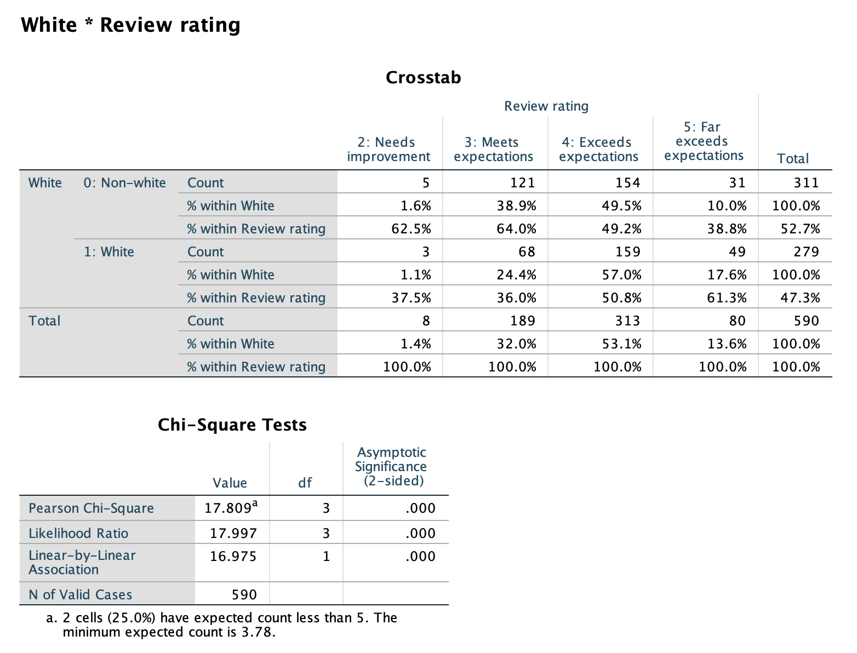

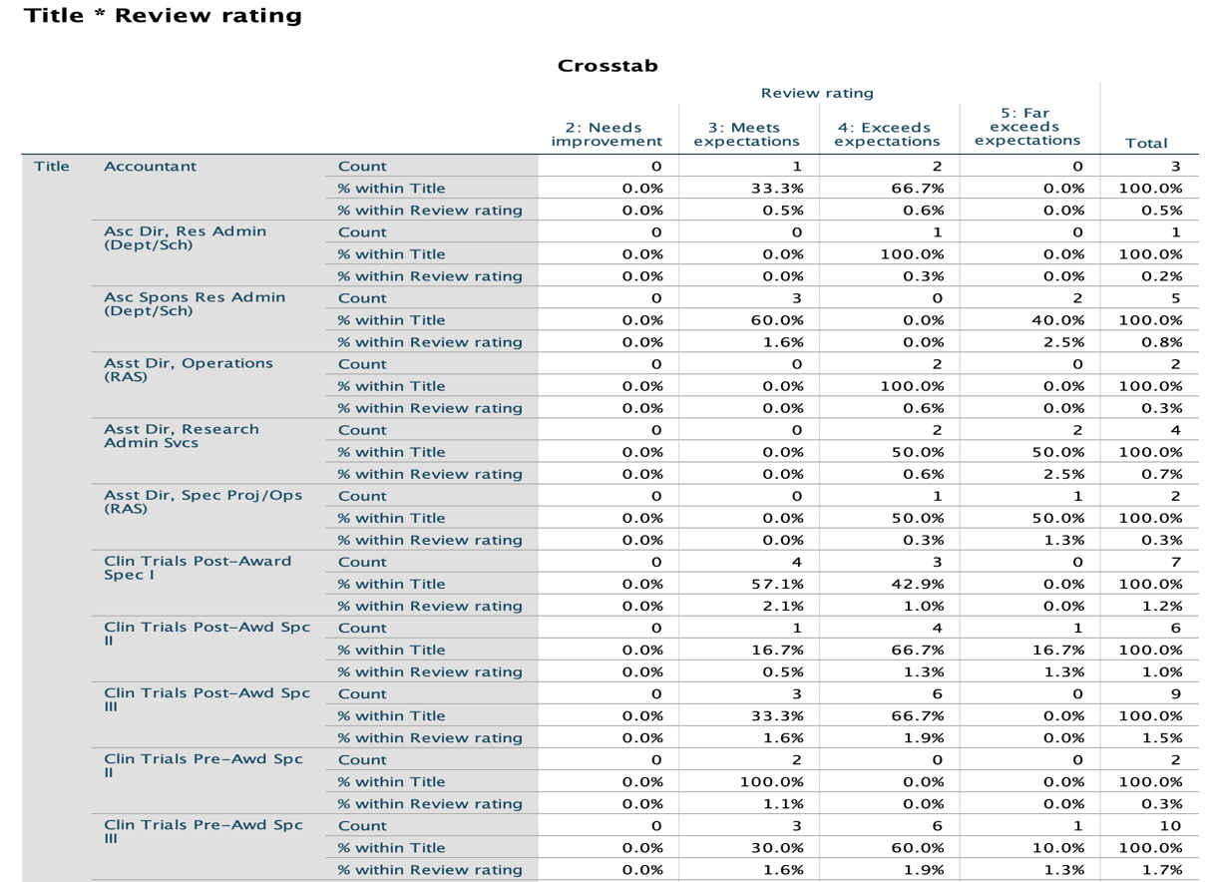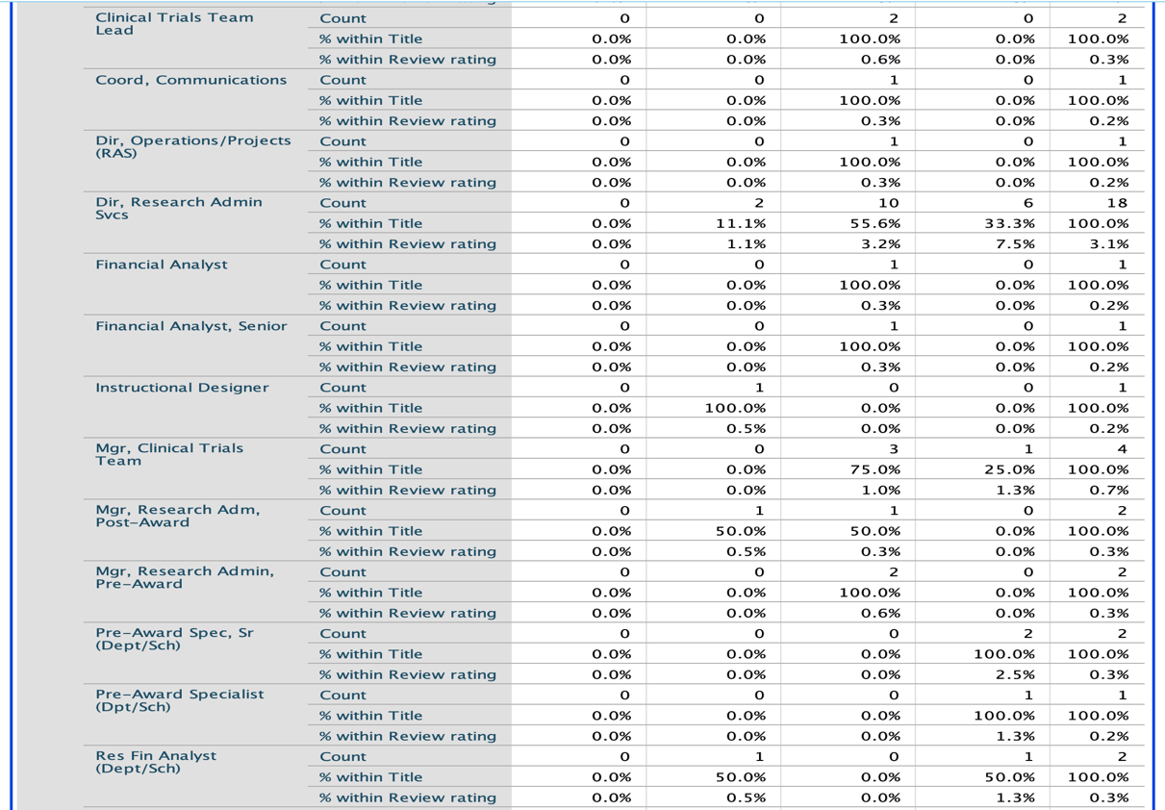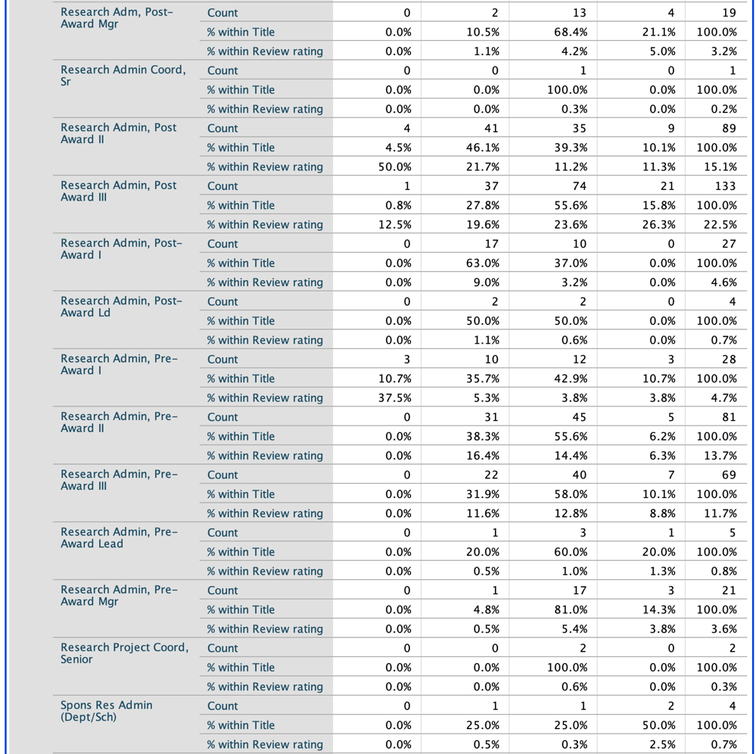

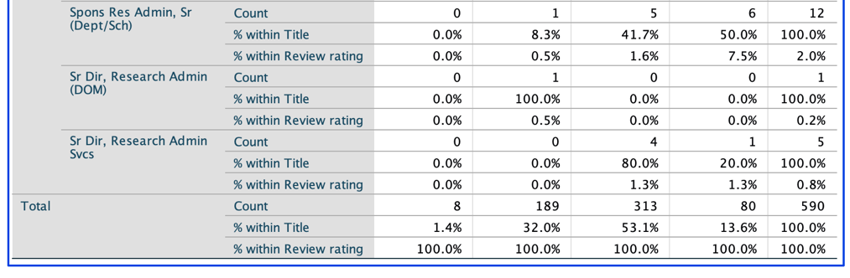

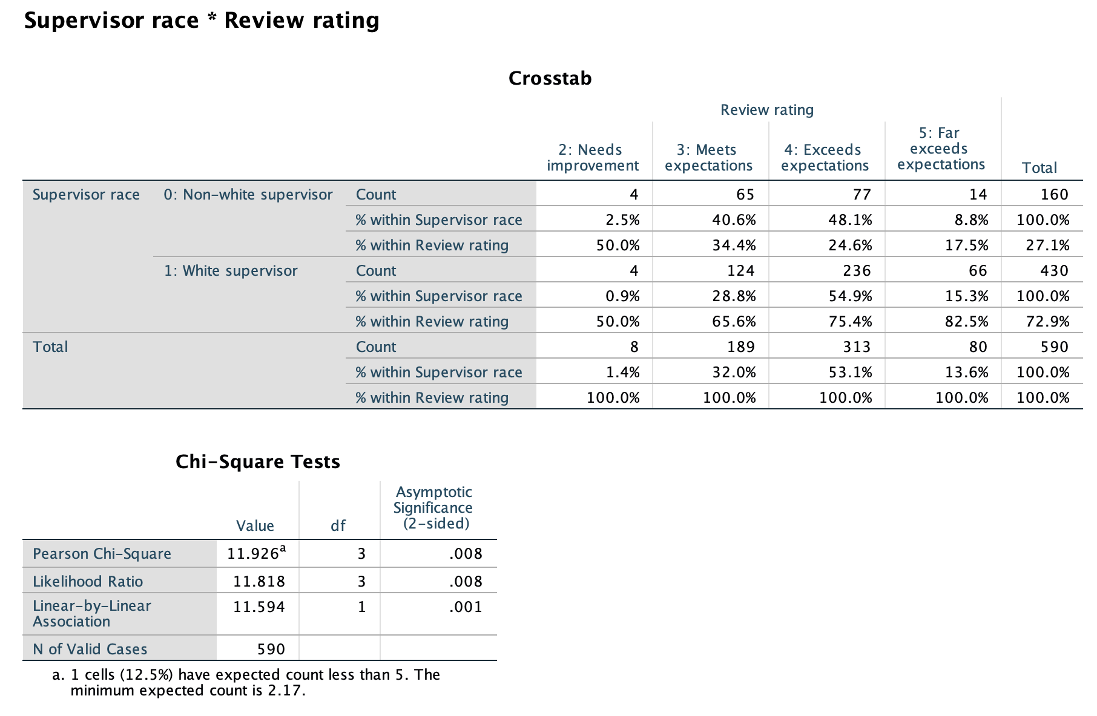

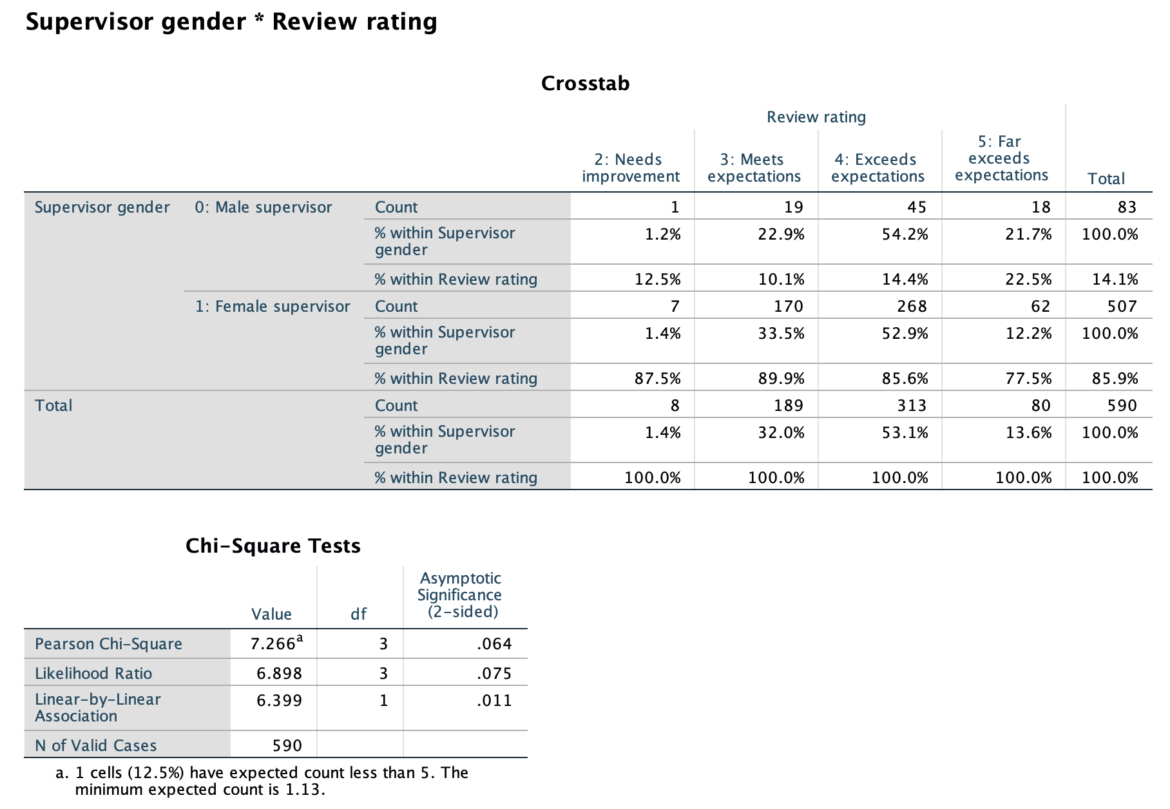

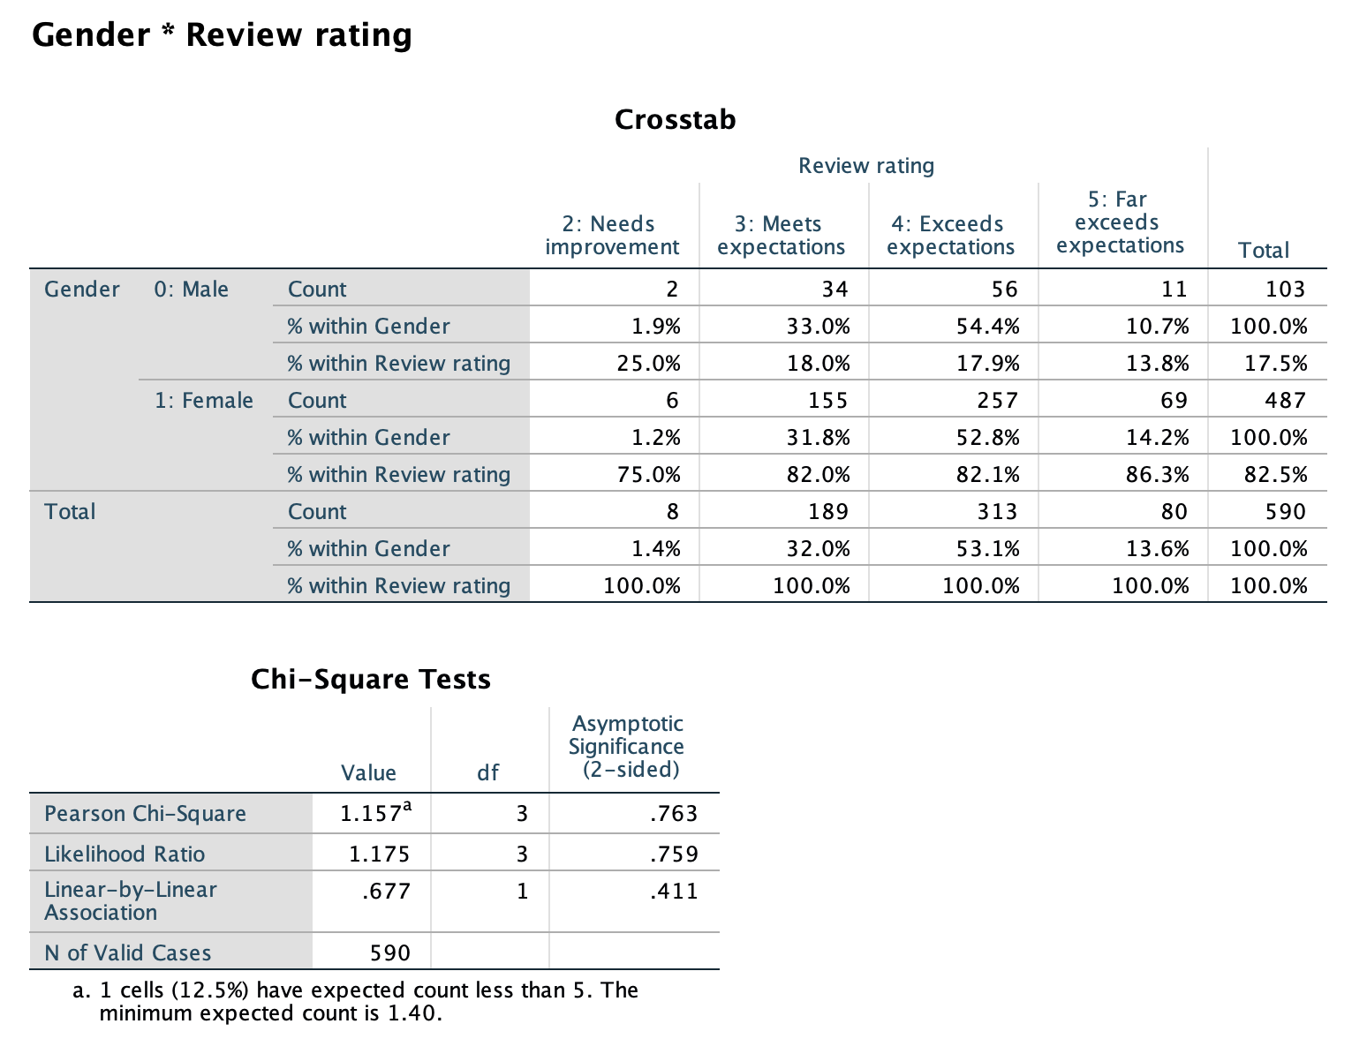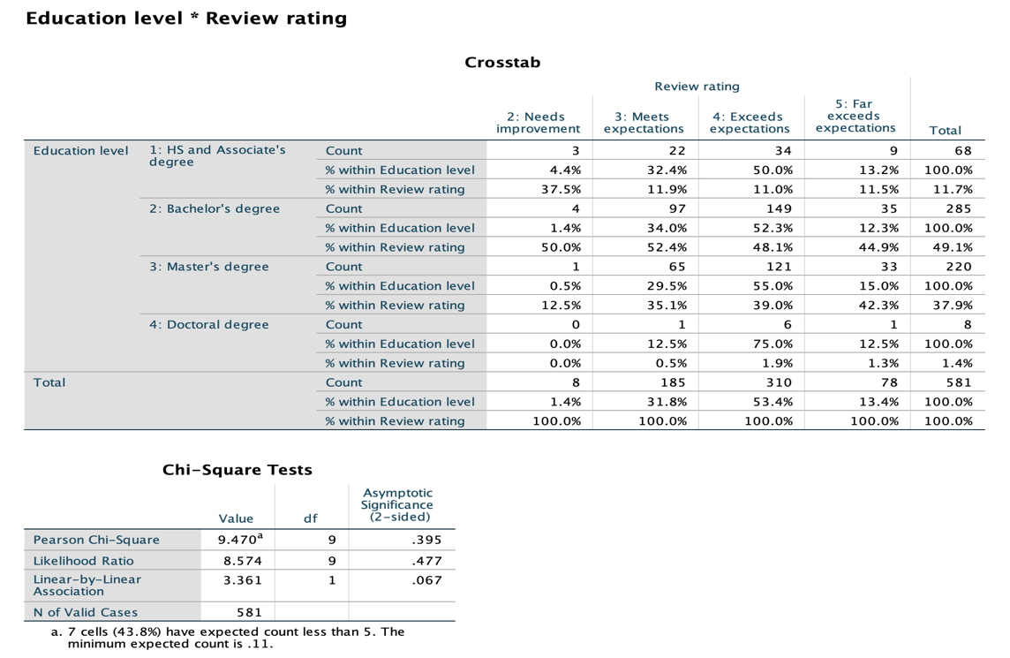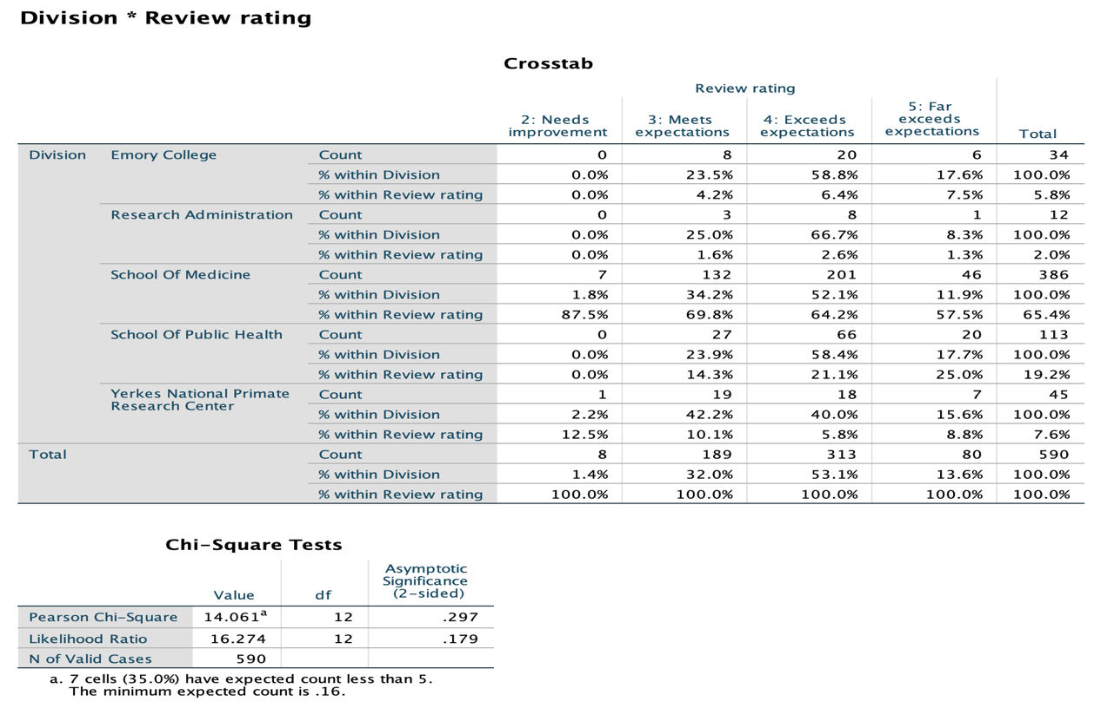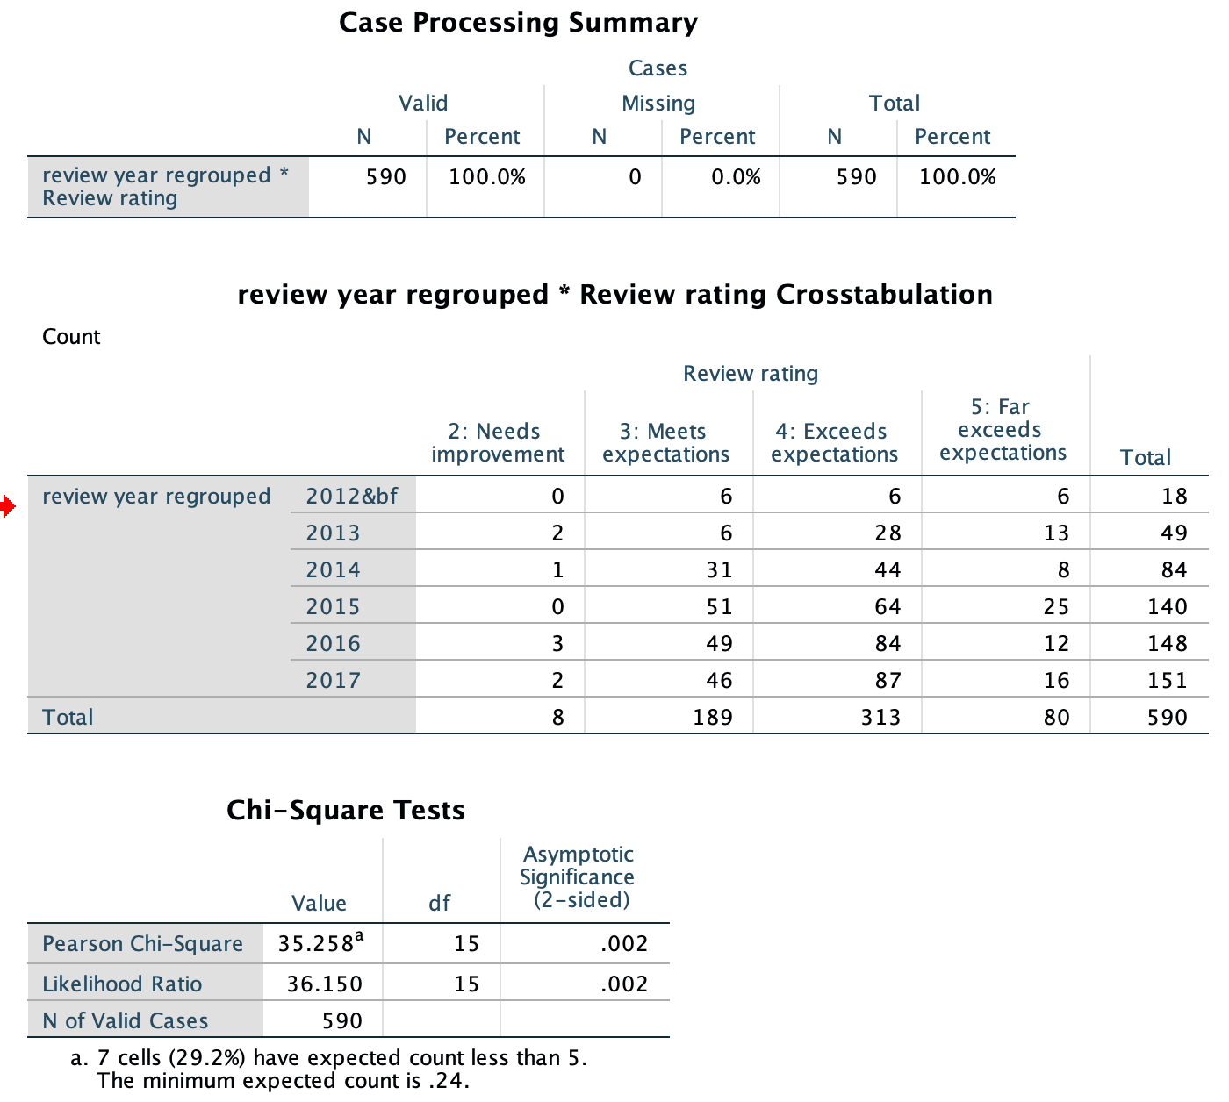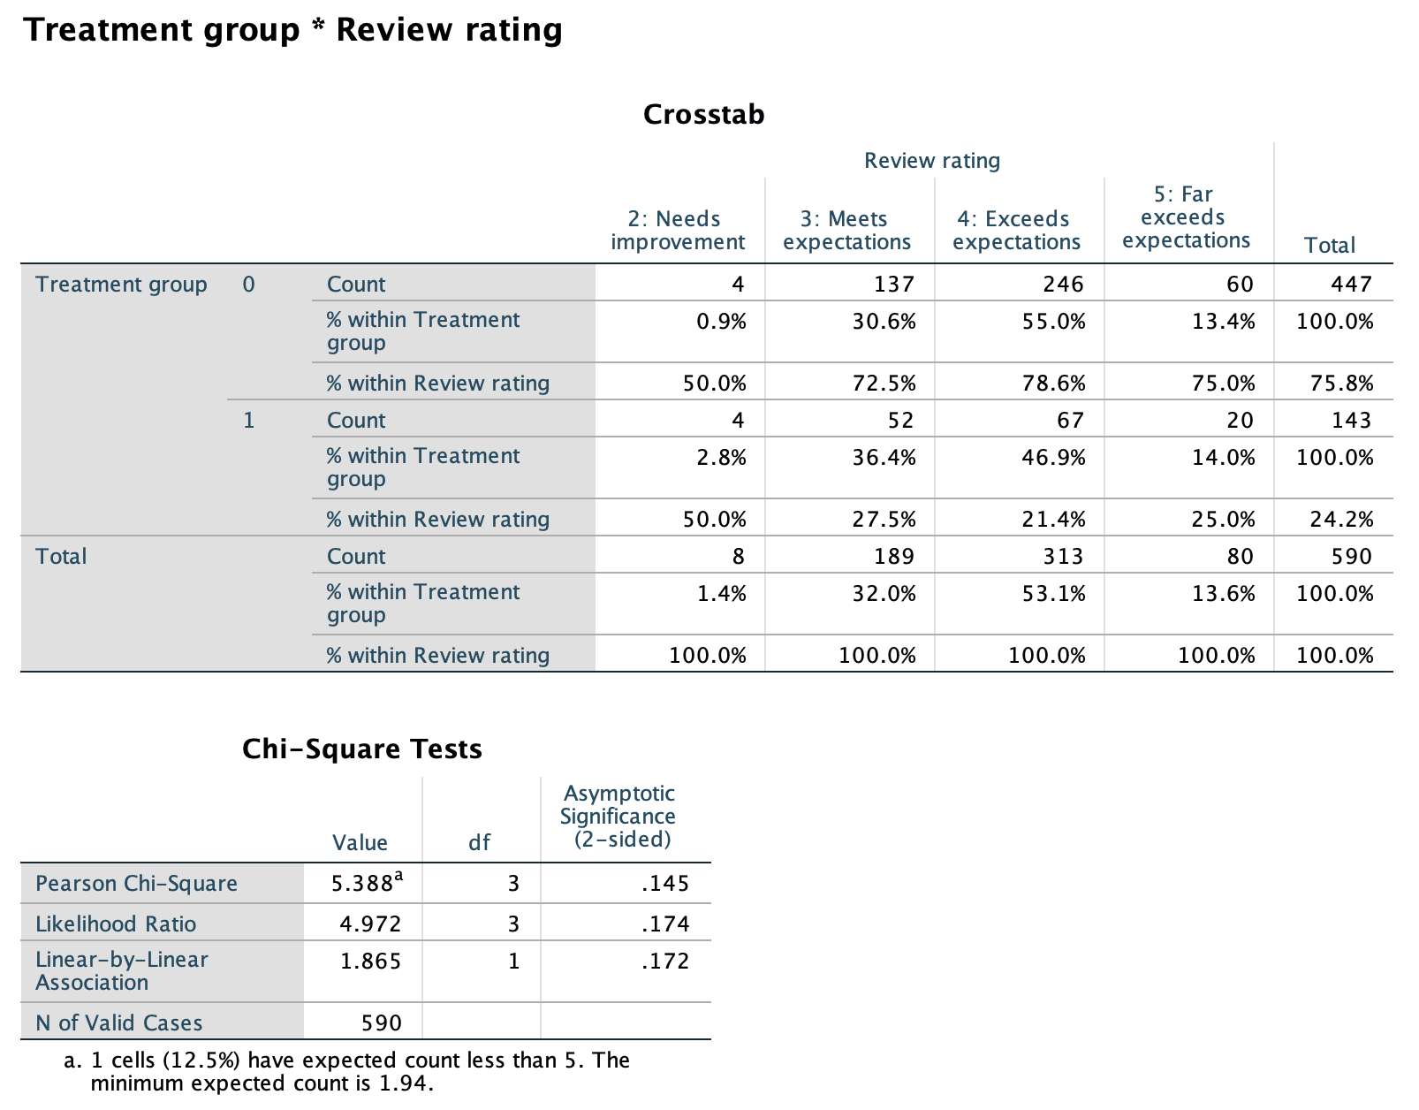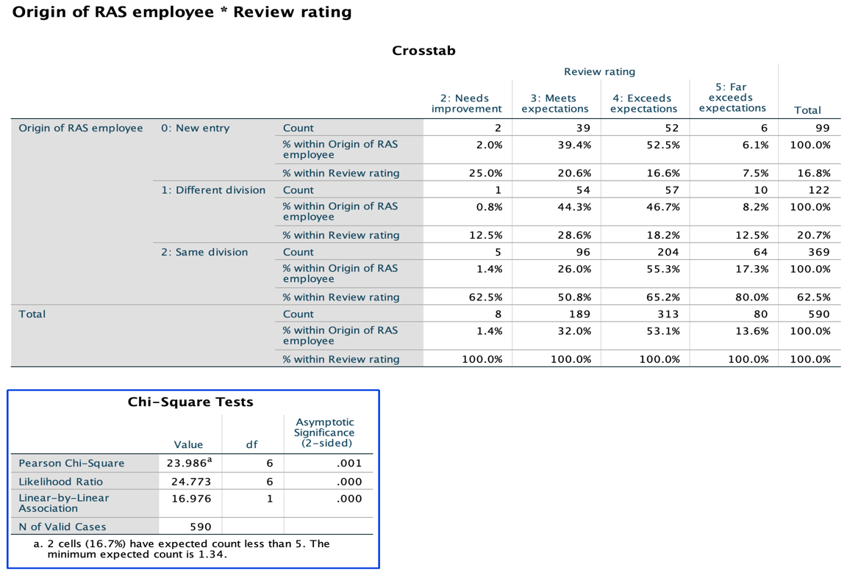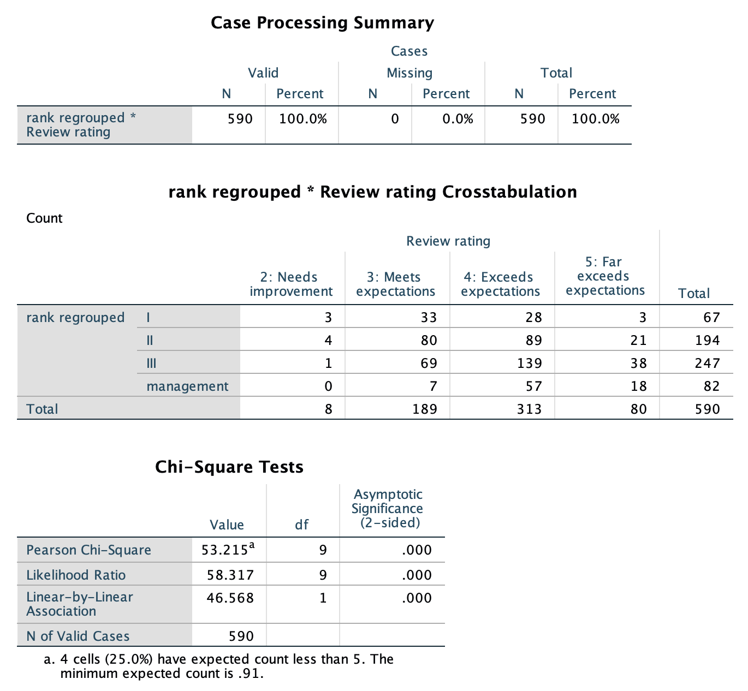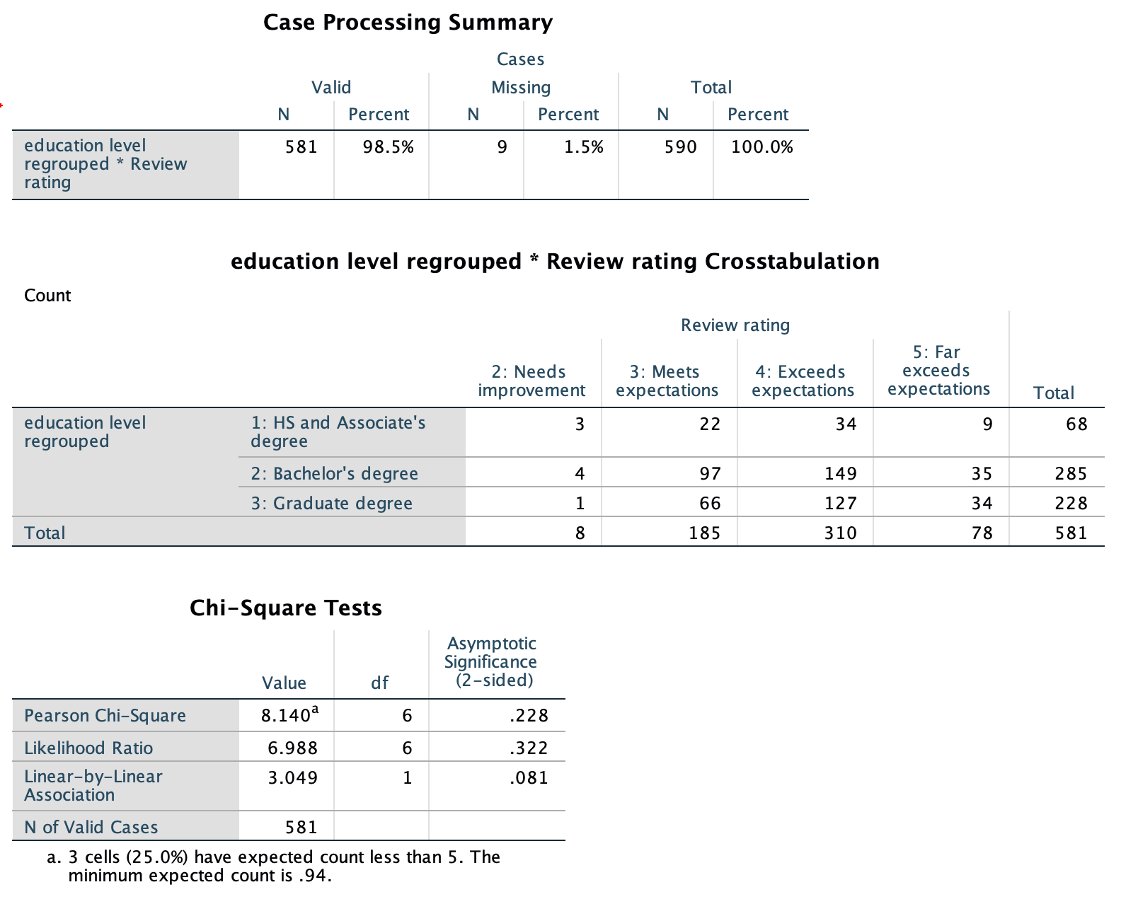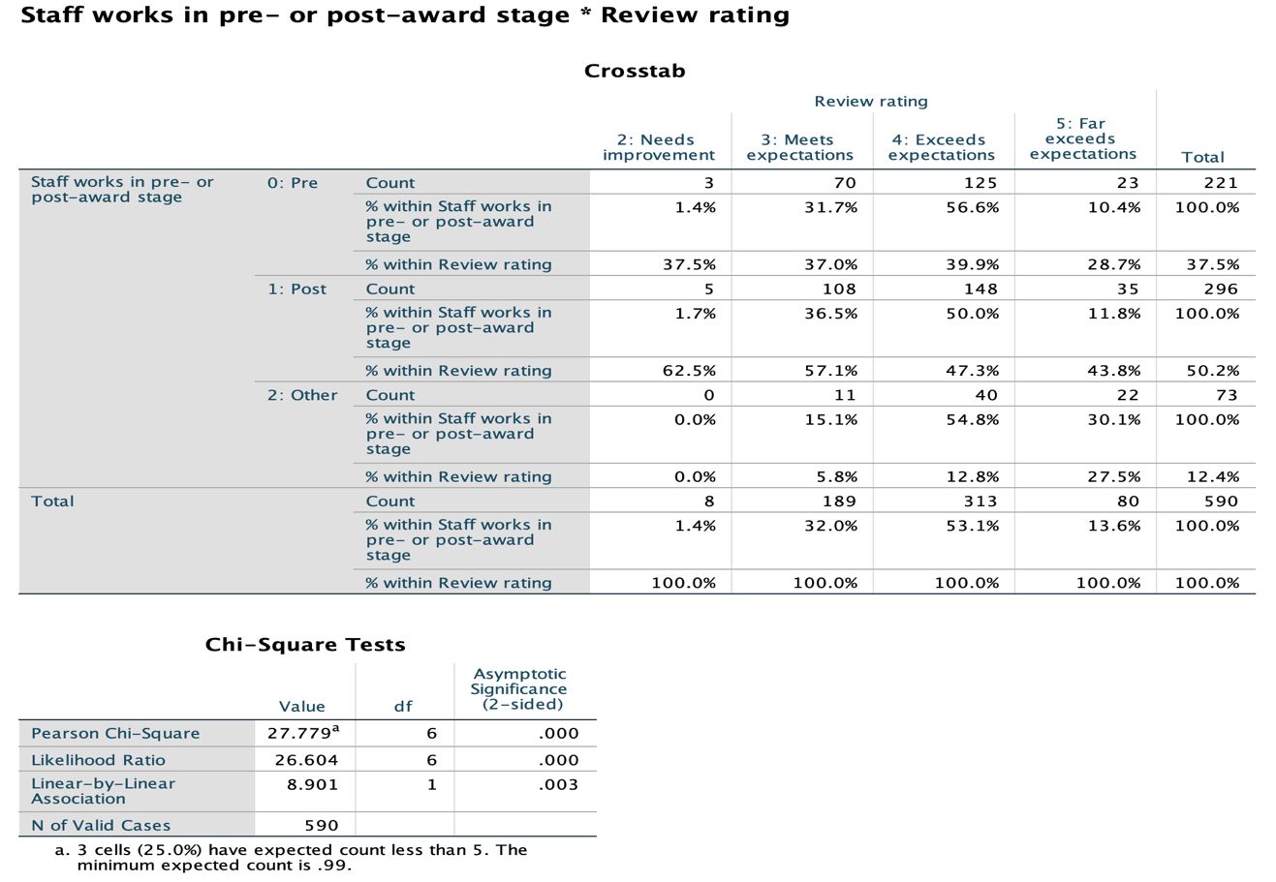

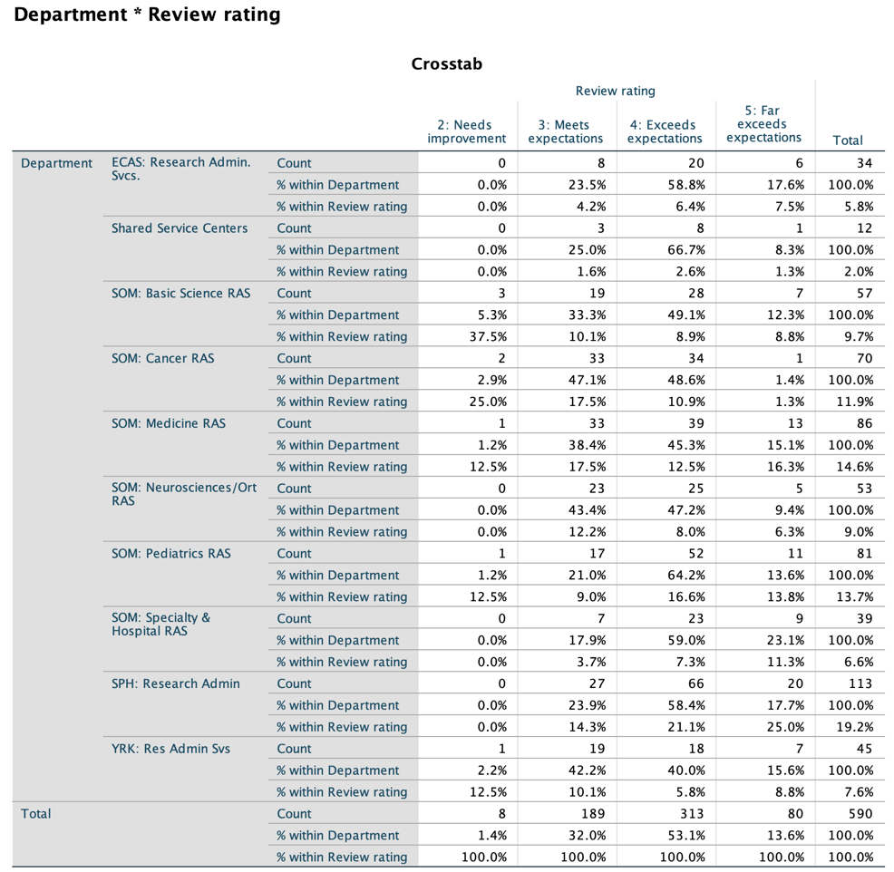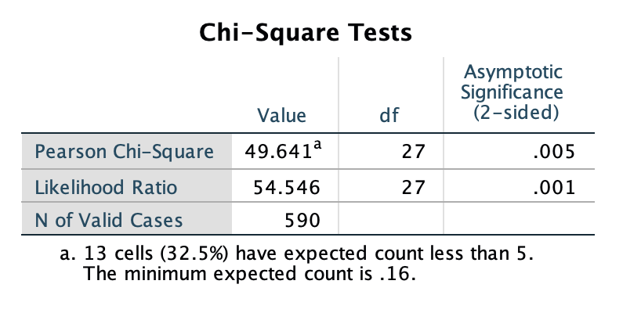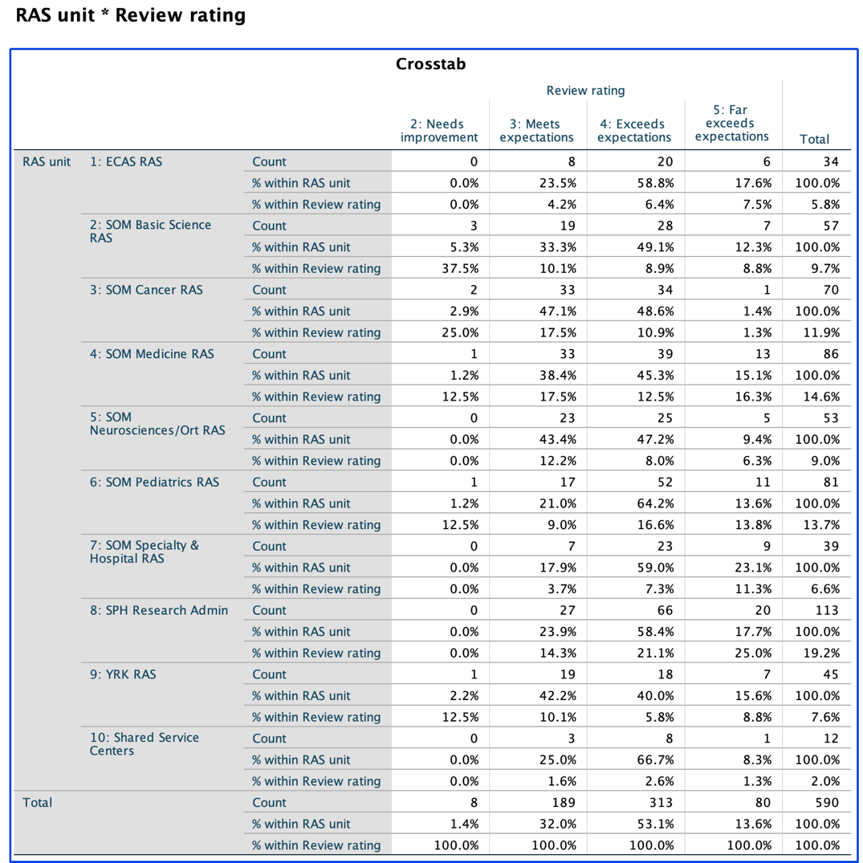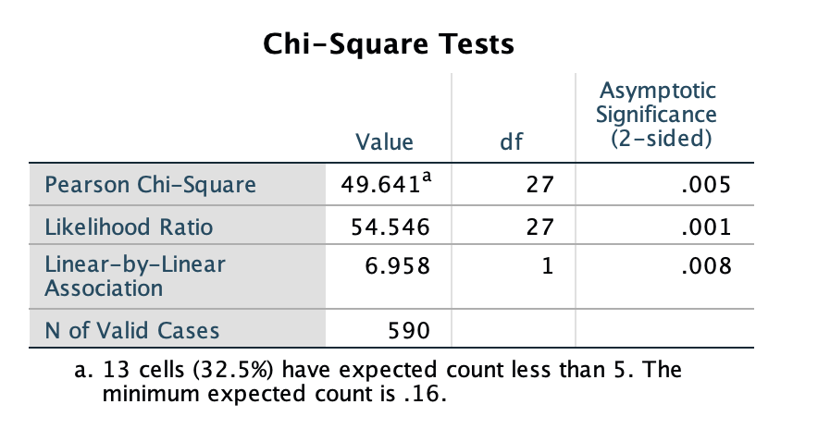

2).Frequency Tables:

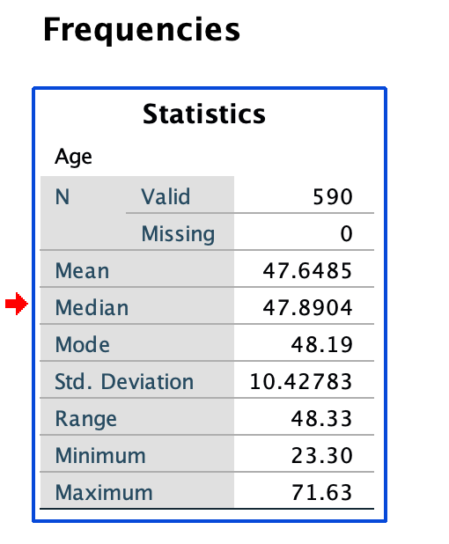

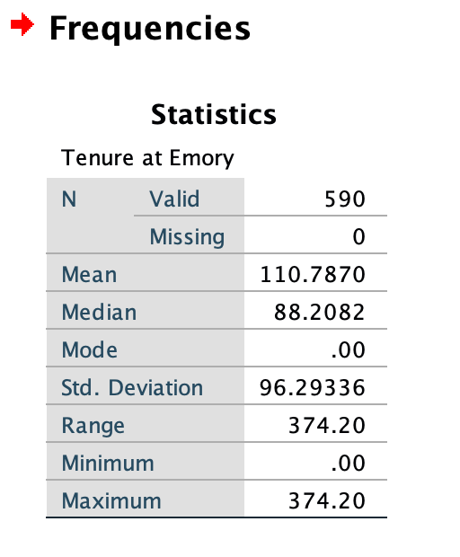

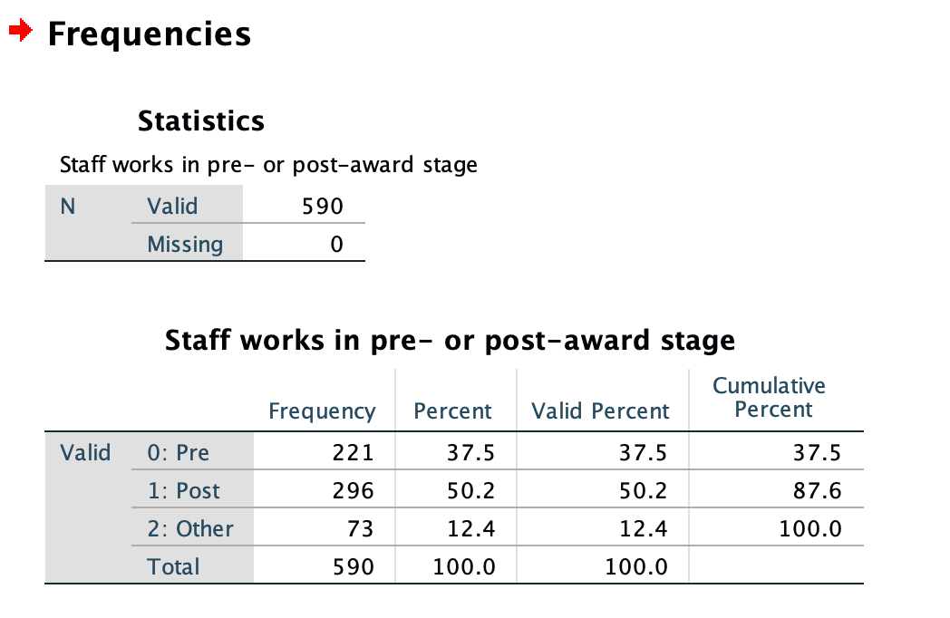

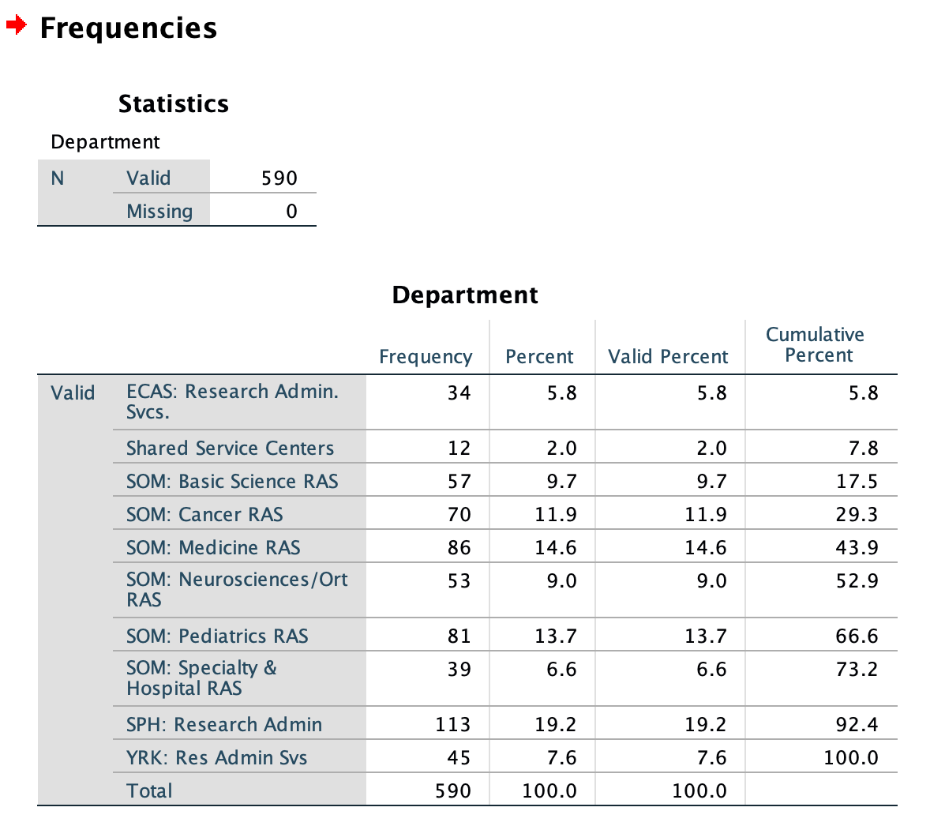

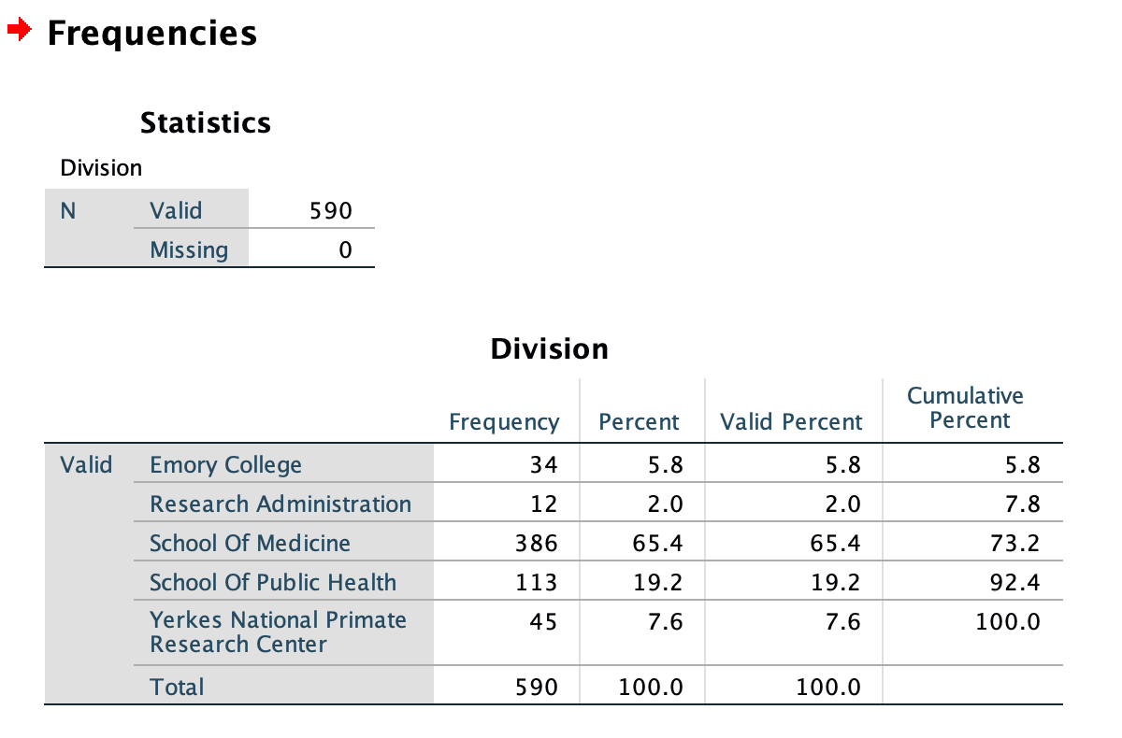

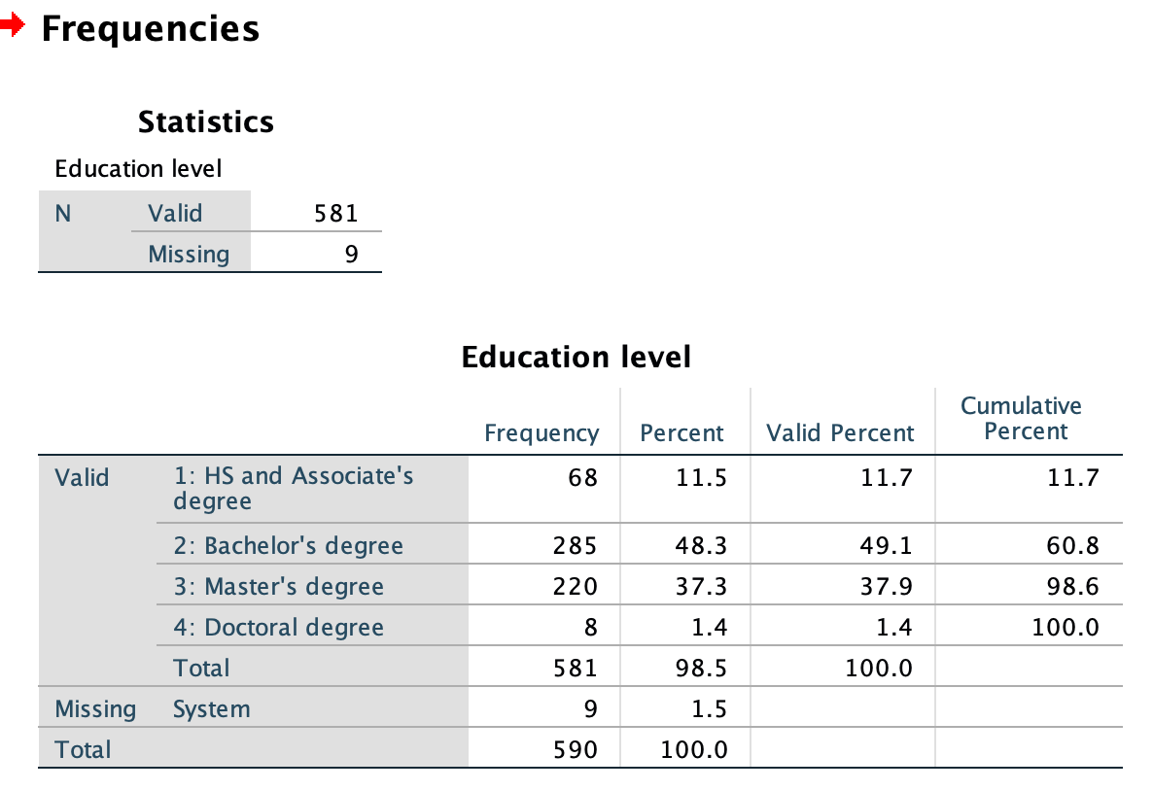

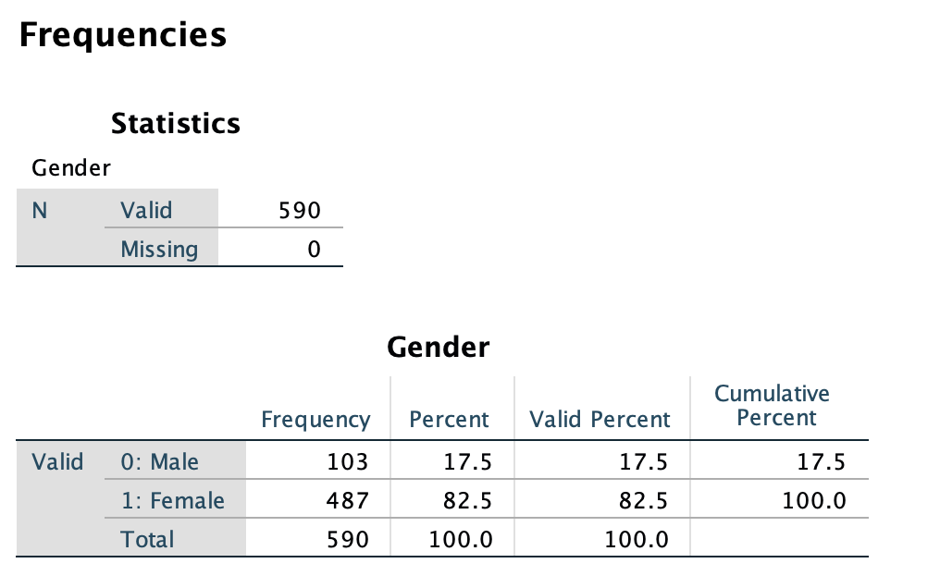

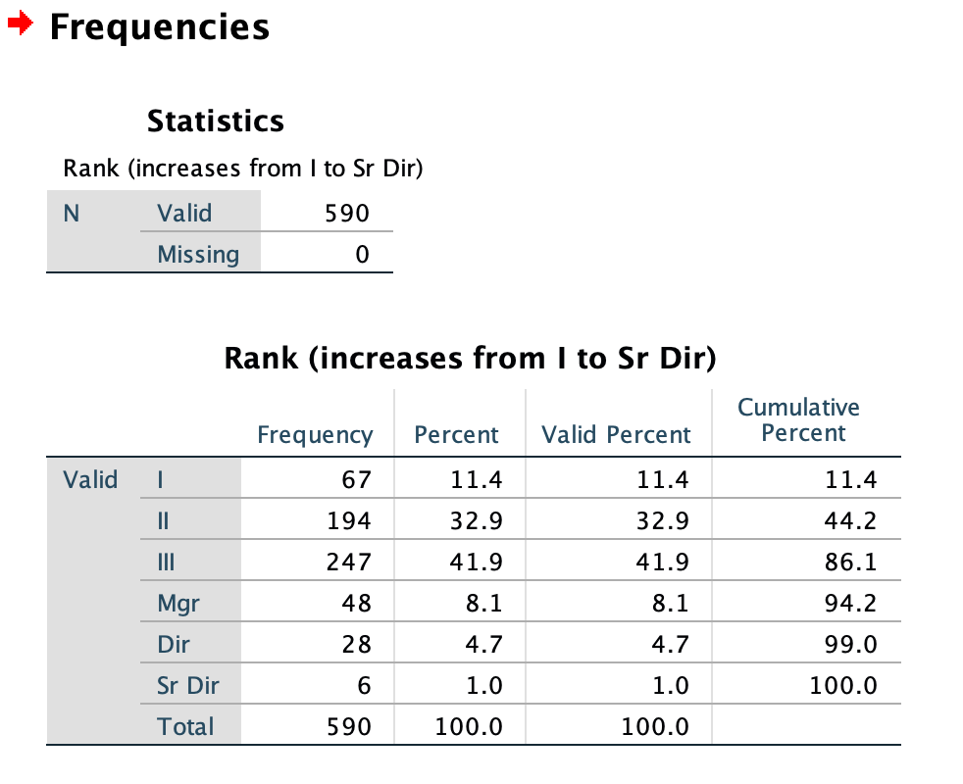

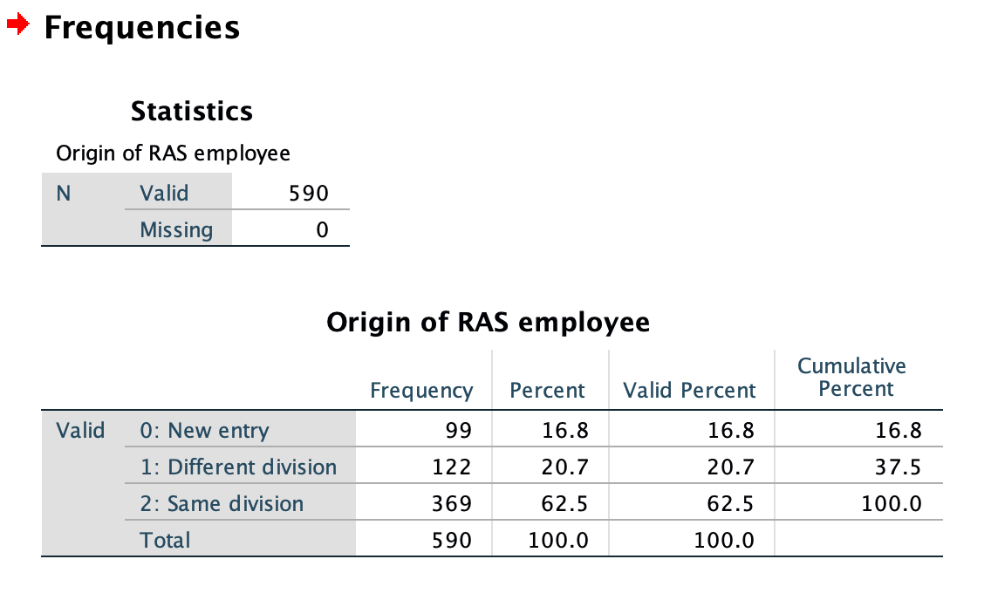

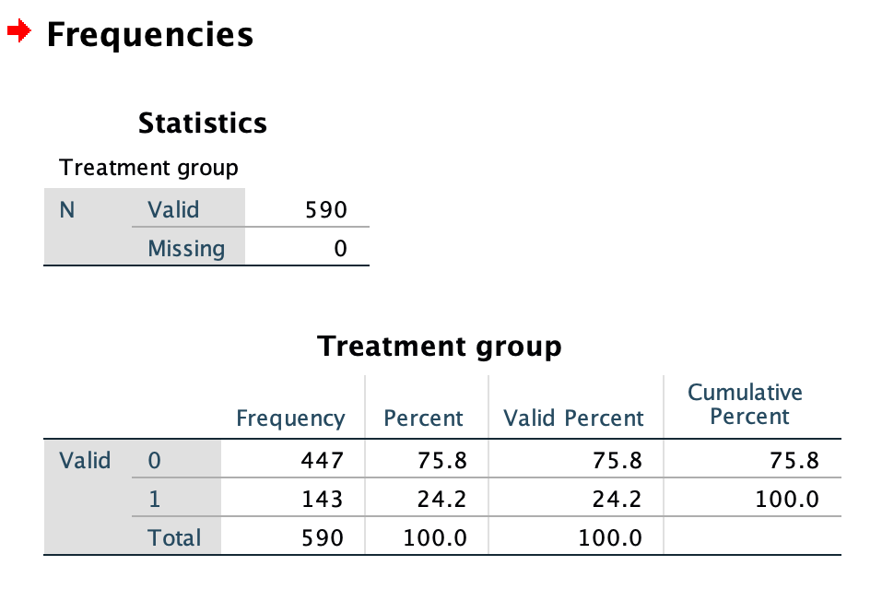

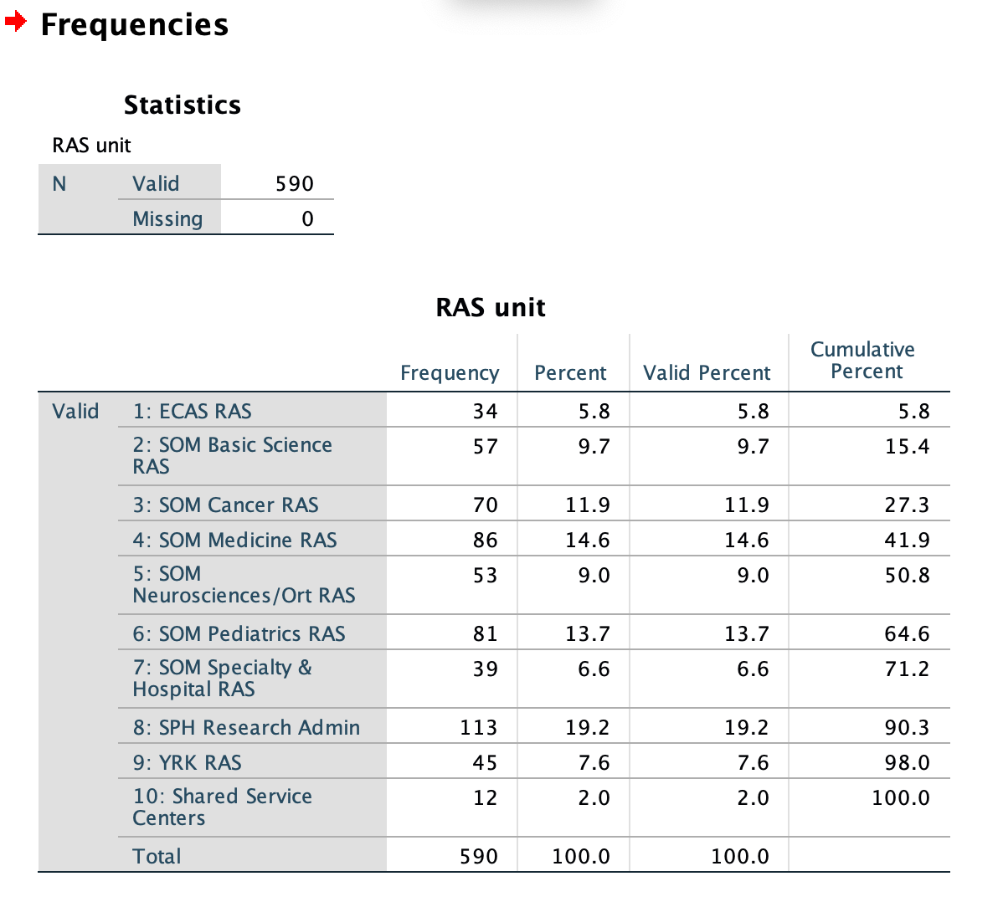

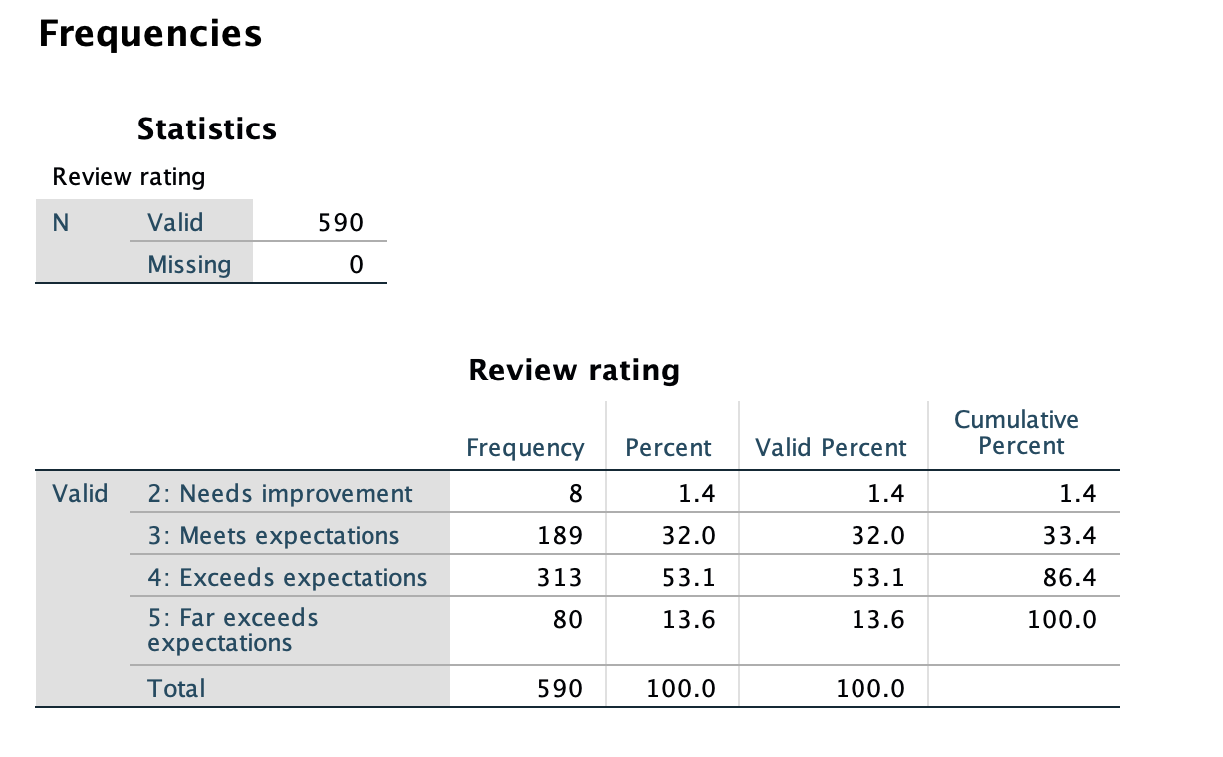

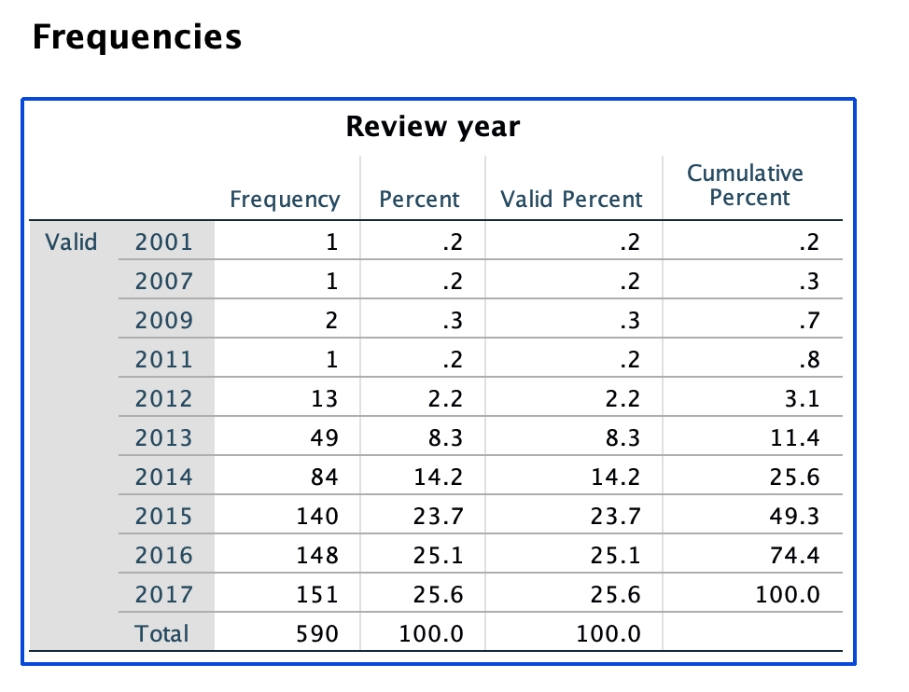

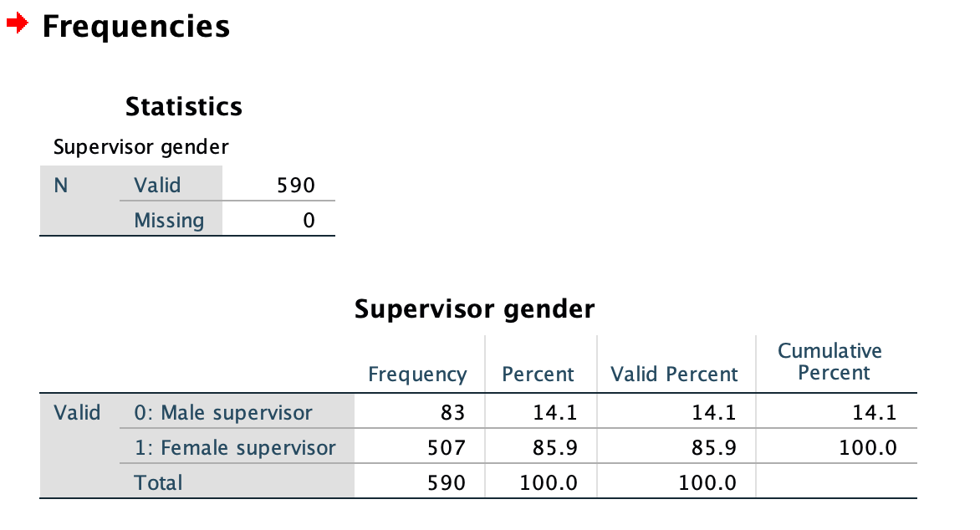

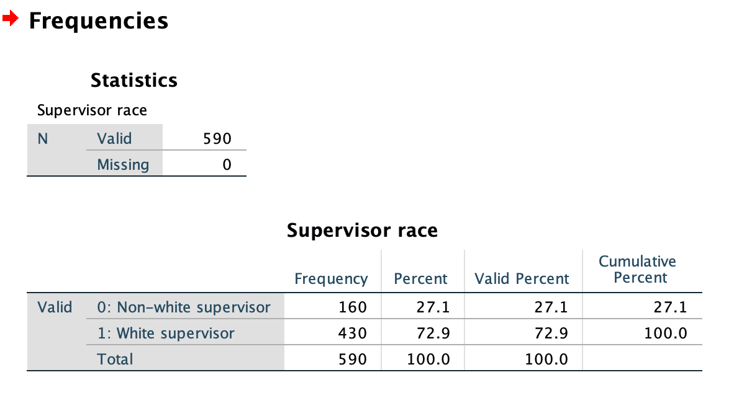

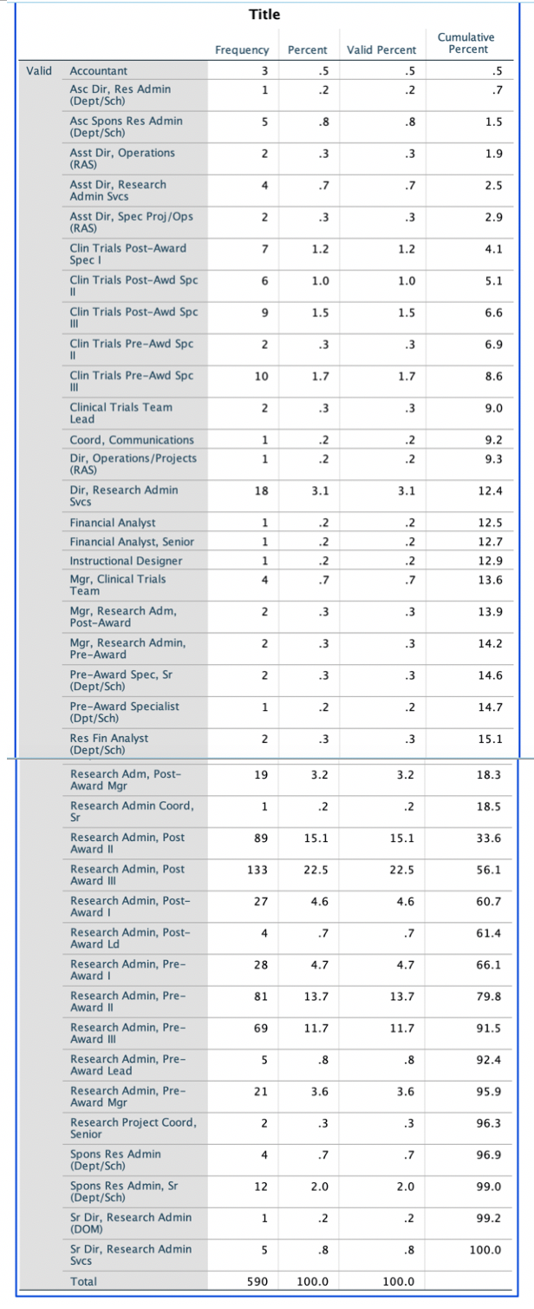

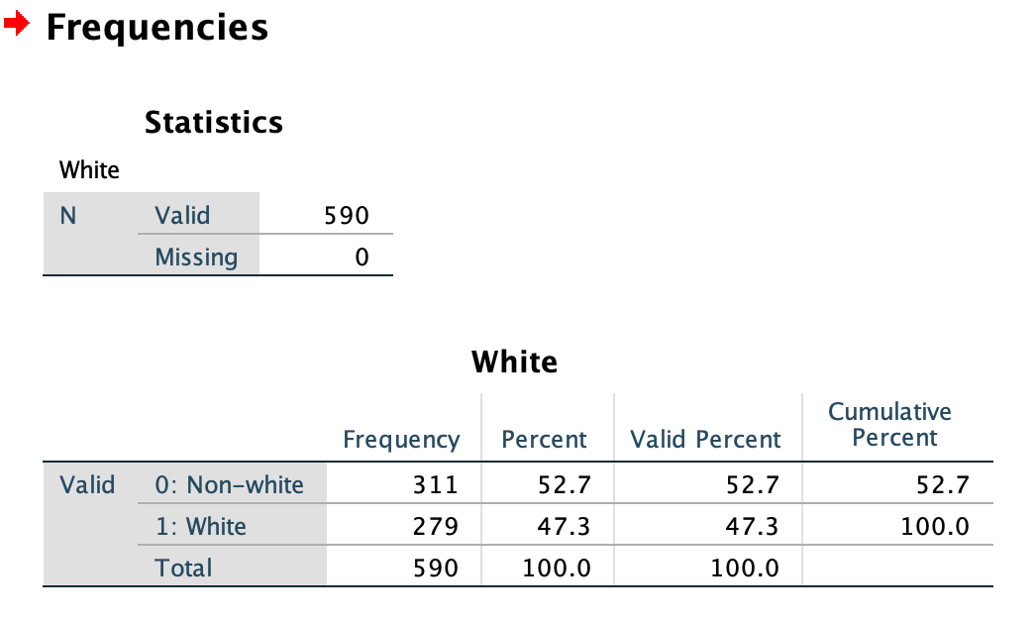

3).histograms for significant variables:

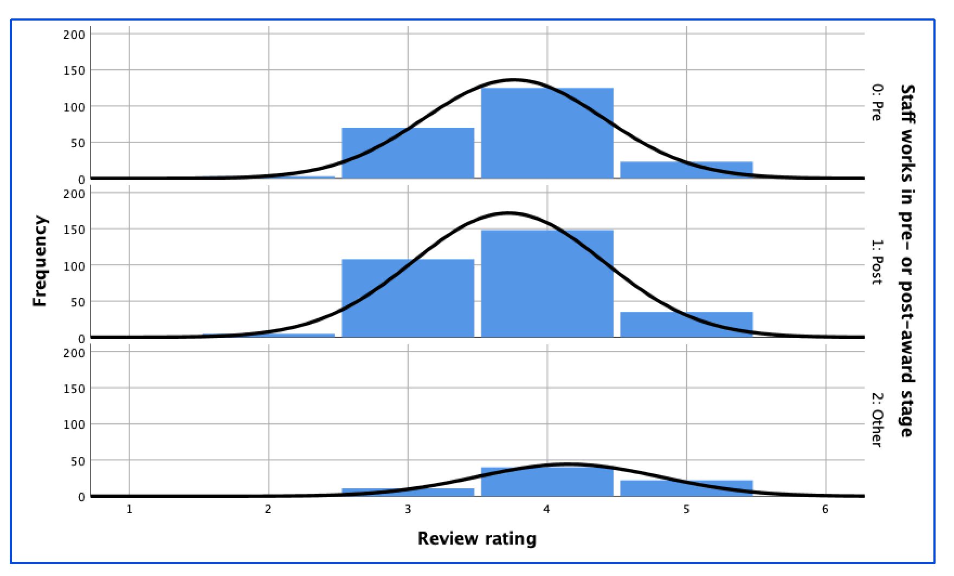

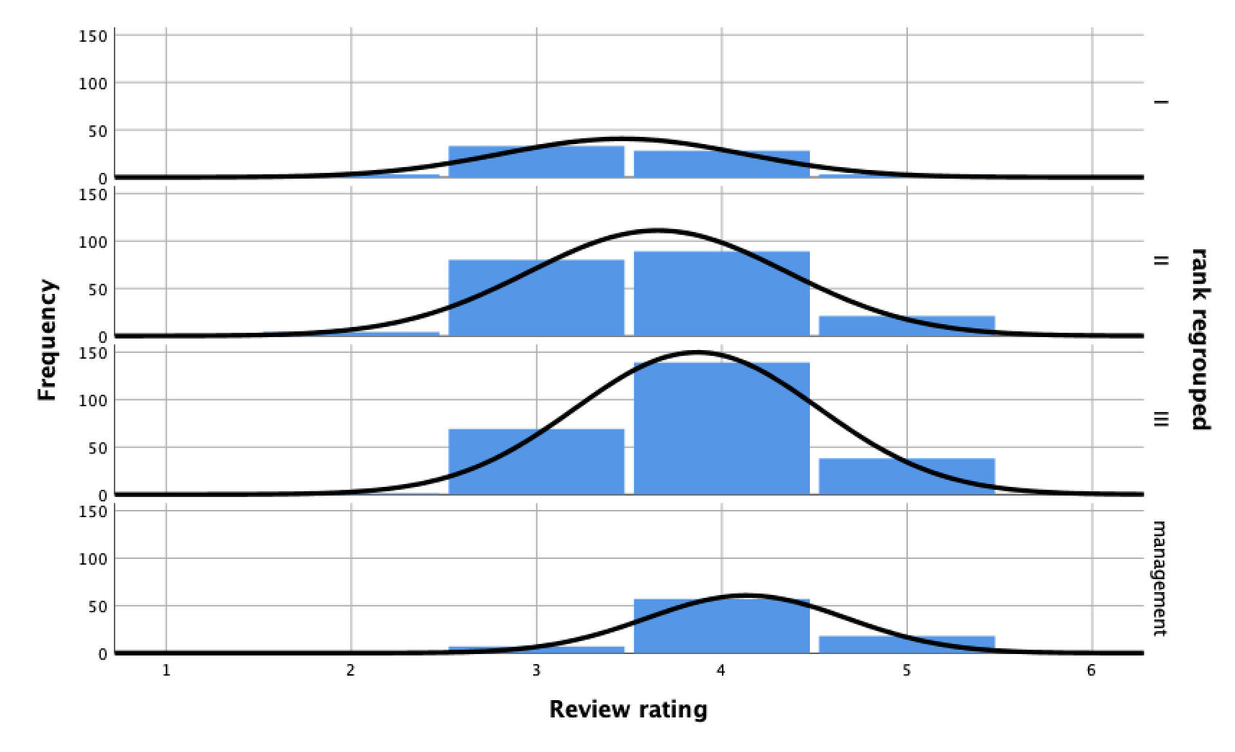

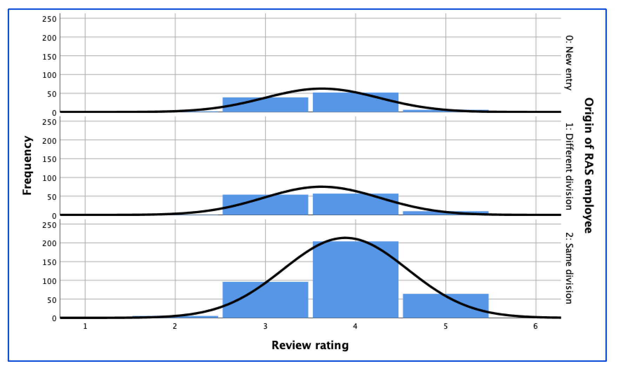

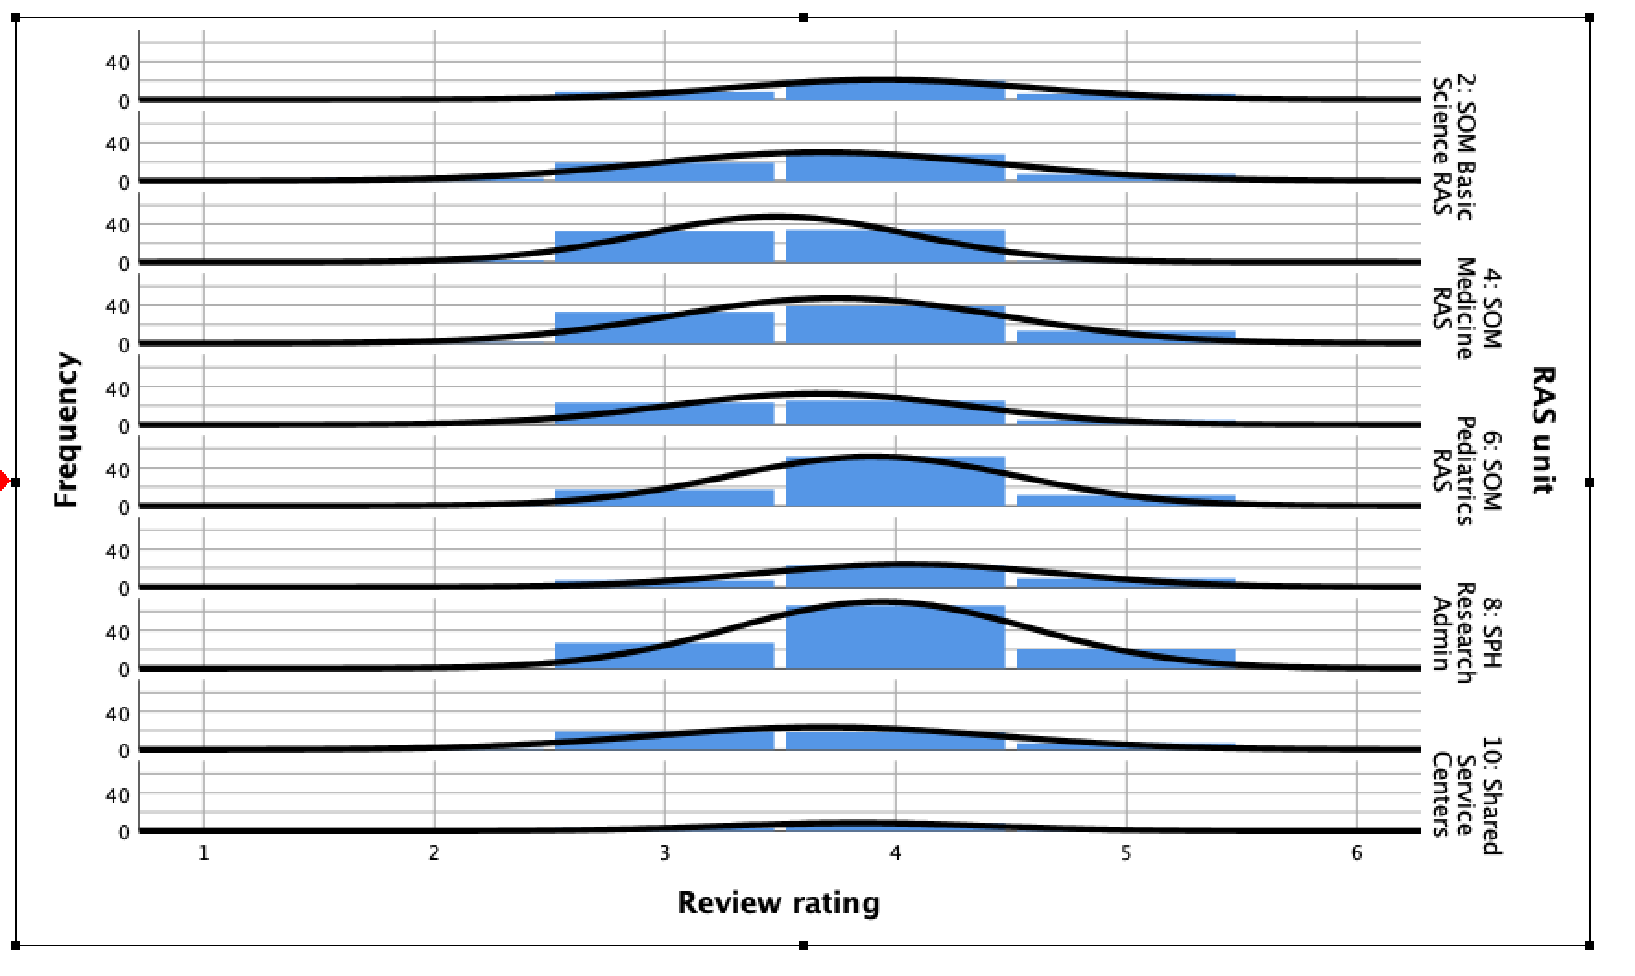

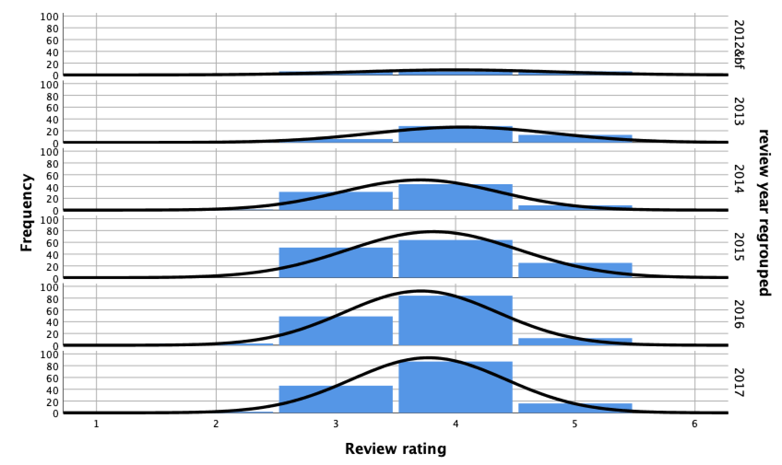

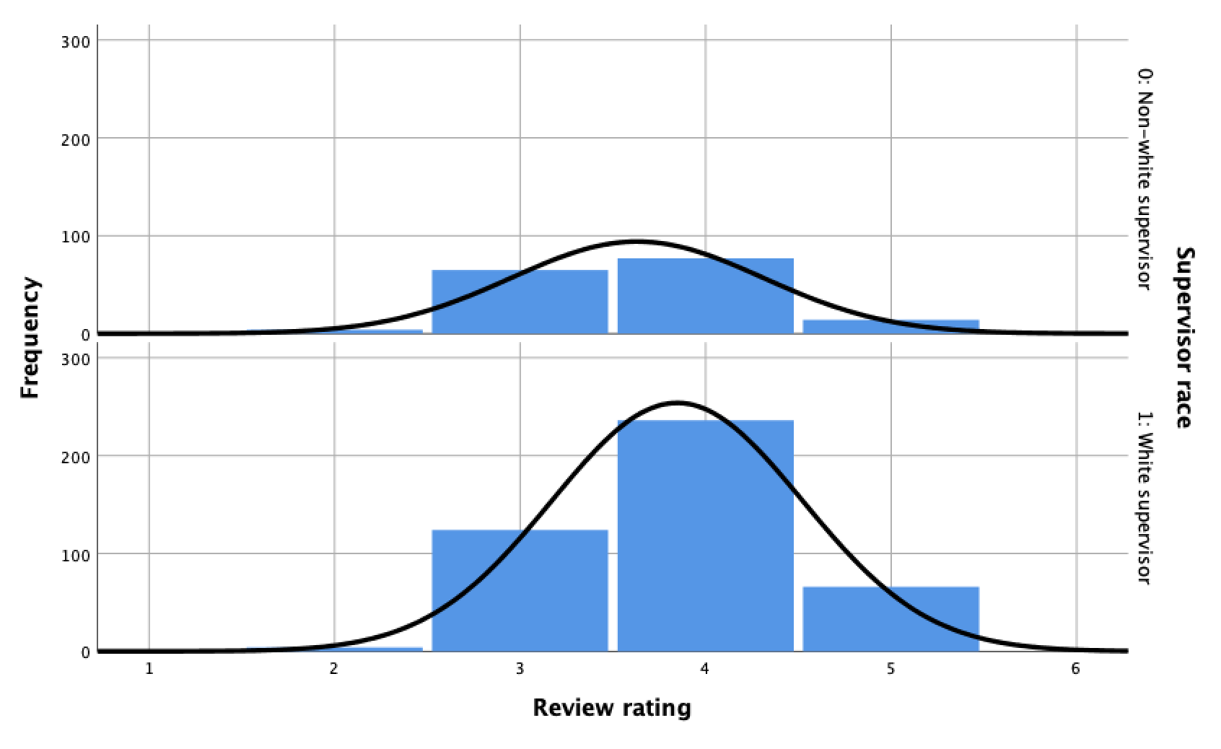

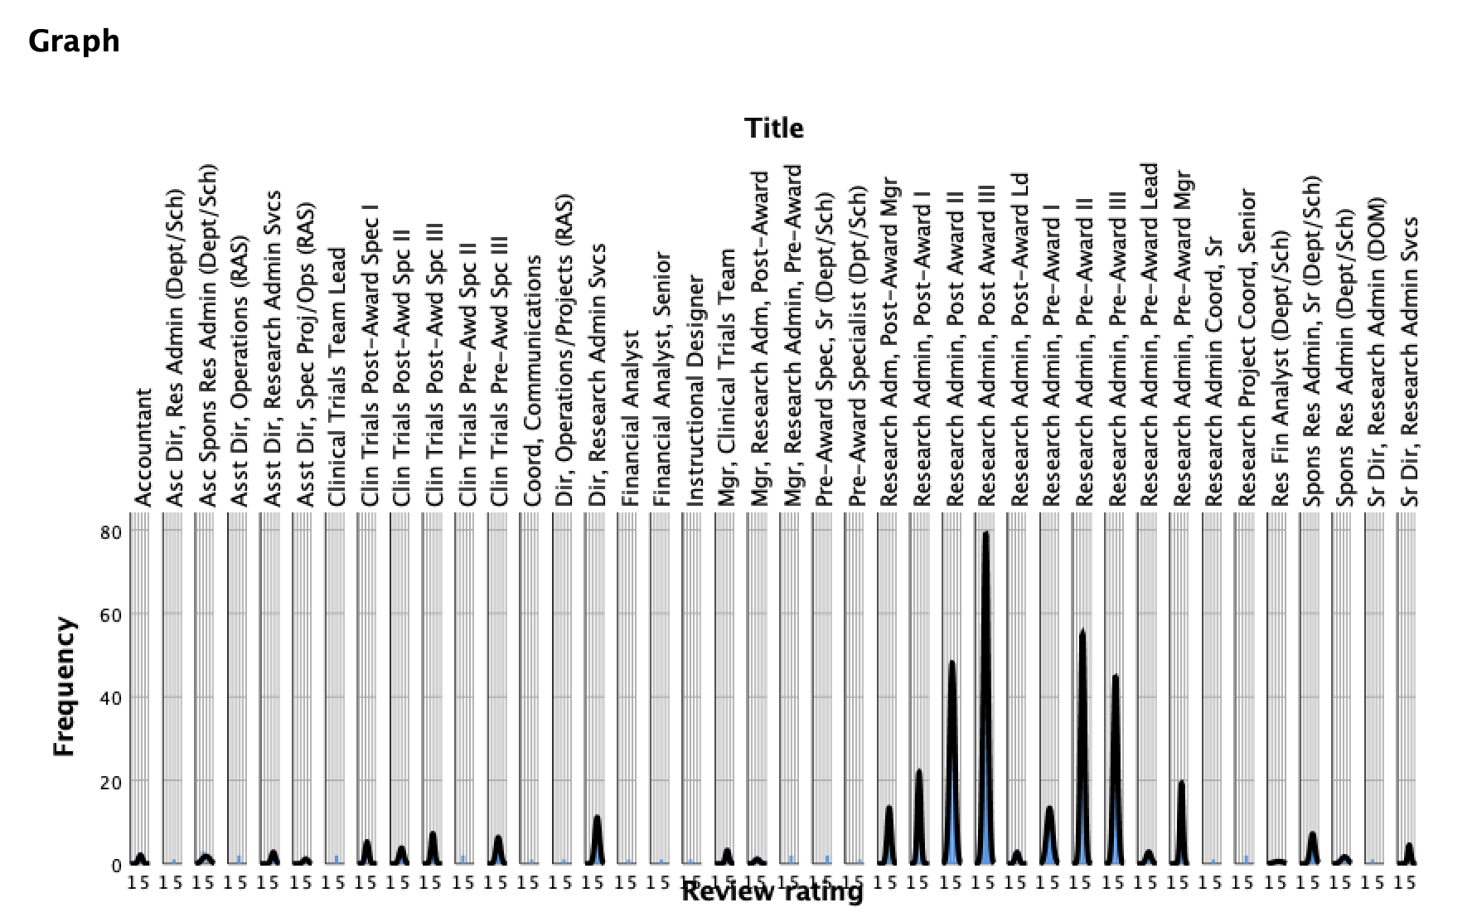

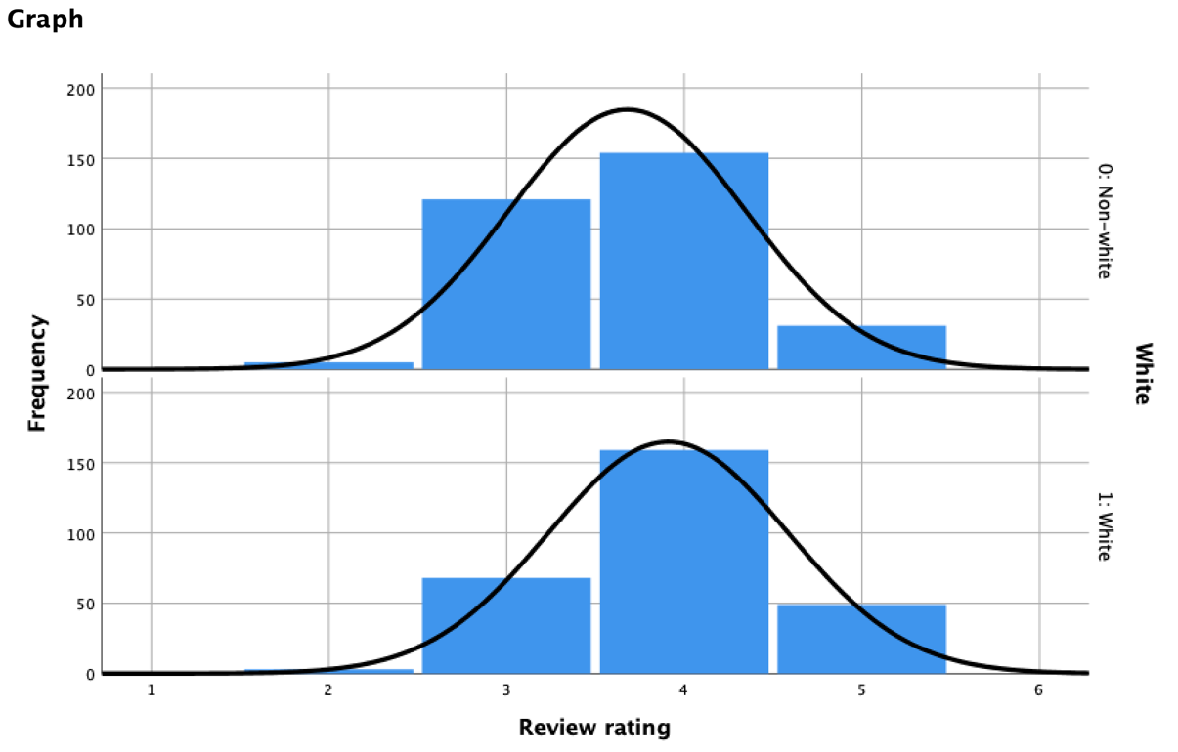

4).correlation matrix (for reference):

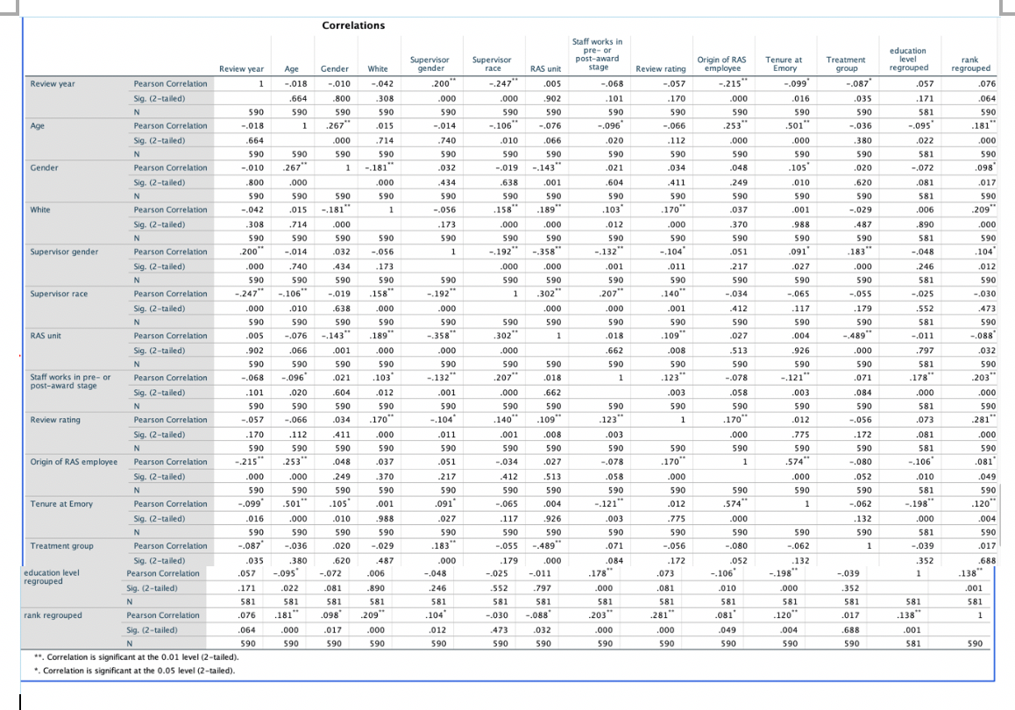

5).Ordinal regression model outputs:

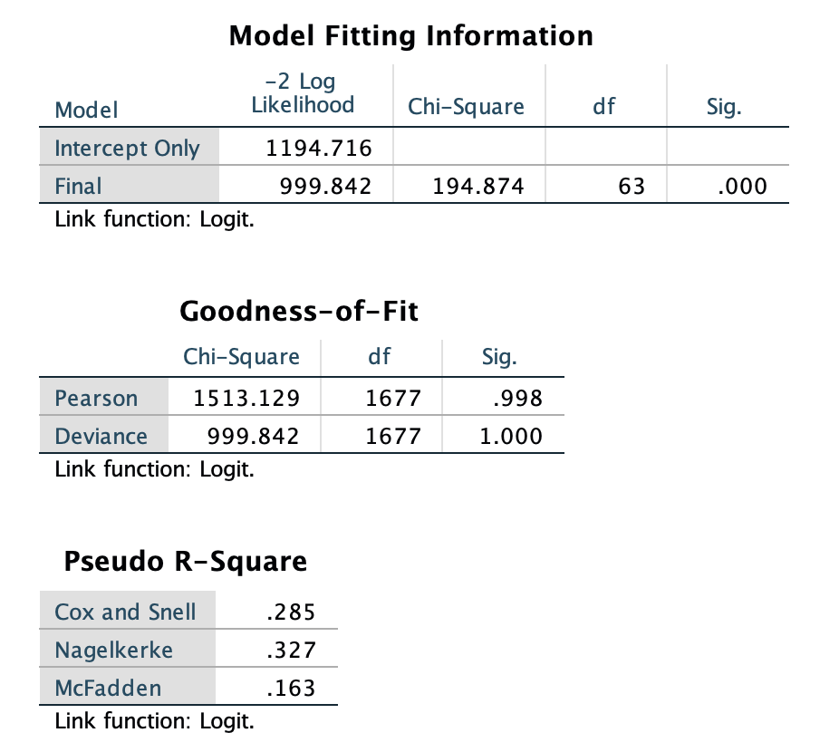

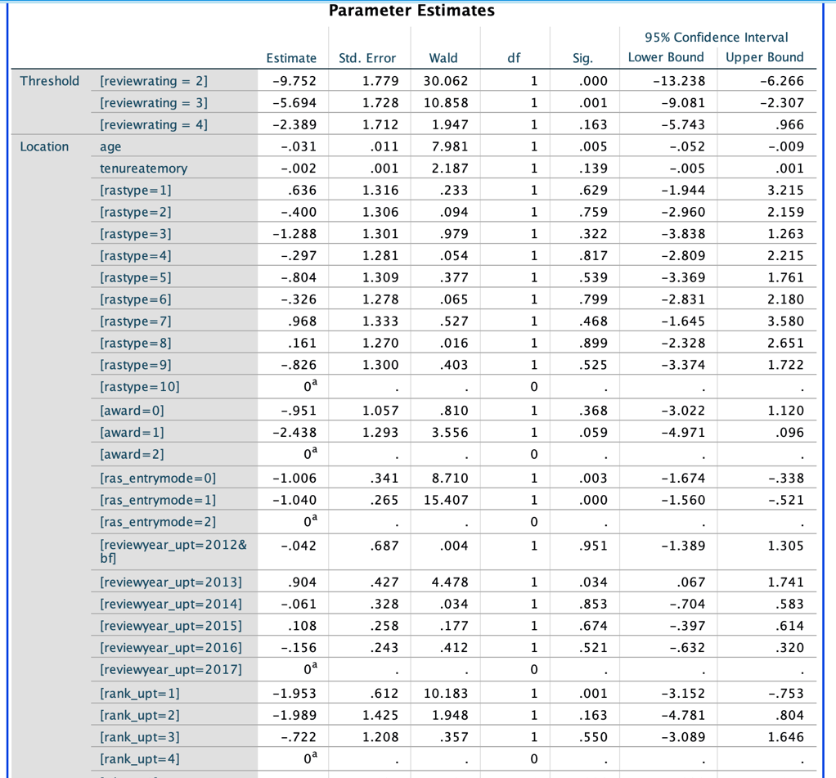

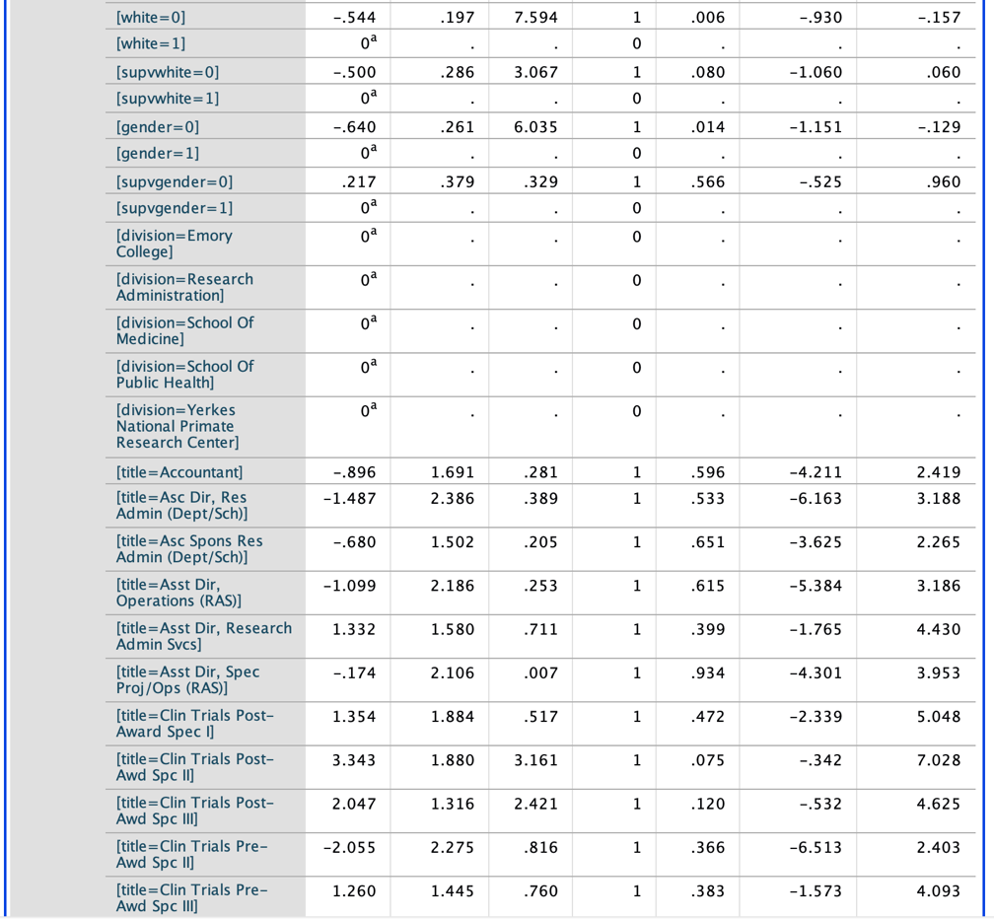

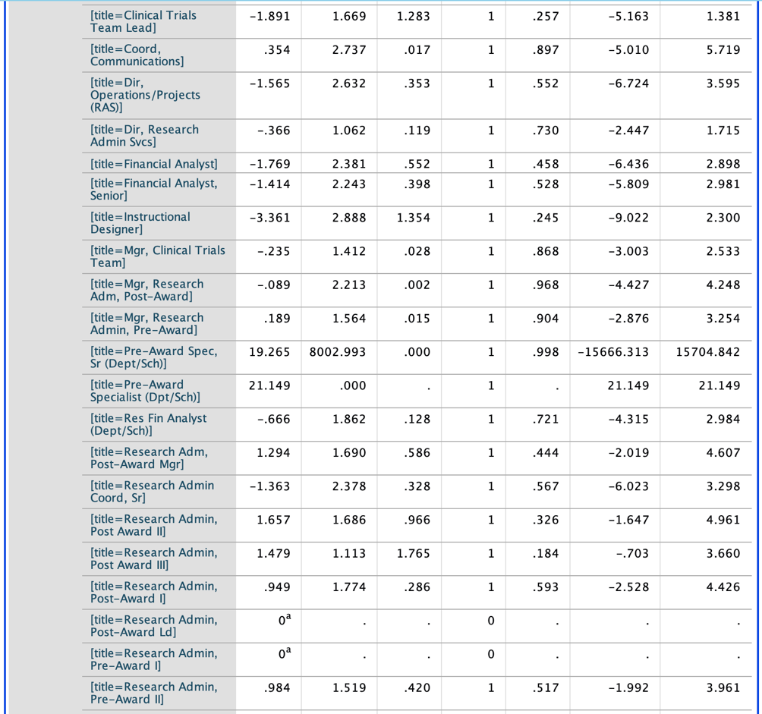

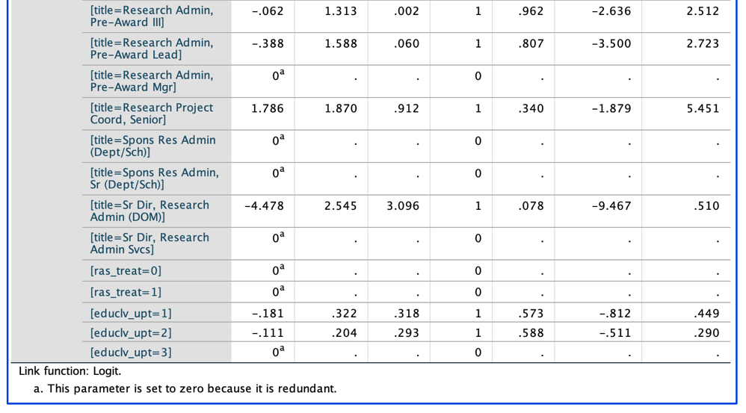

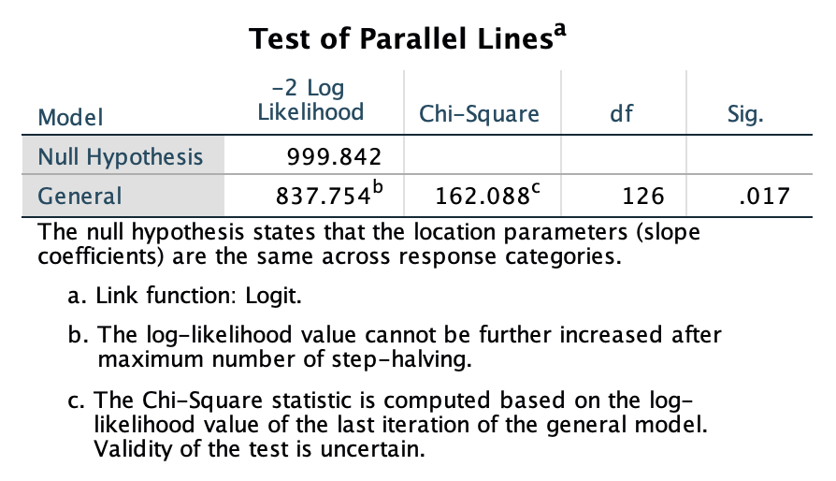

**Section 3:**

1).Frequency Tables:

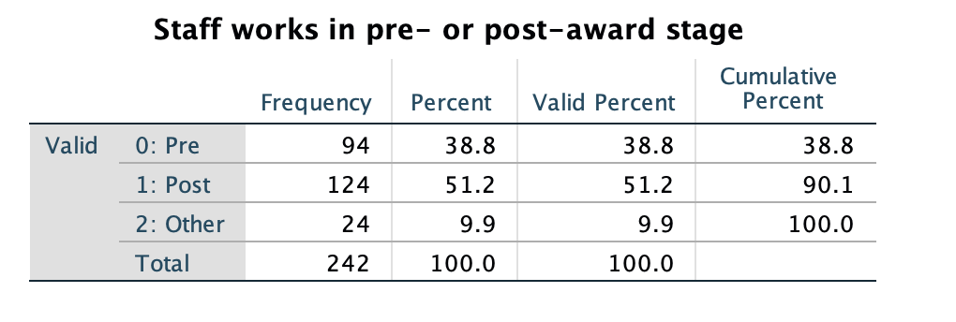

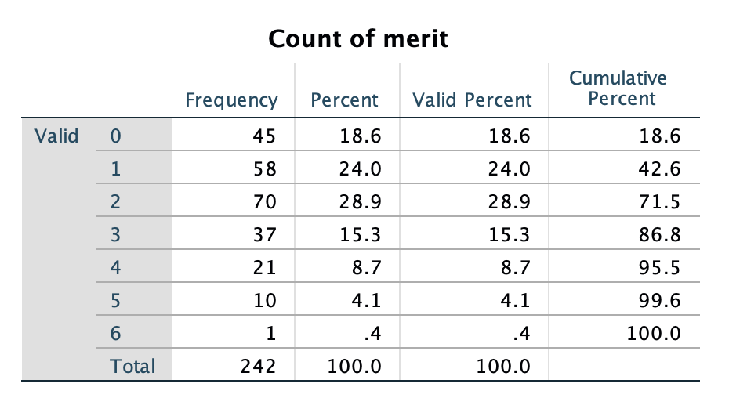

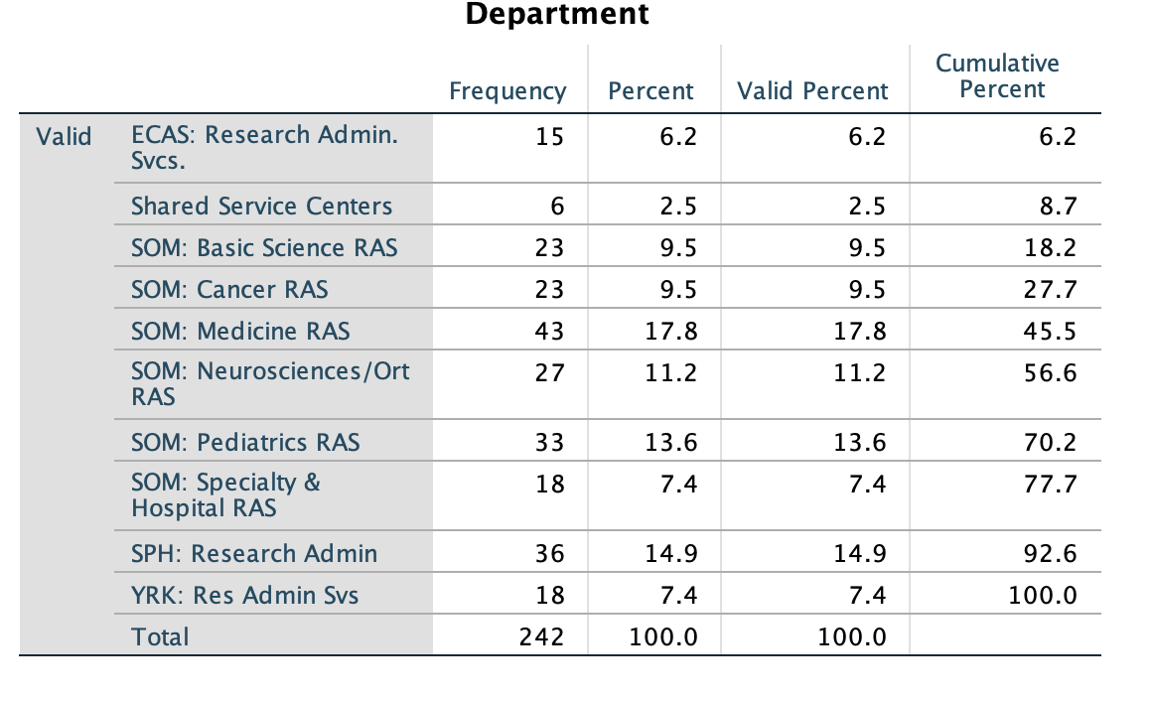

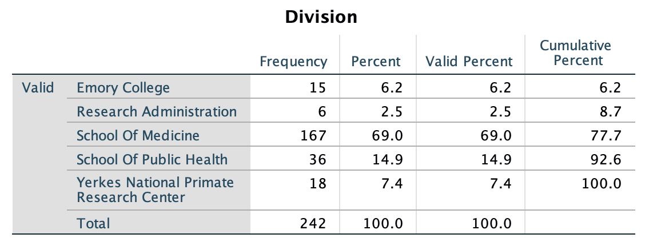

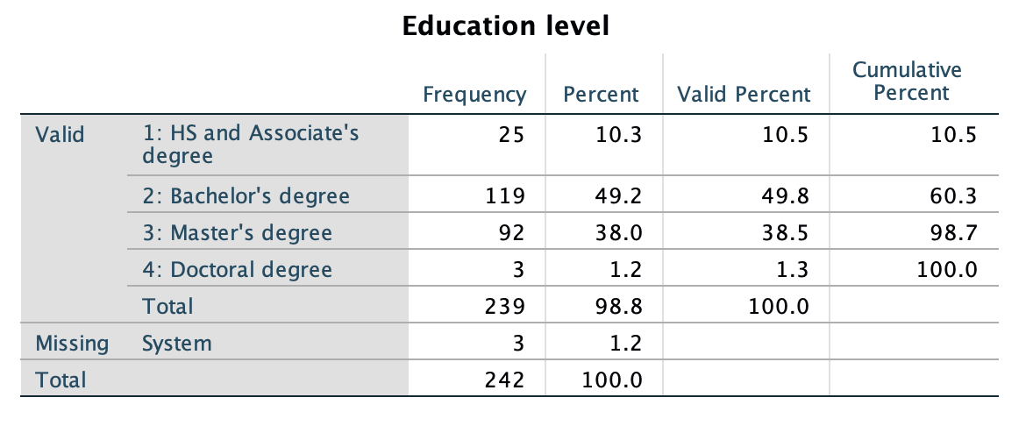

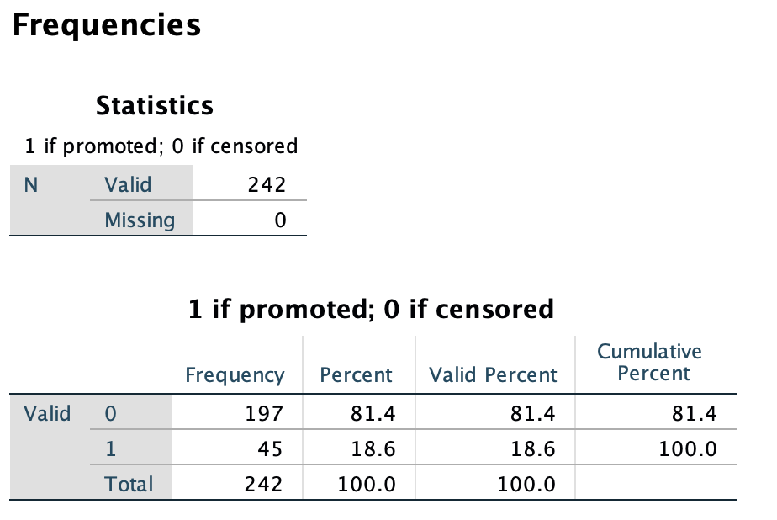

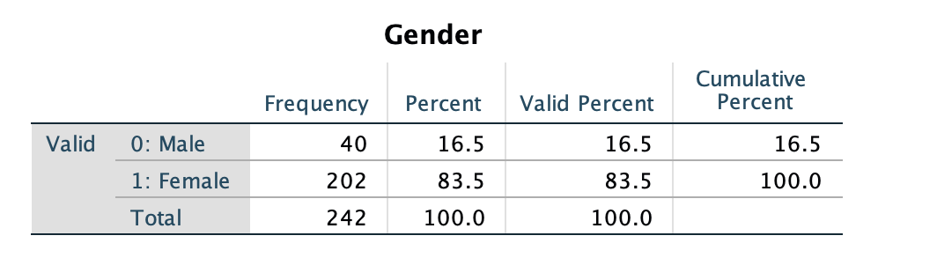

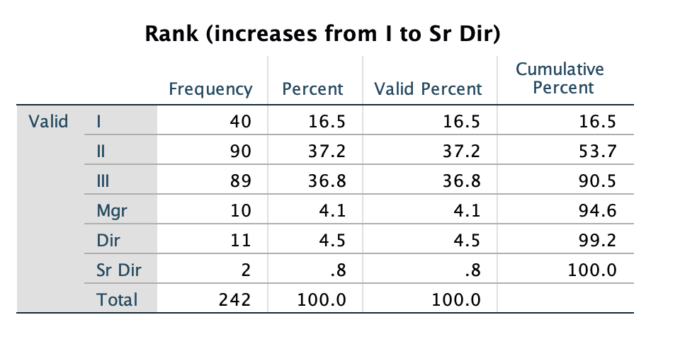

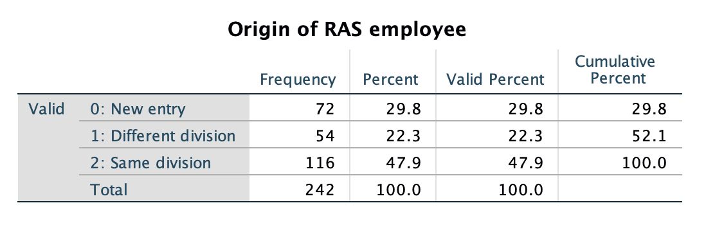

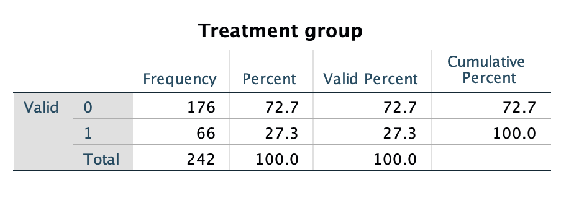

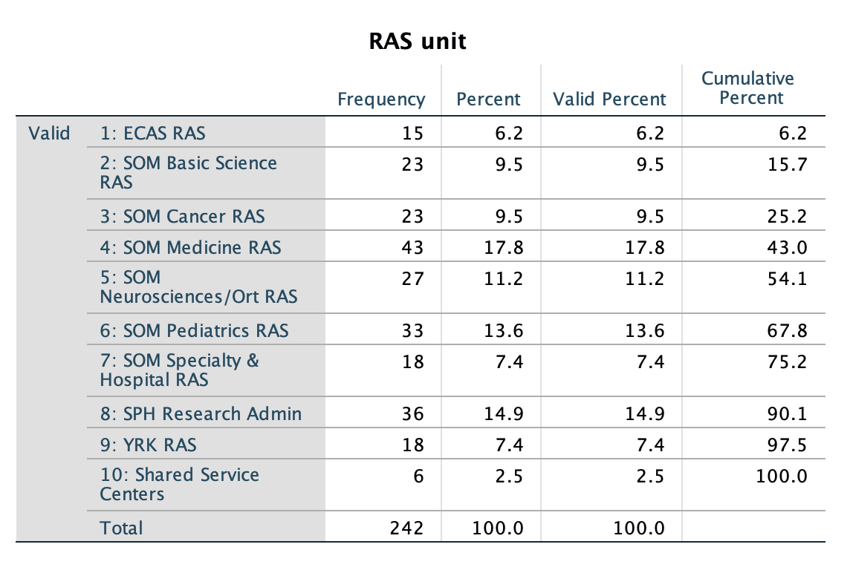

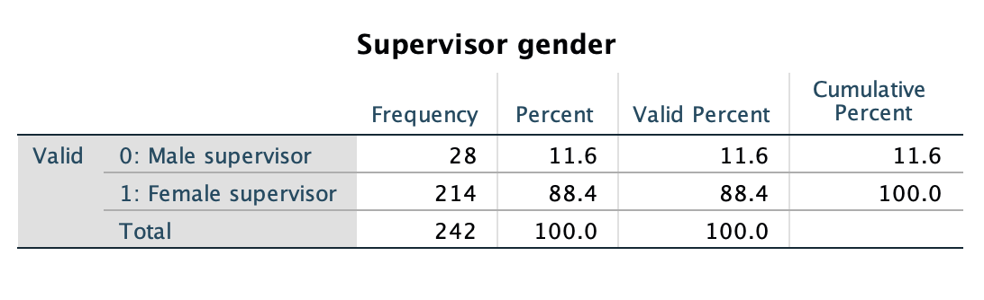

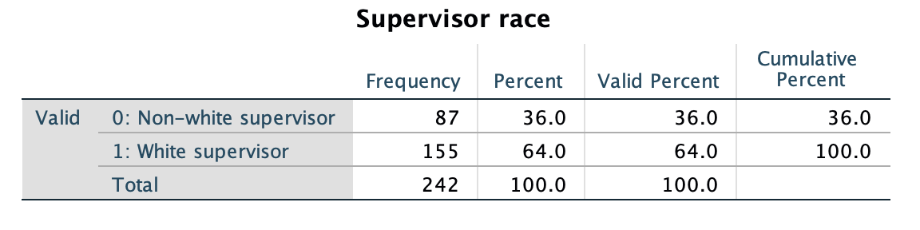

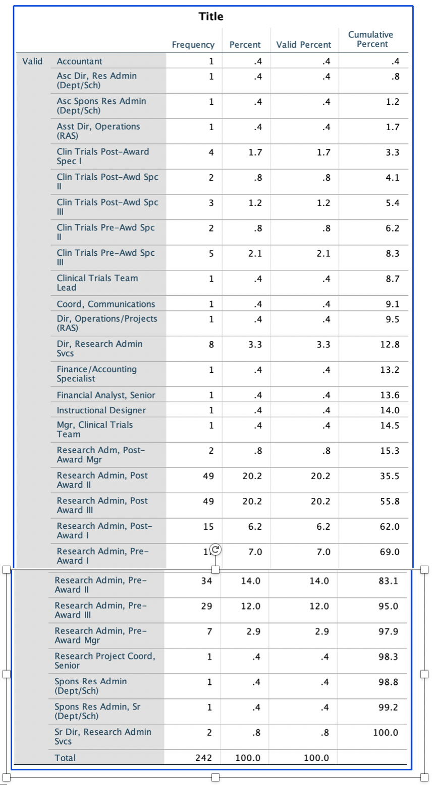

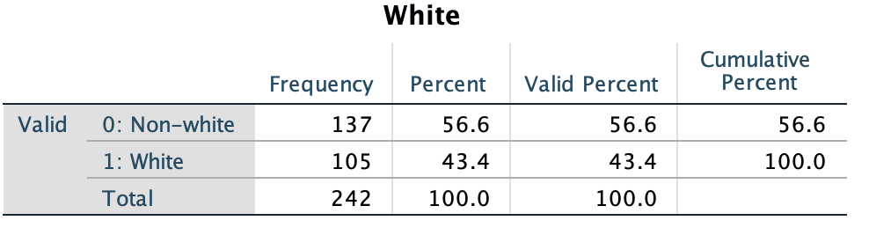

**“Merit Awards” questions:**

1). independent t-tests:

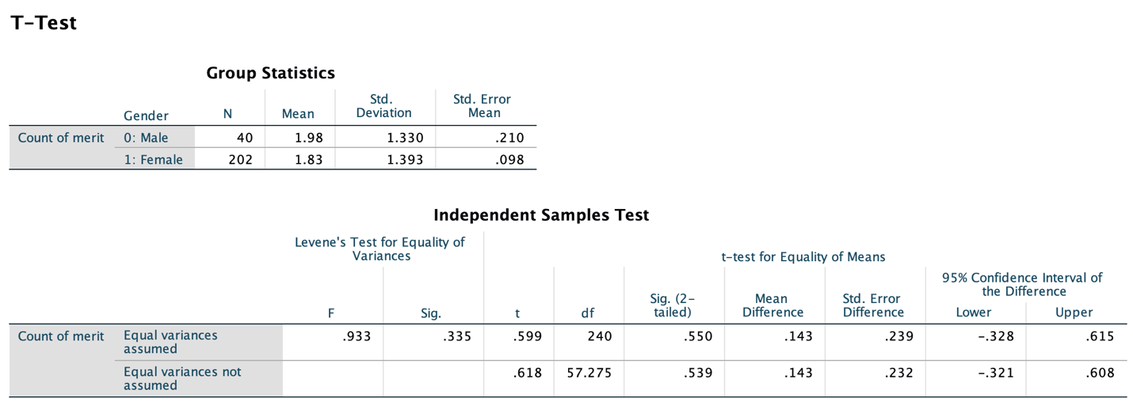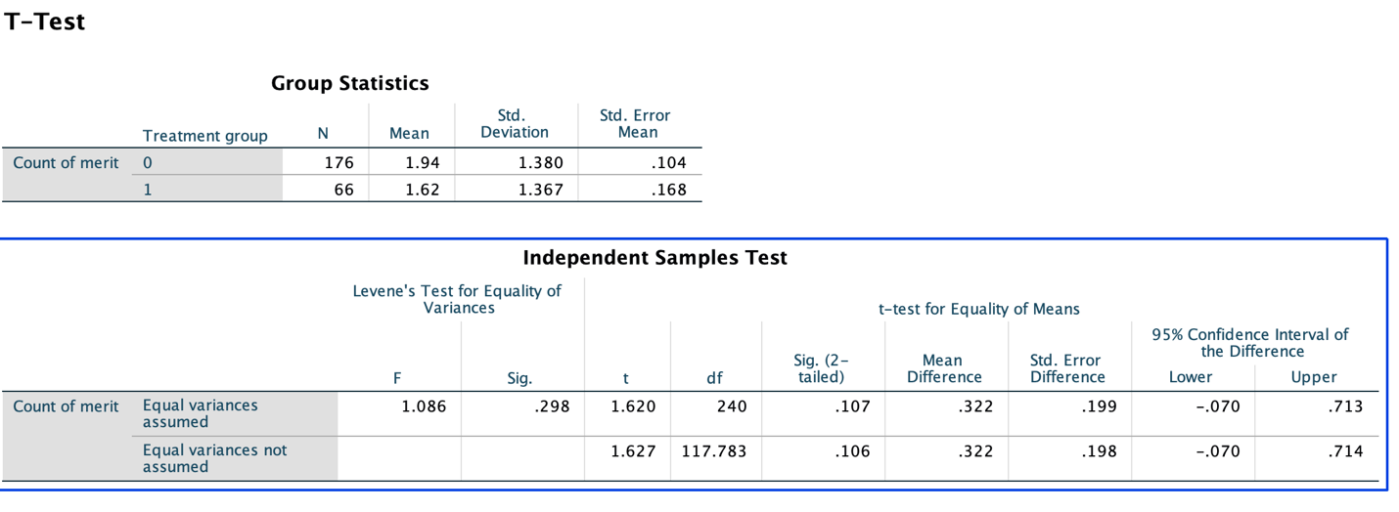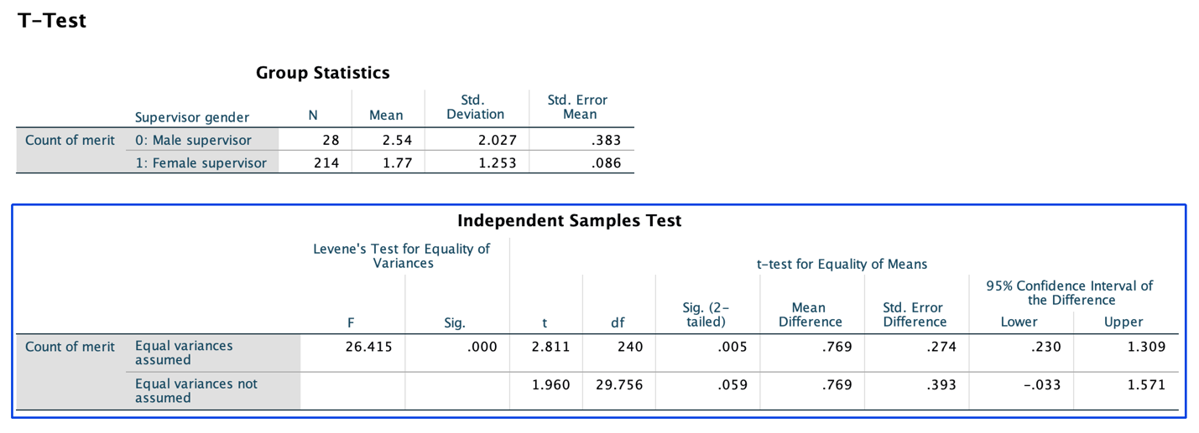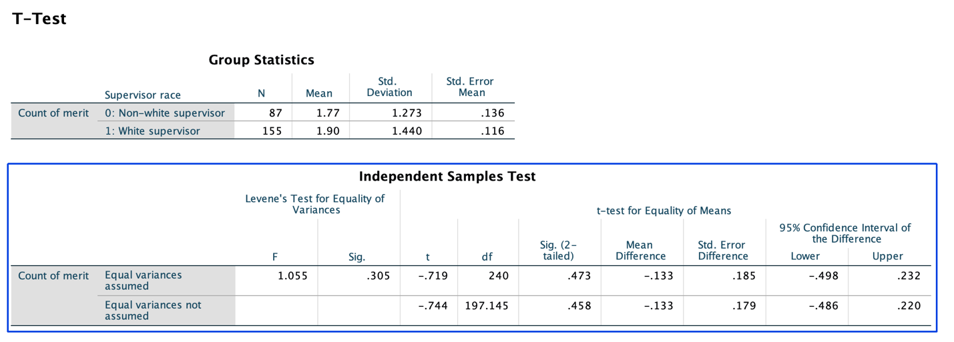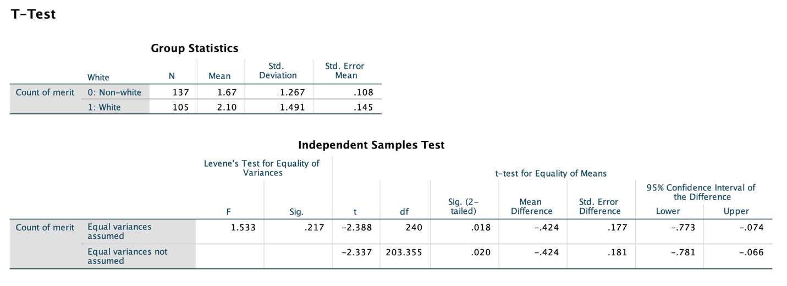

One-way ANOVA:

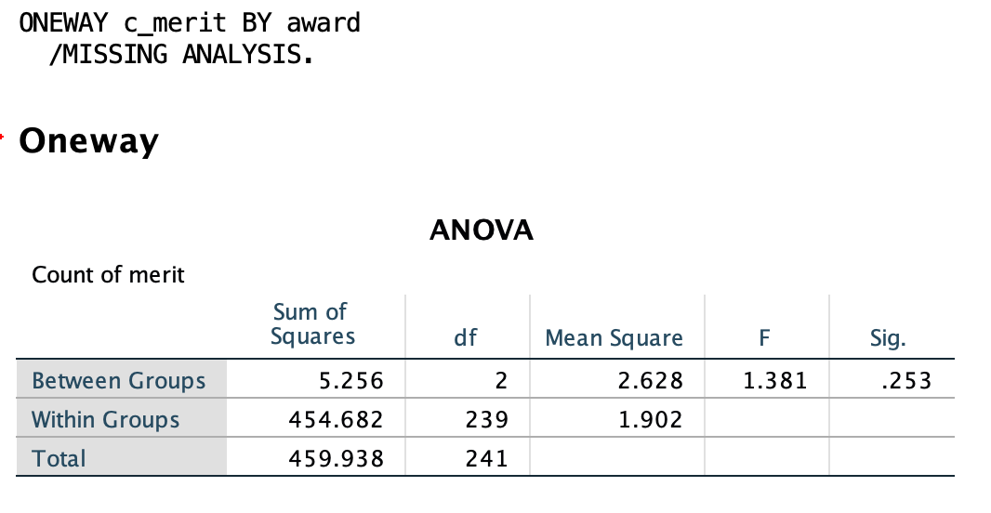

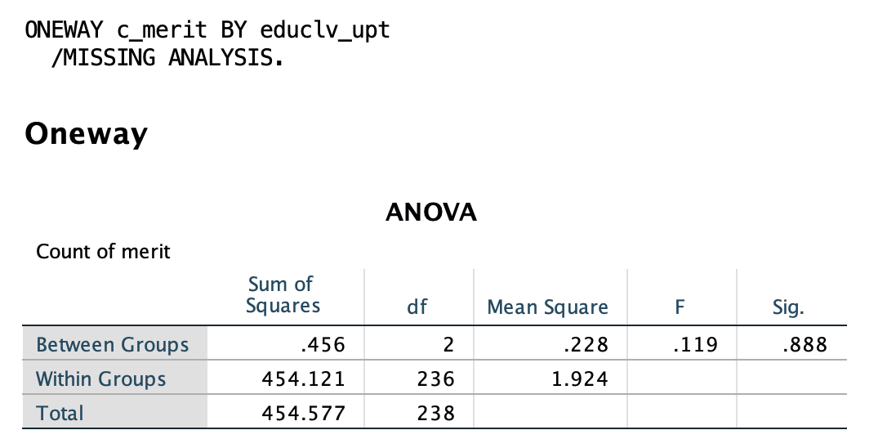

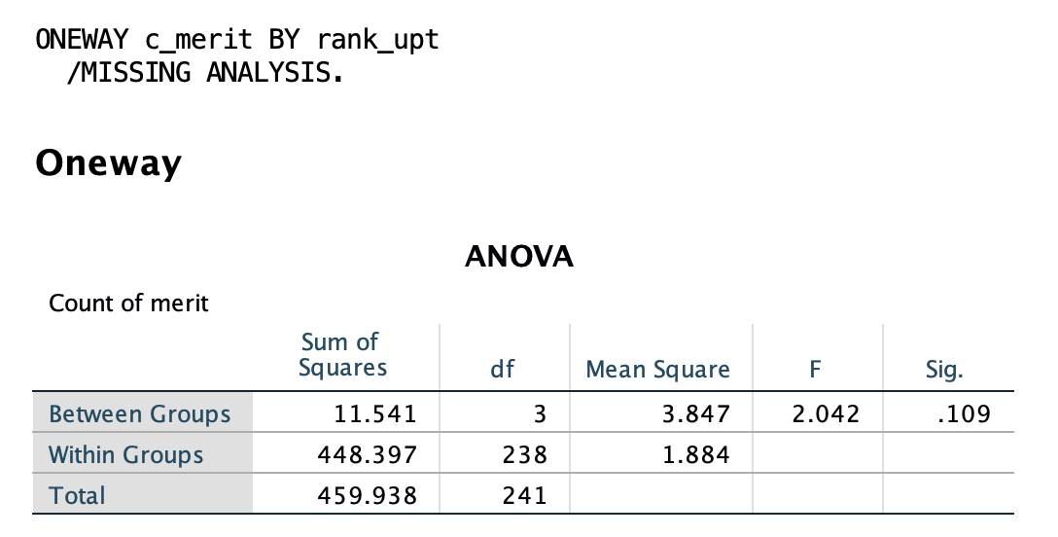

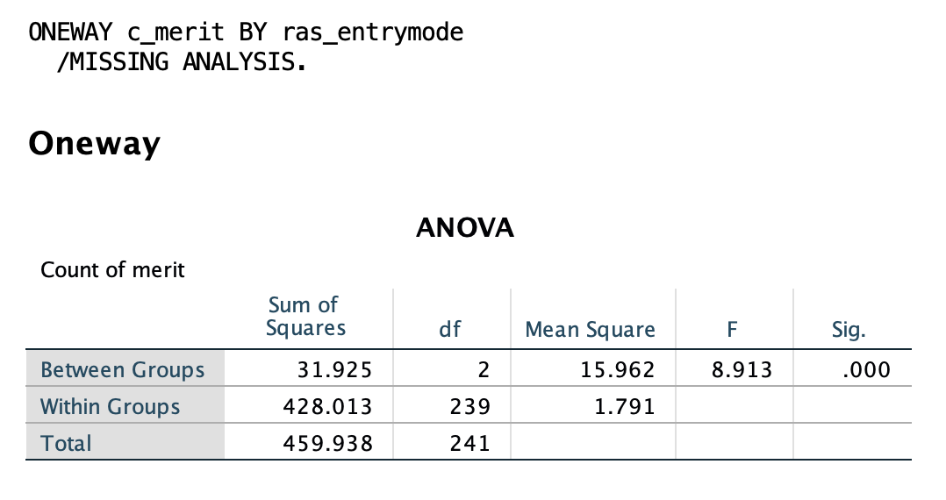

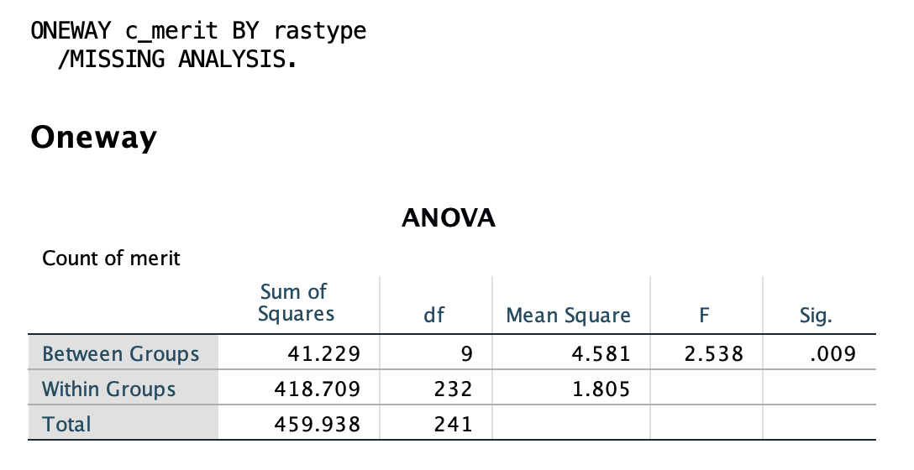

2). Histograms for significant variables:

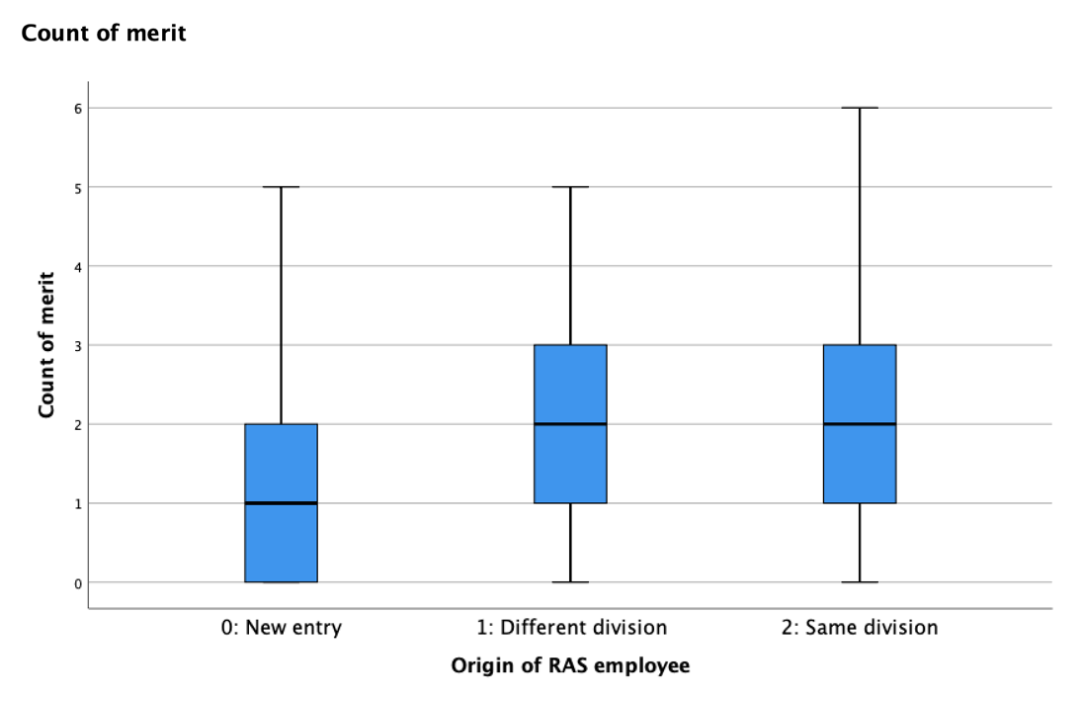

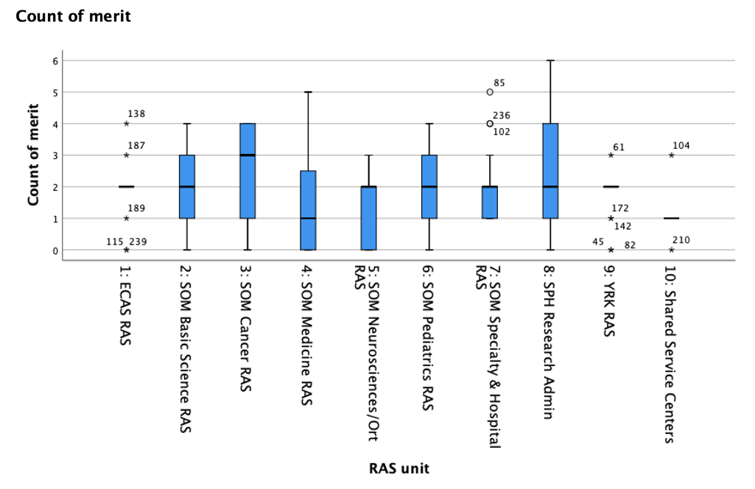

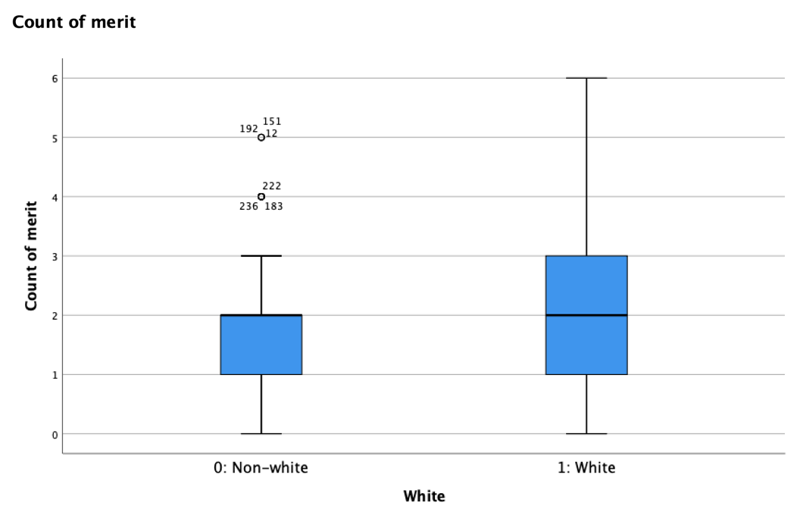

3). Poisson regression model outputs:

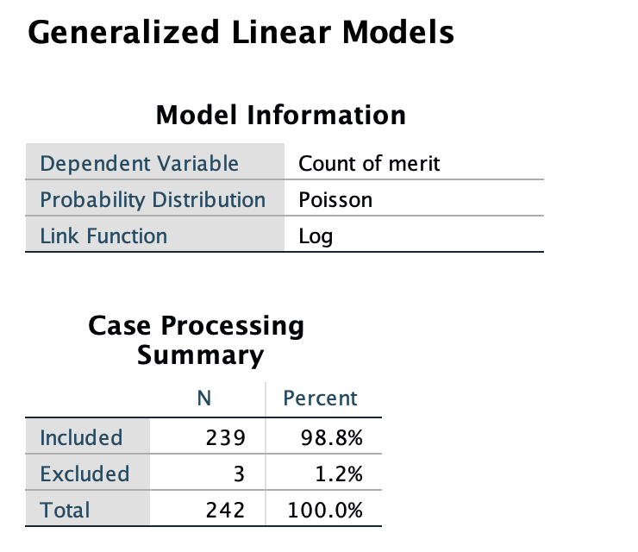

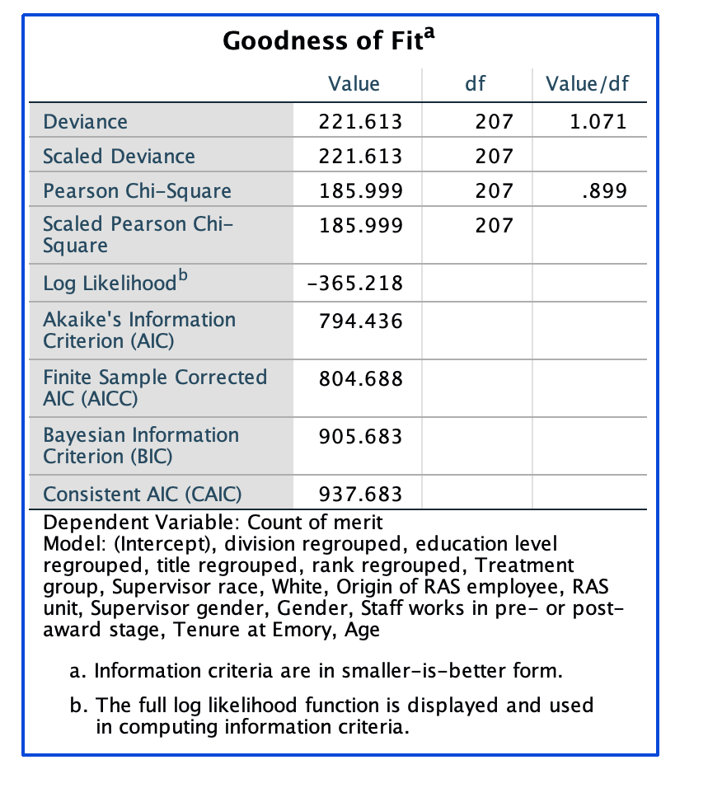

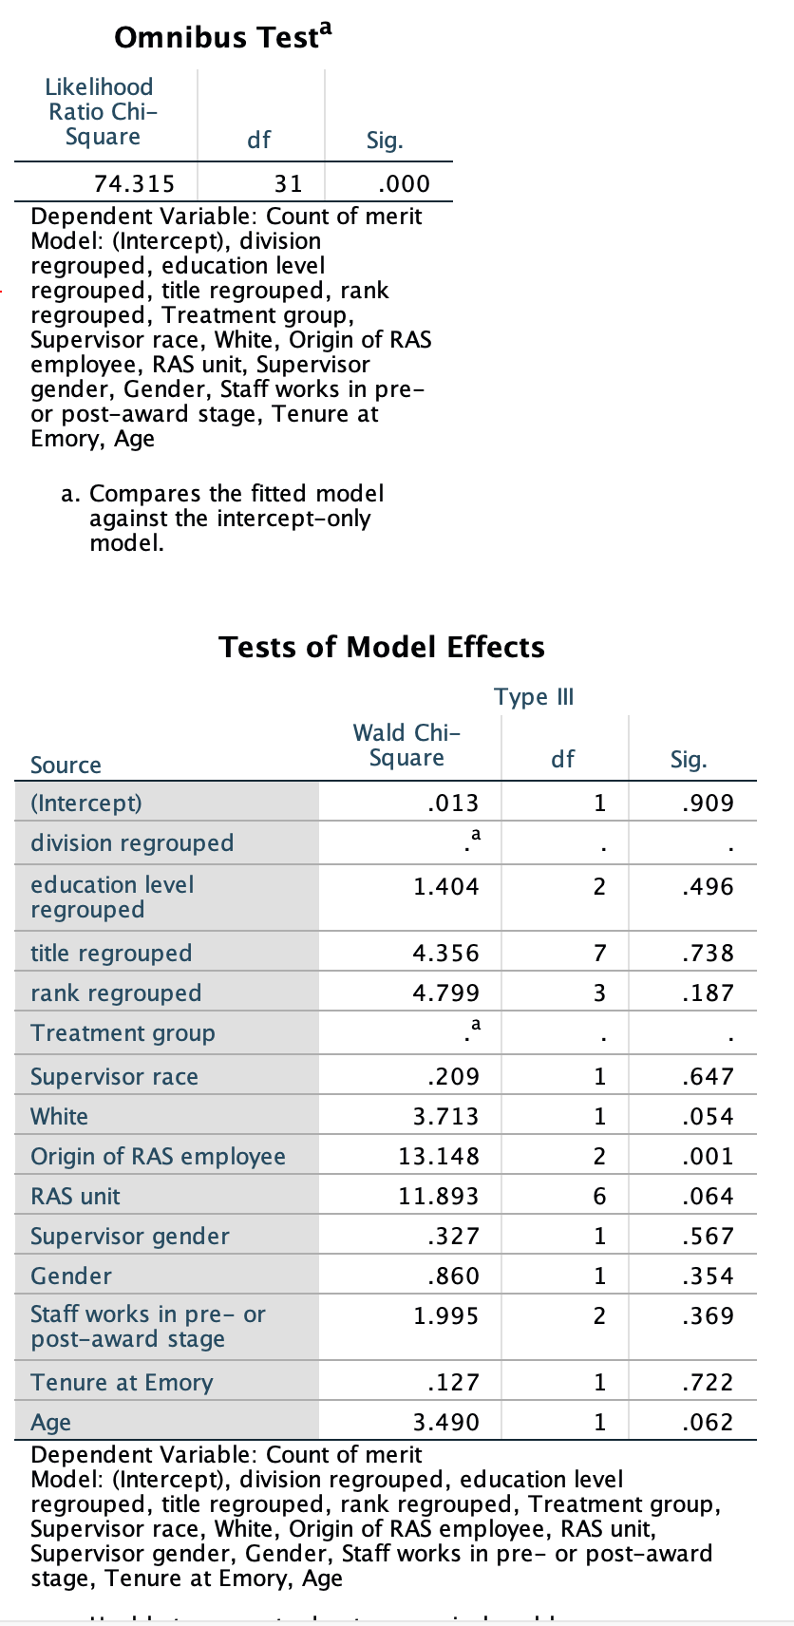

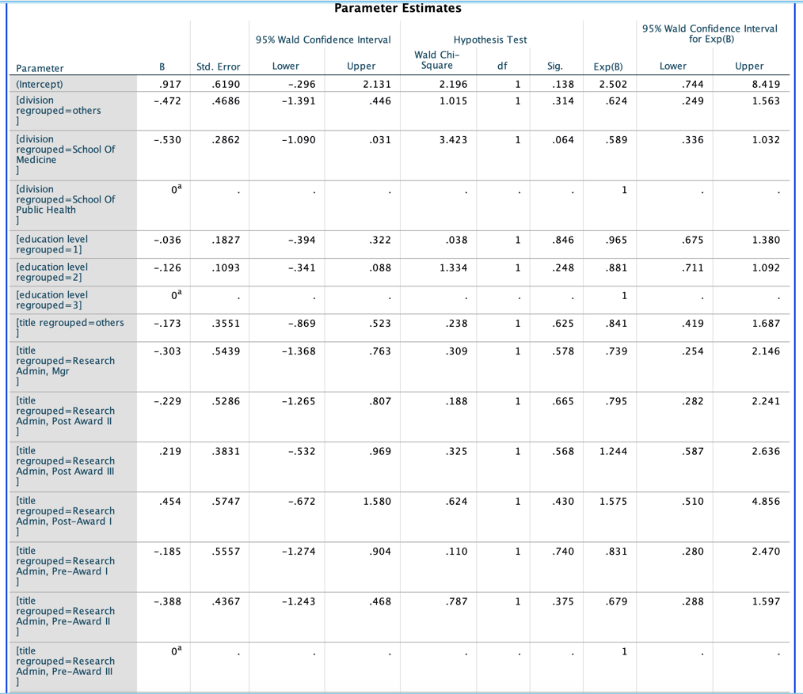

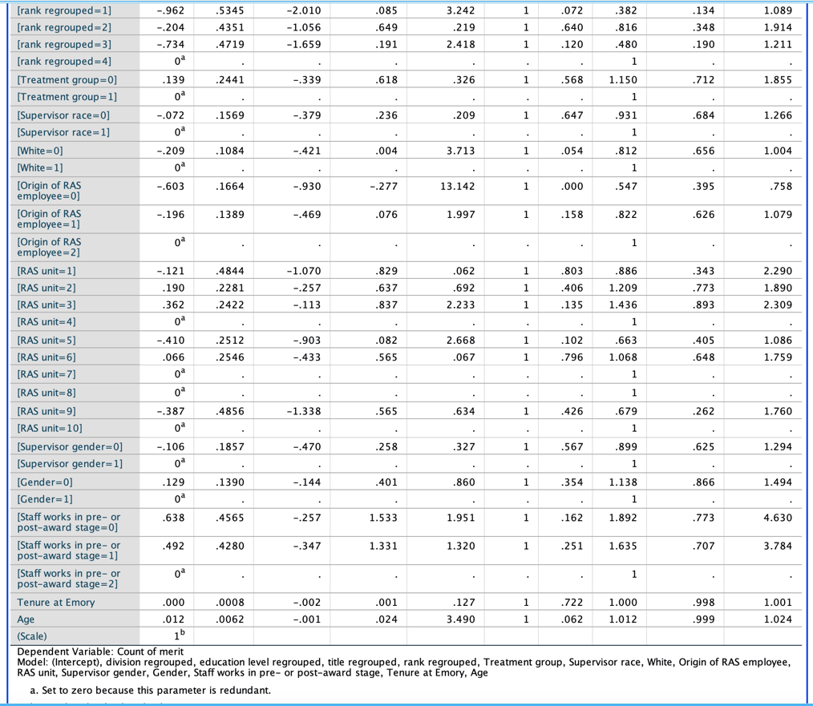

**“Promotion” question:**

1). Crosstabs & Chi-square analysis:

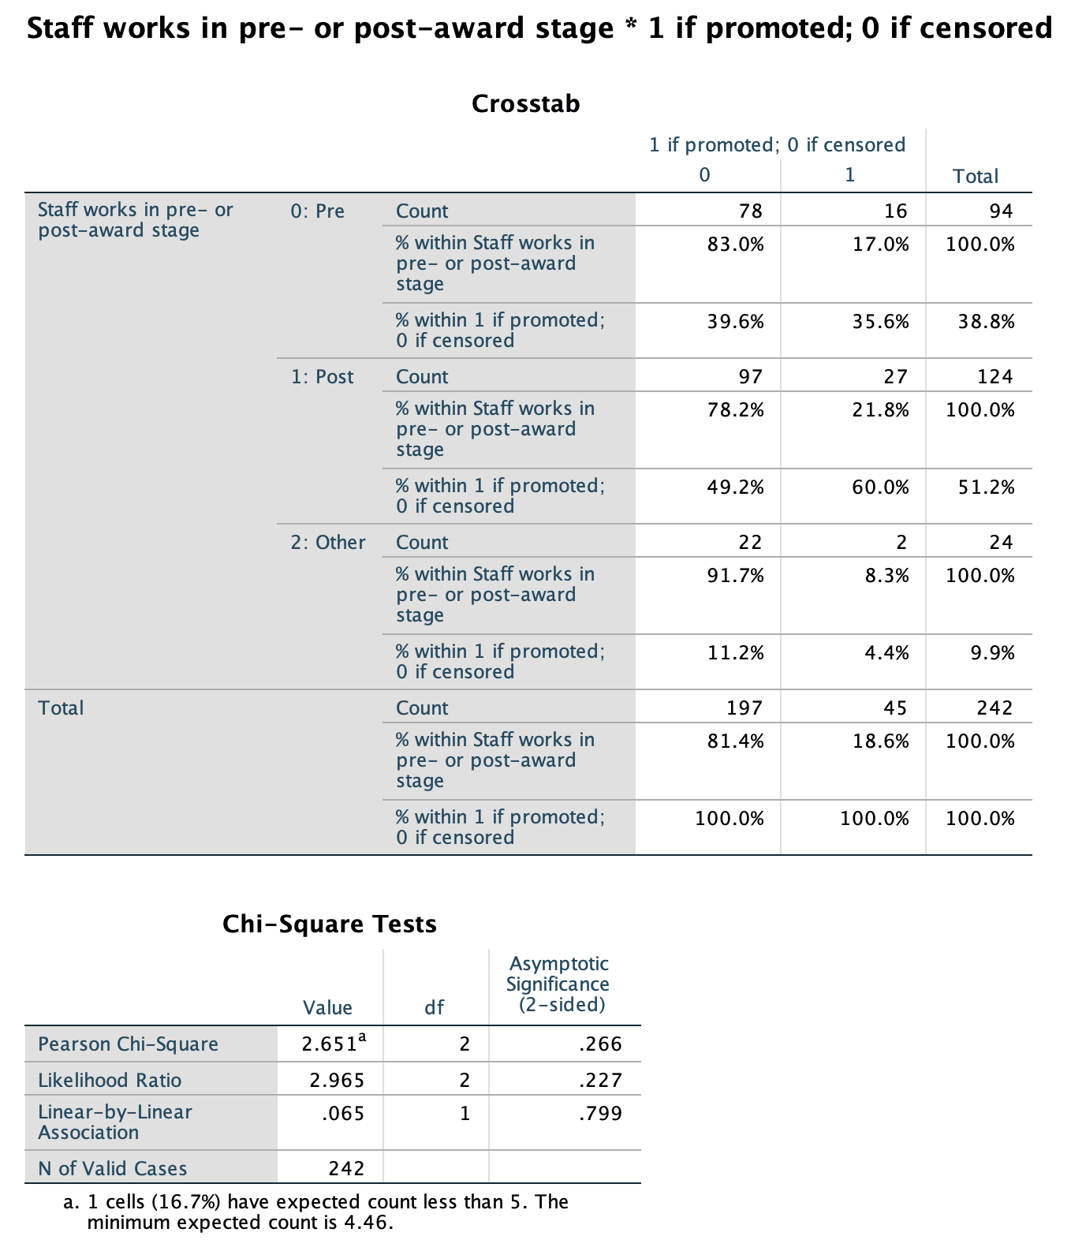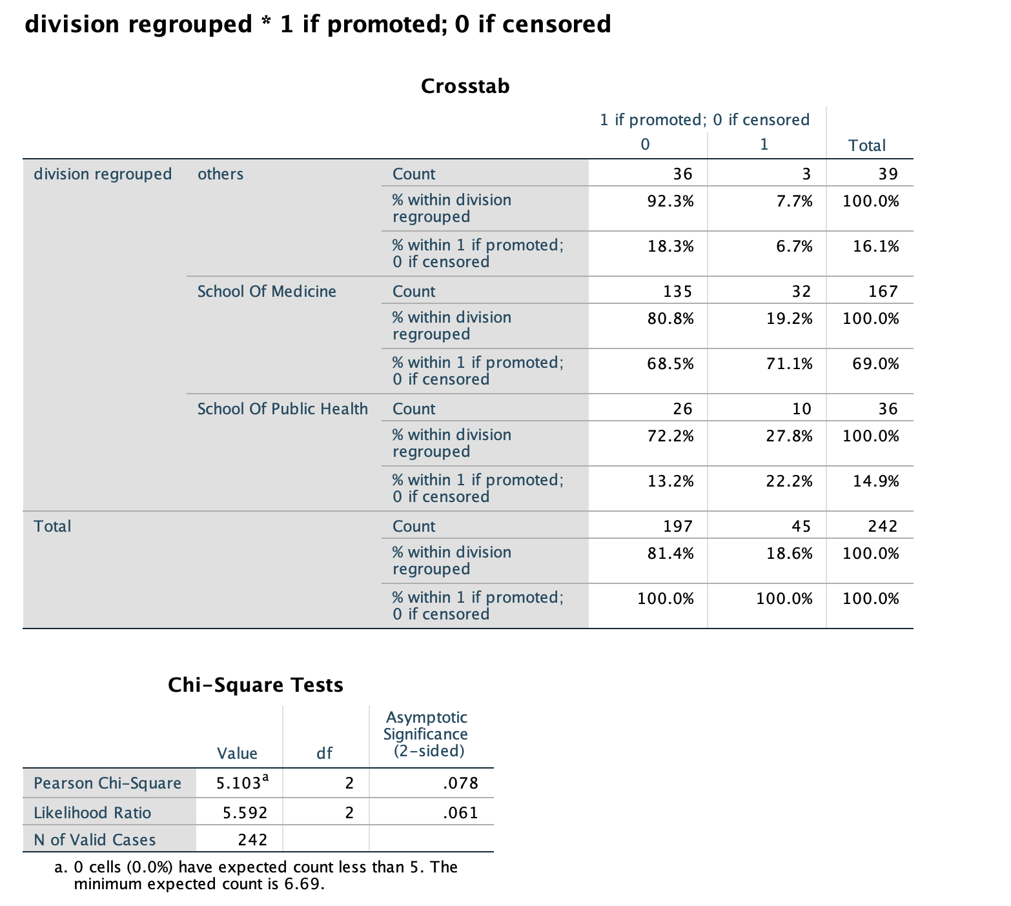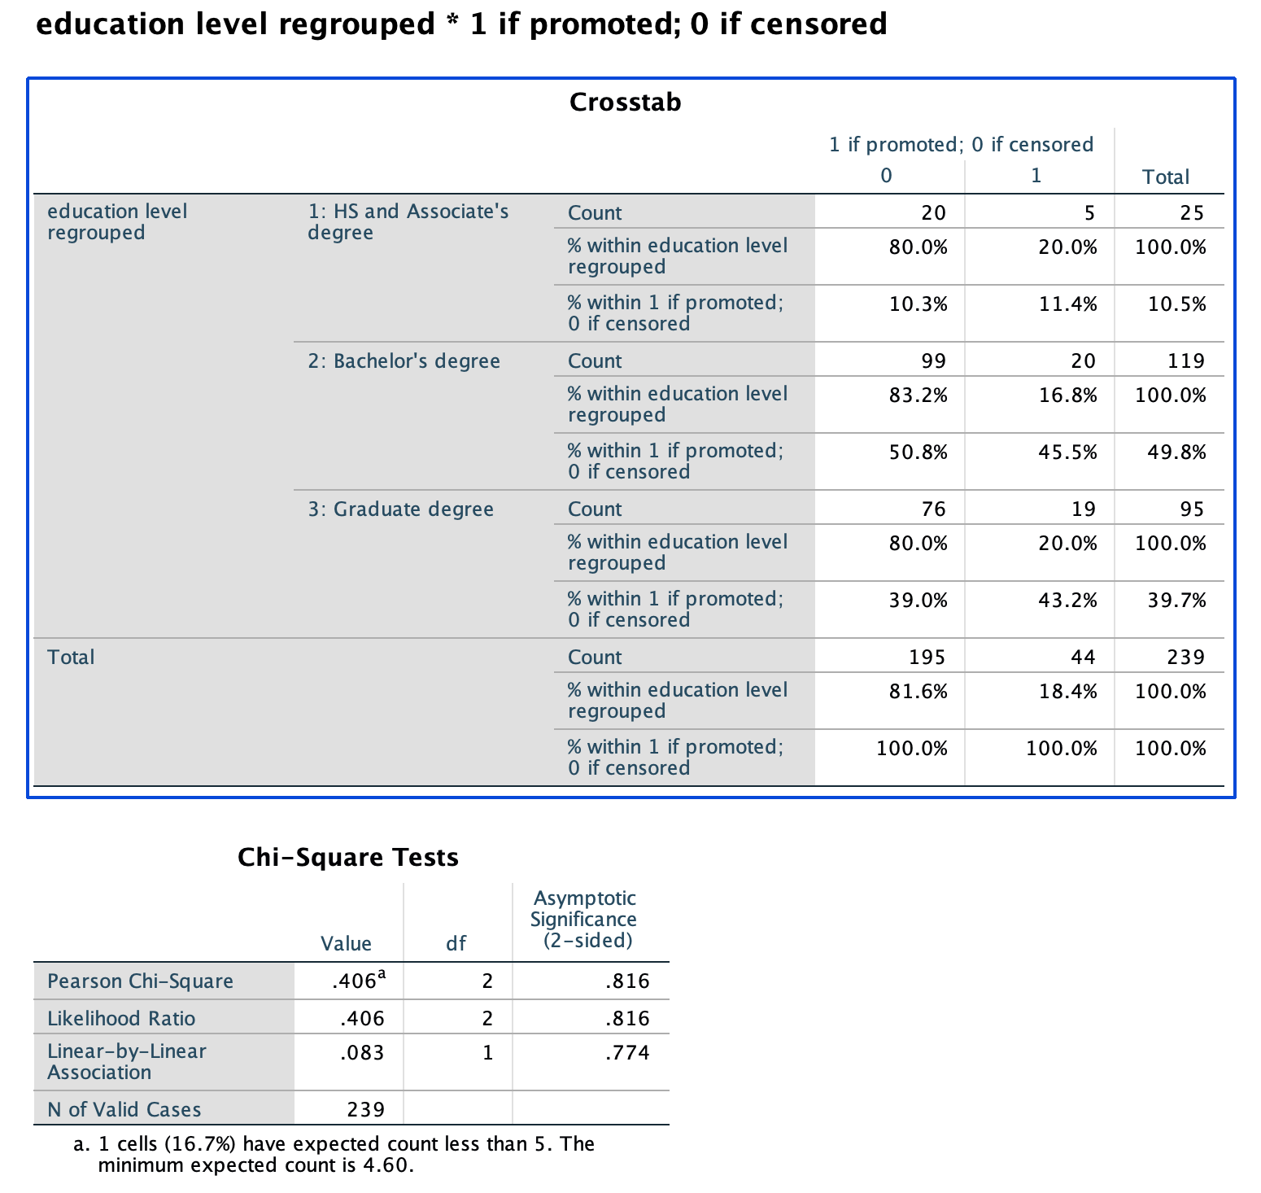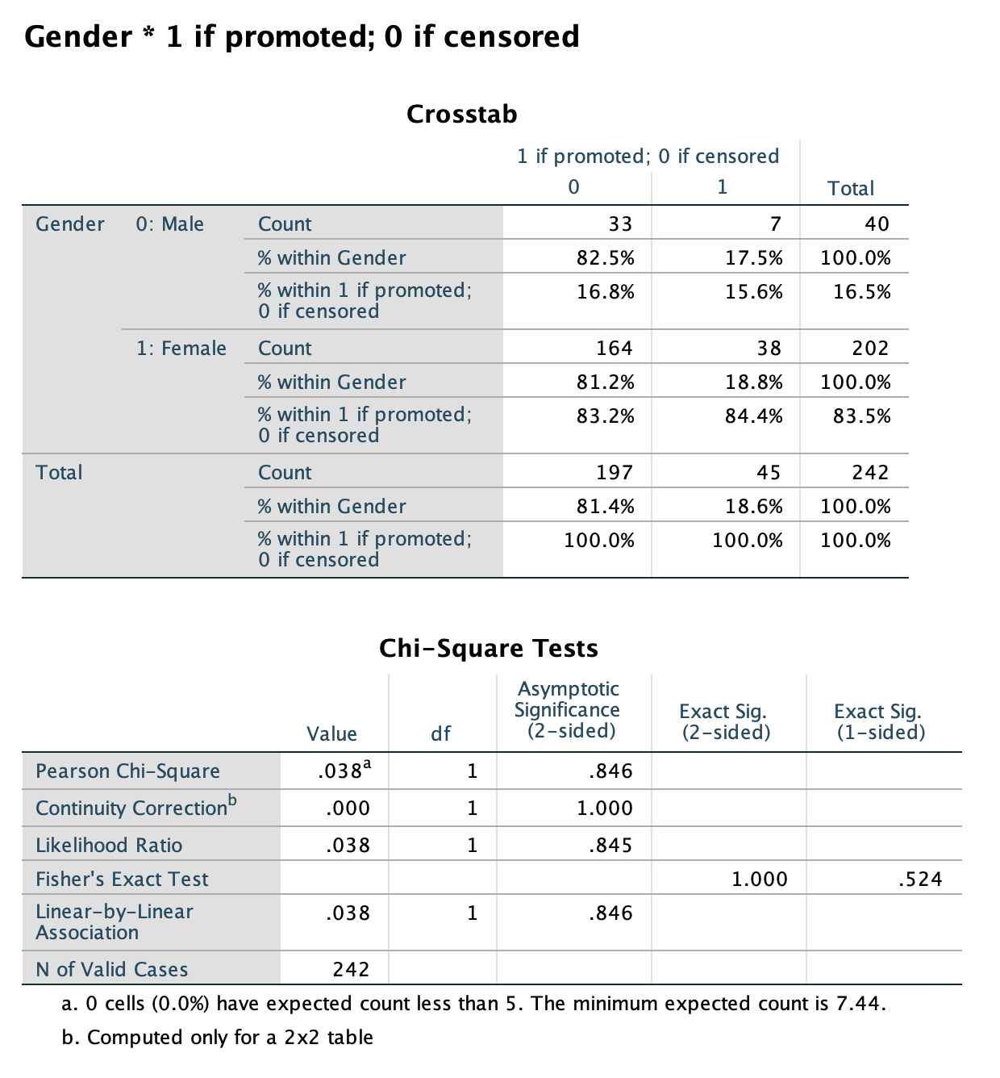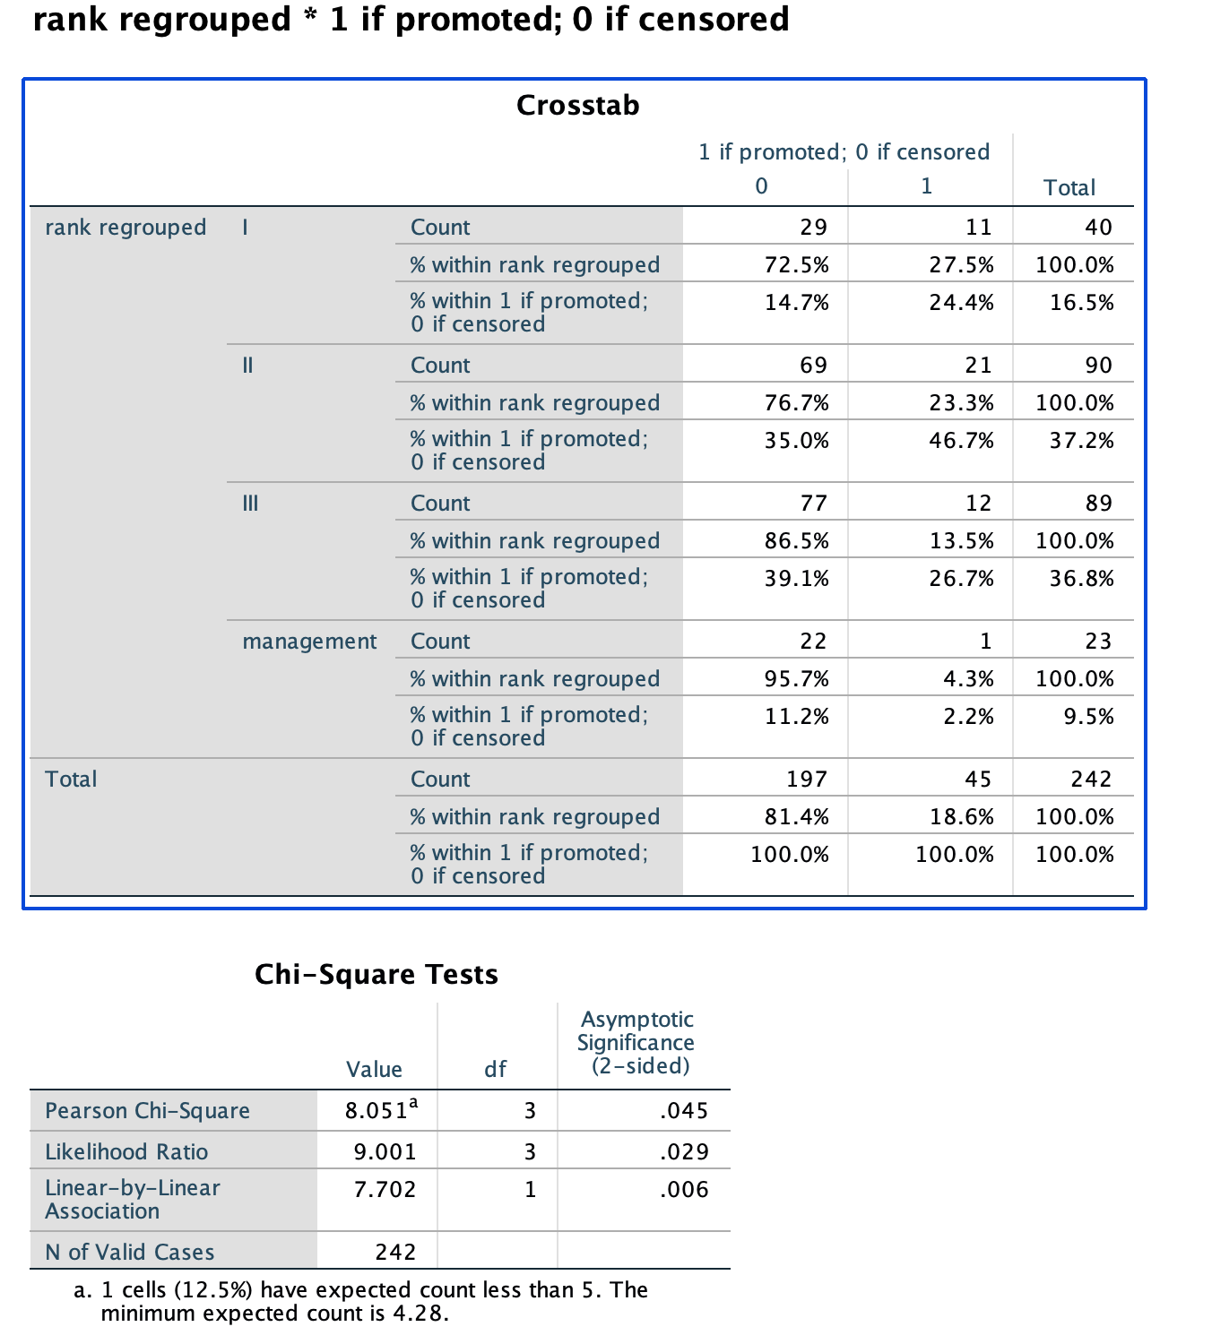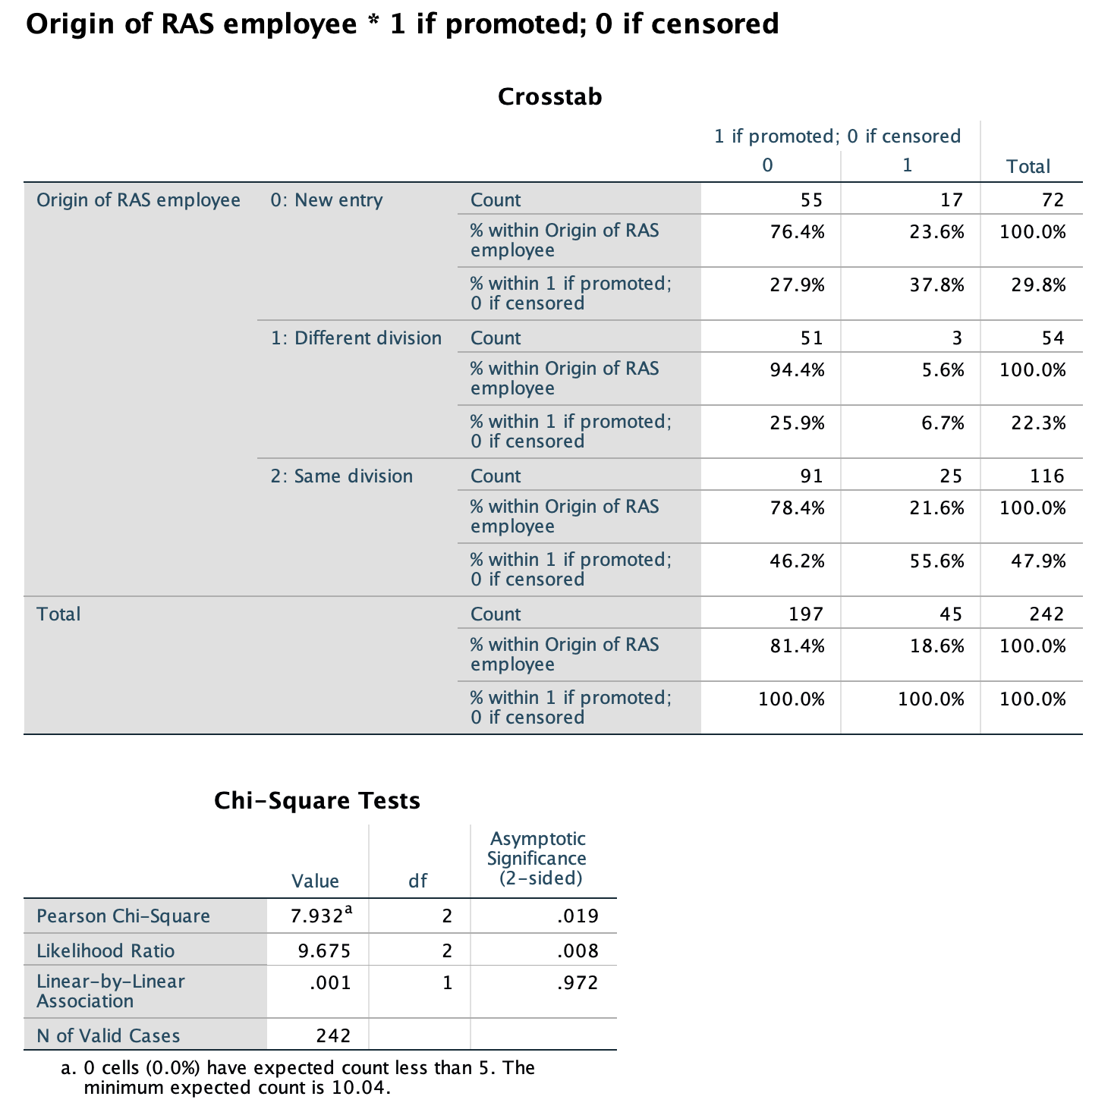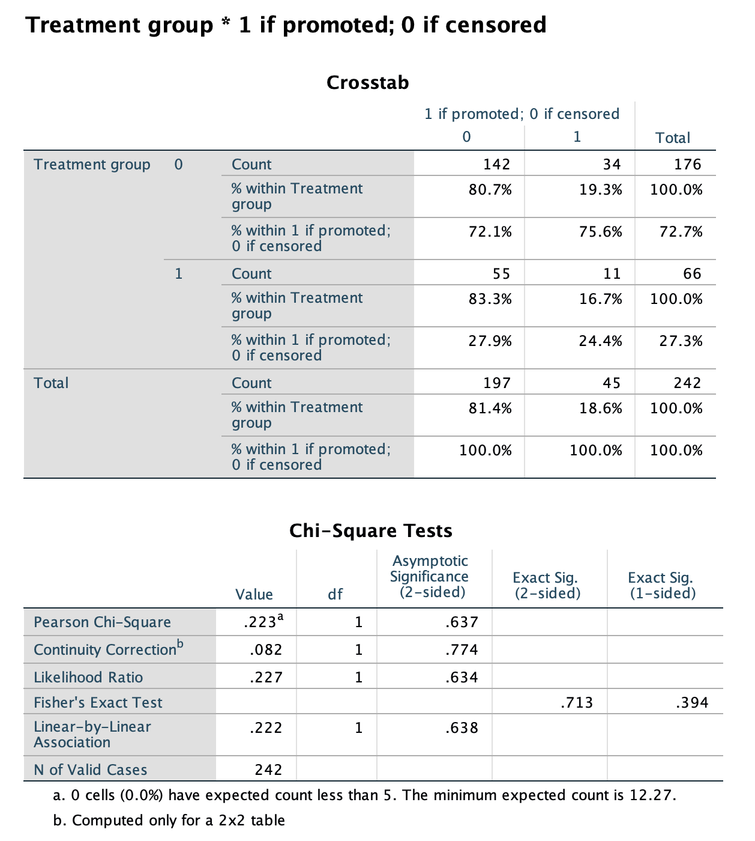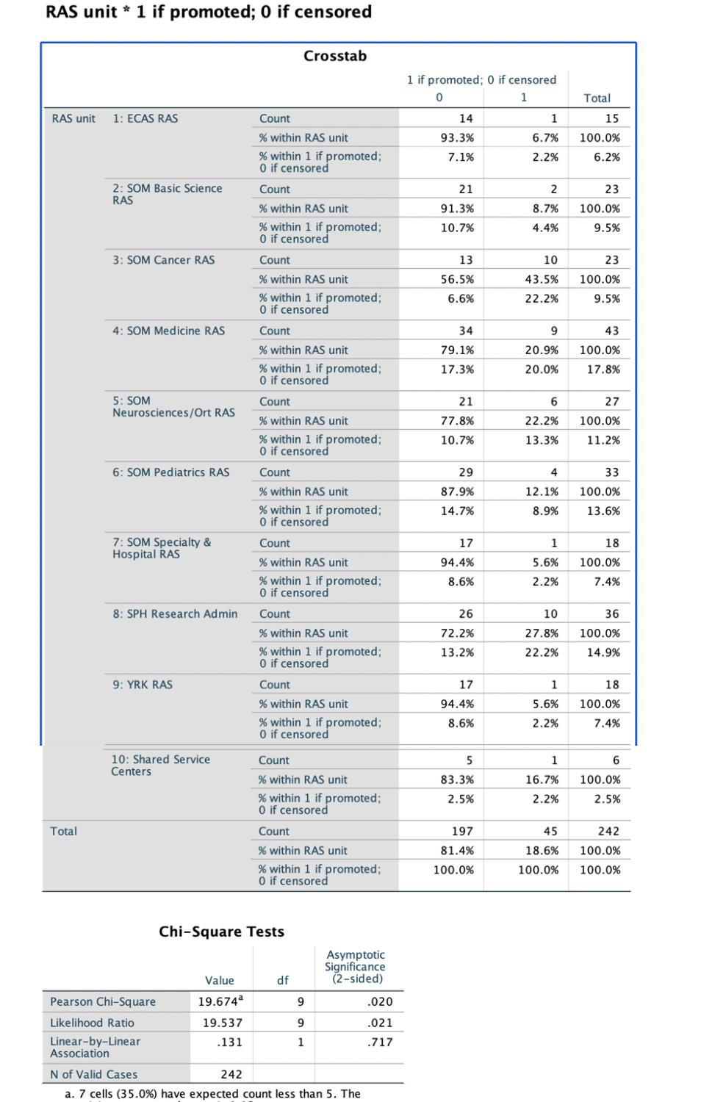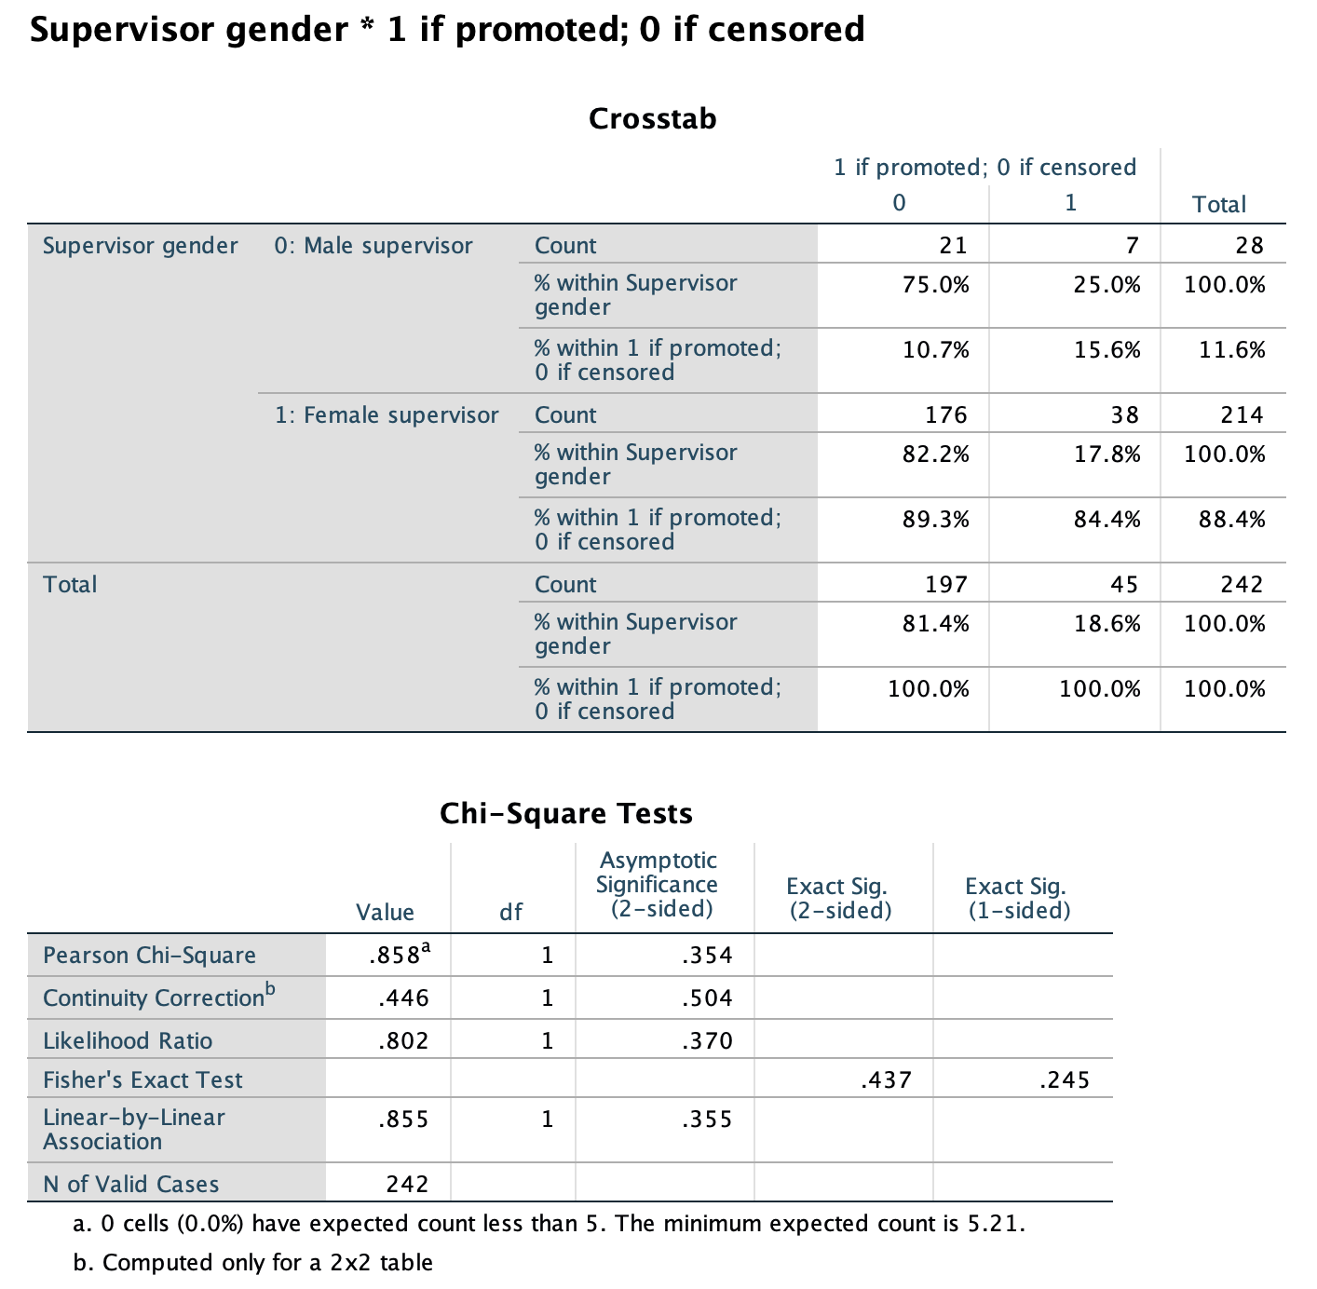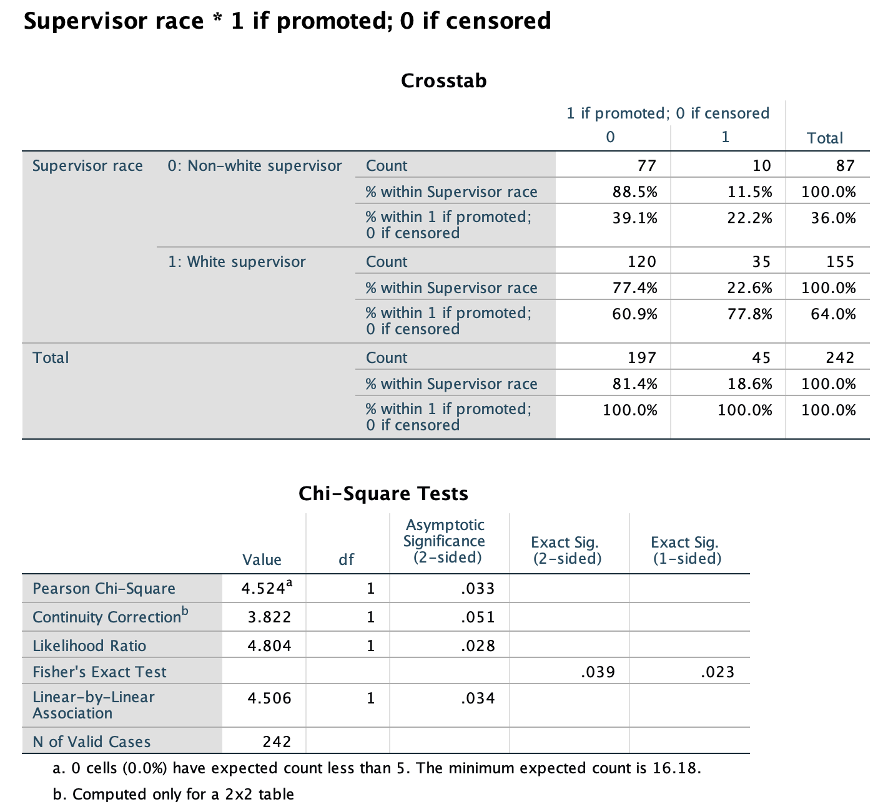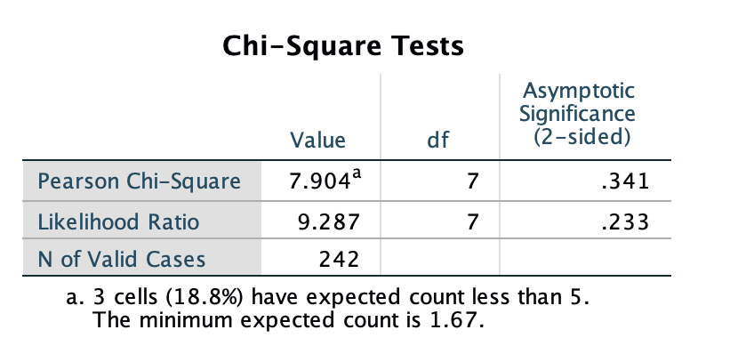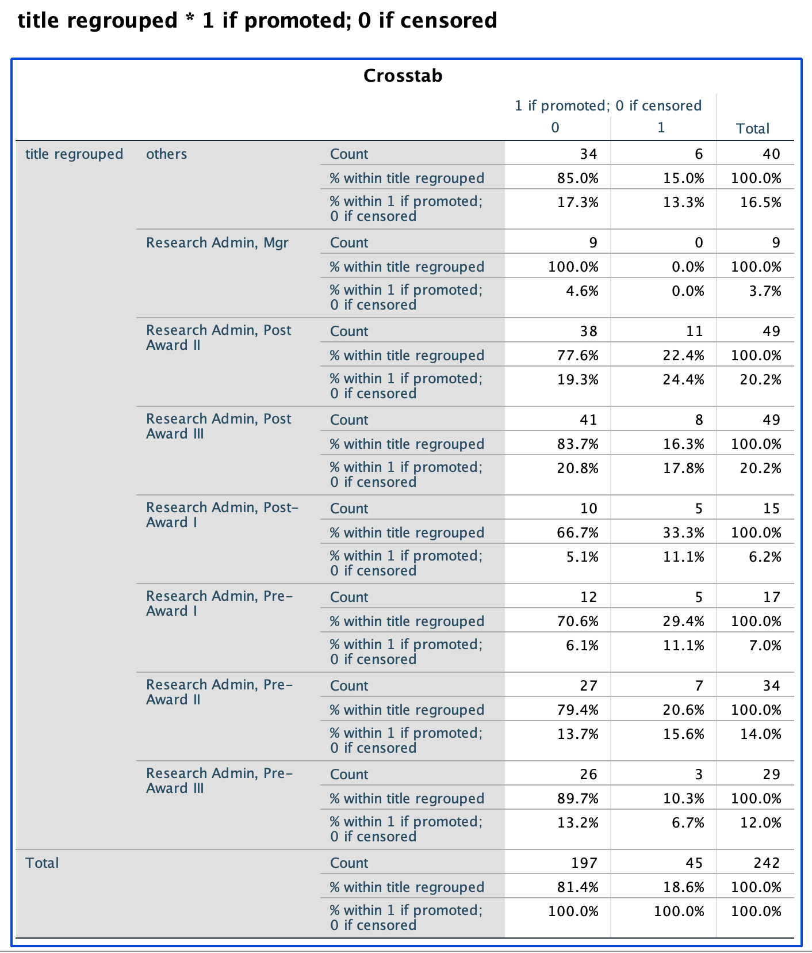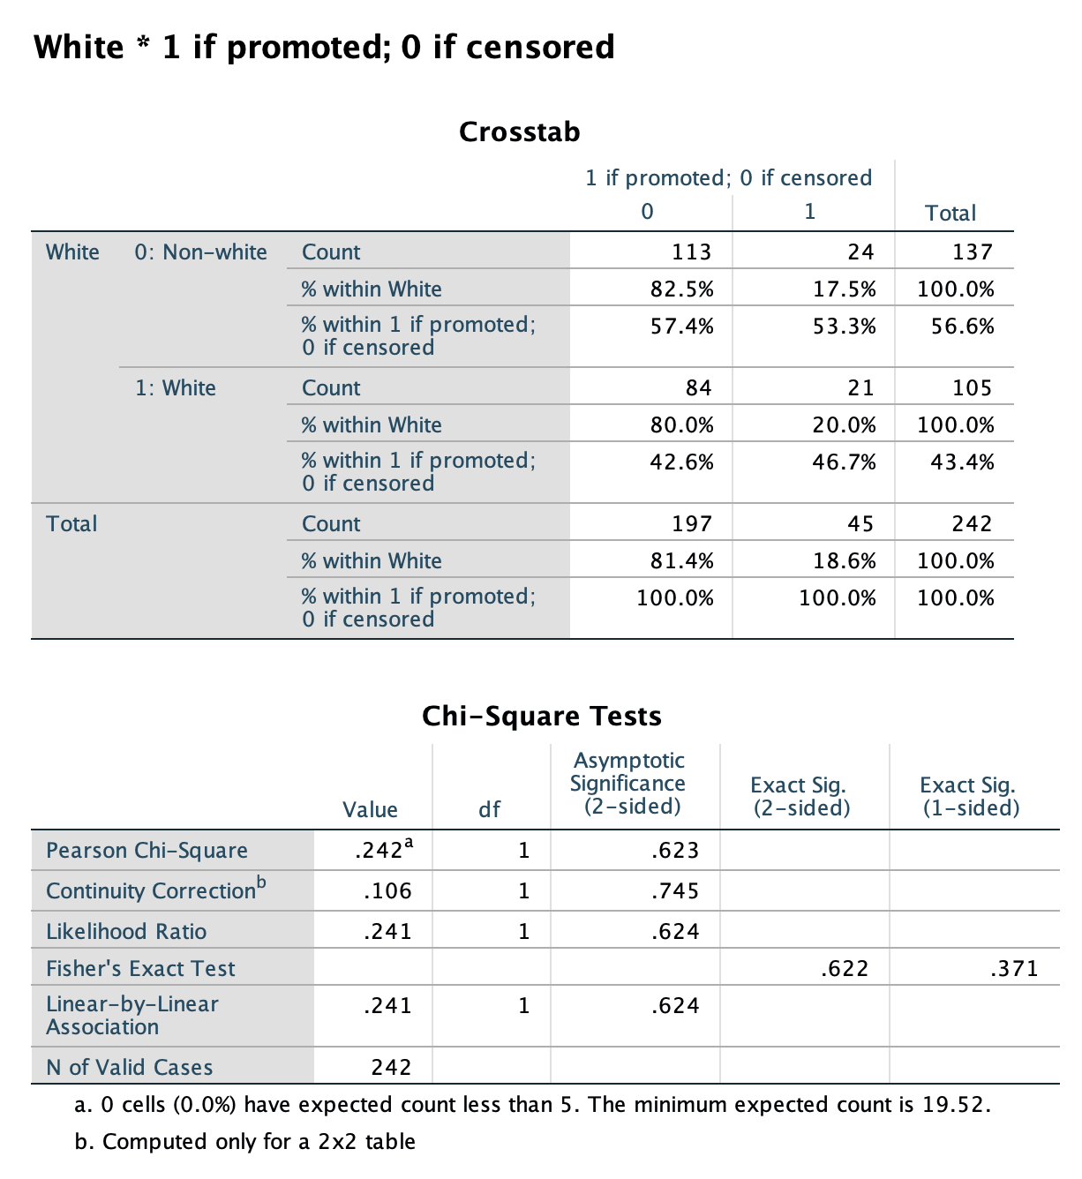

2).histograms for significant variables:

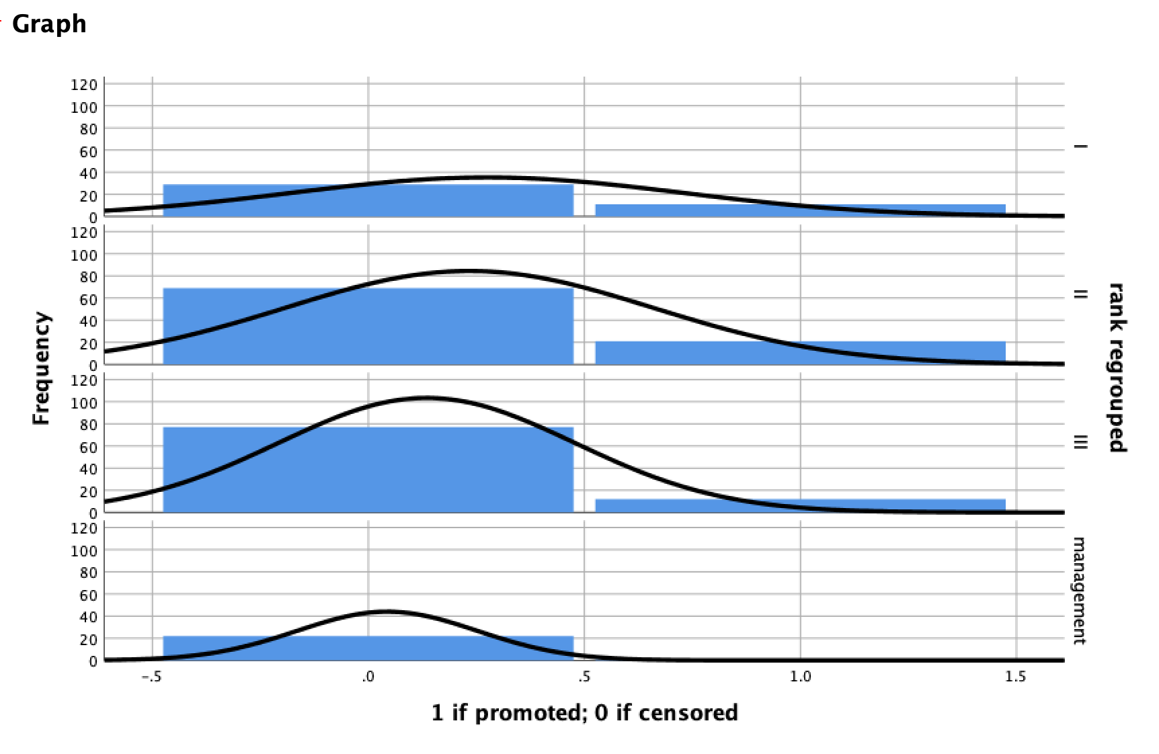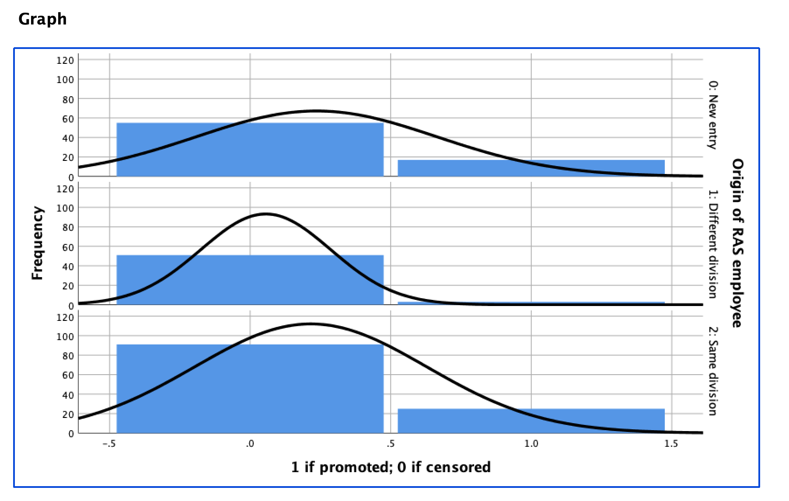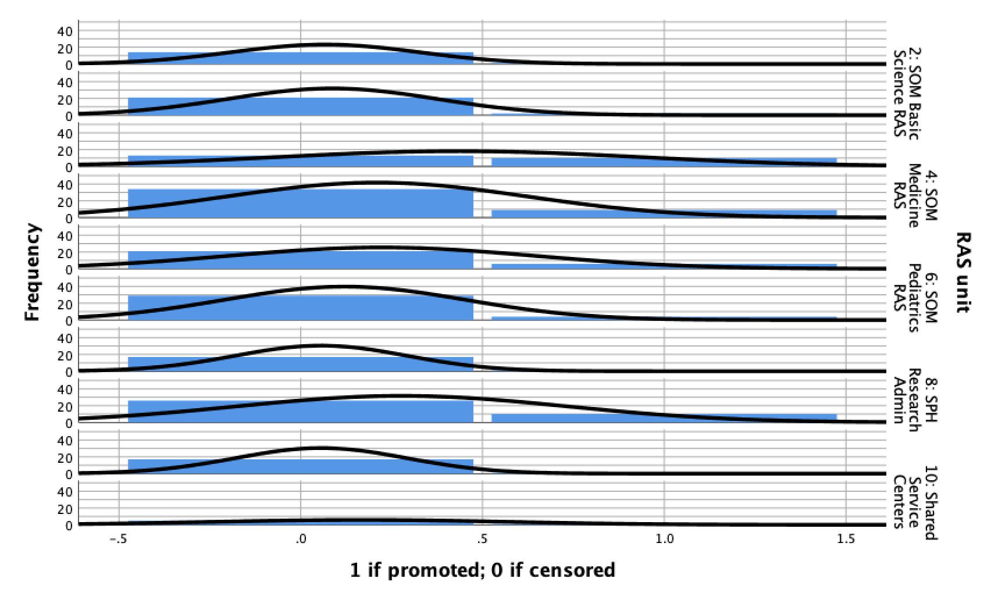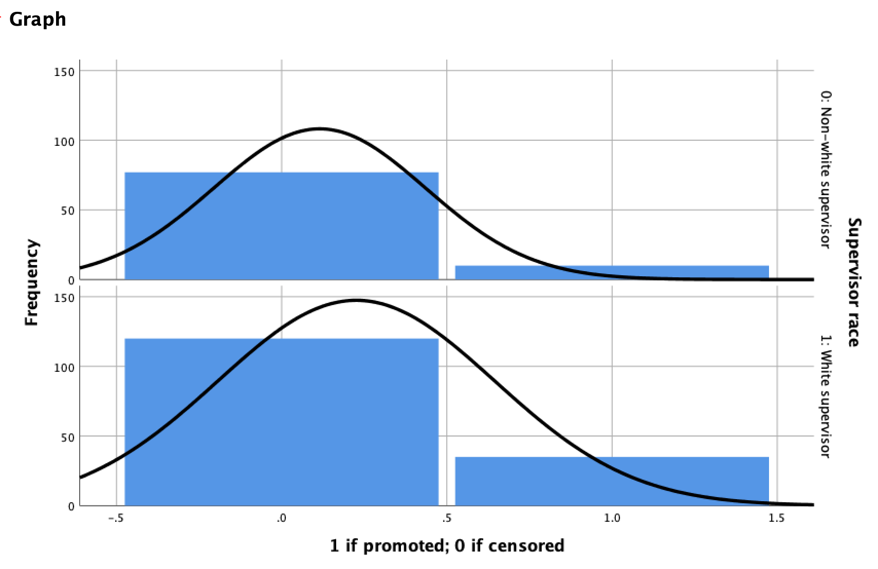

3).Kaplan Meier survival plots and log-rank statistics:

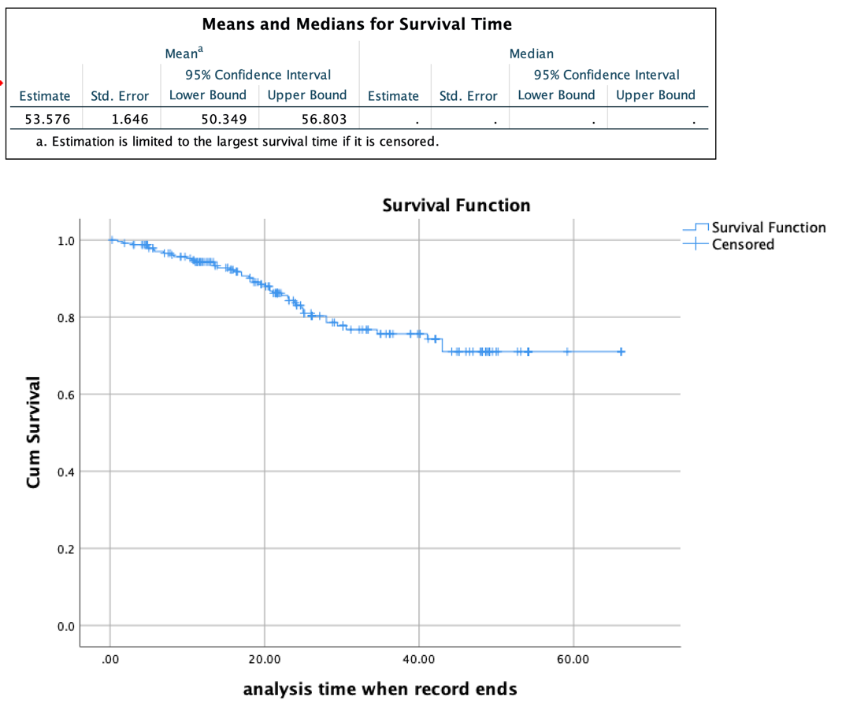

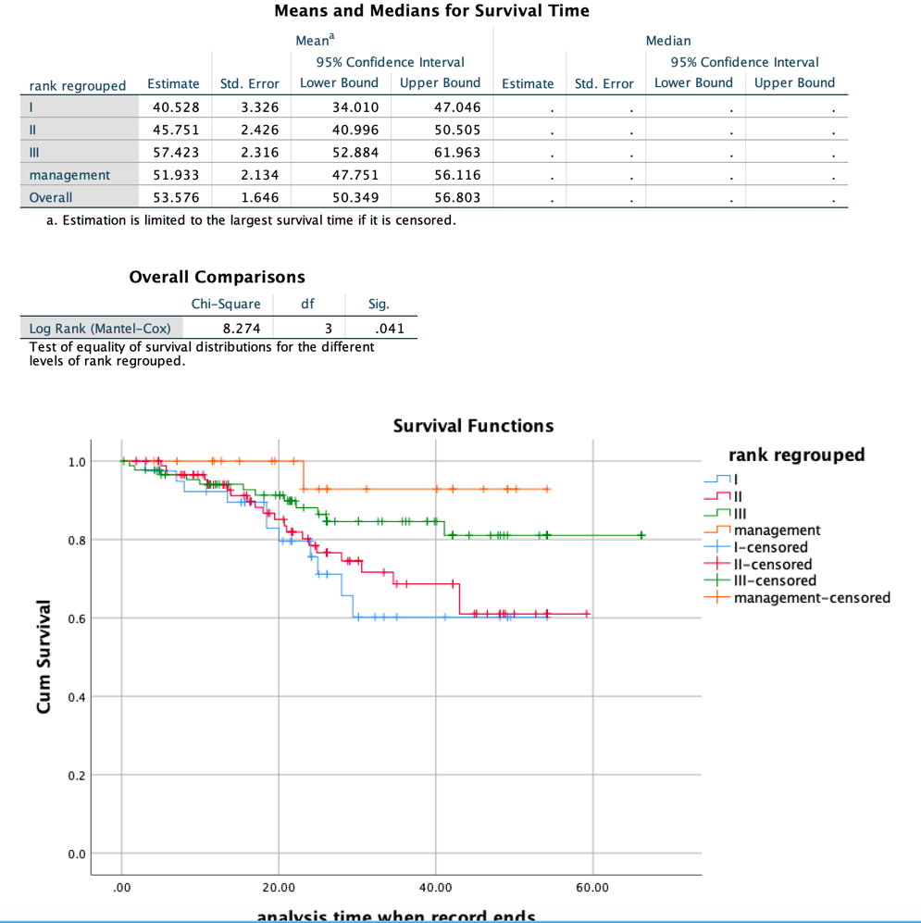

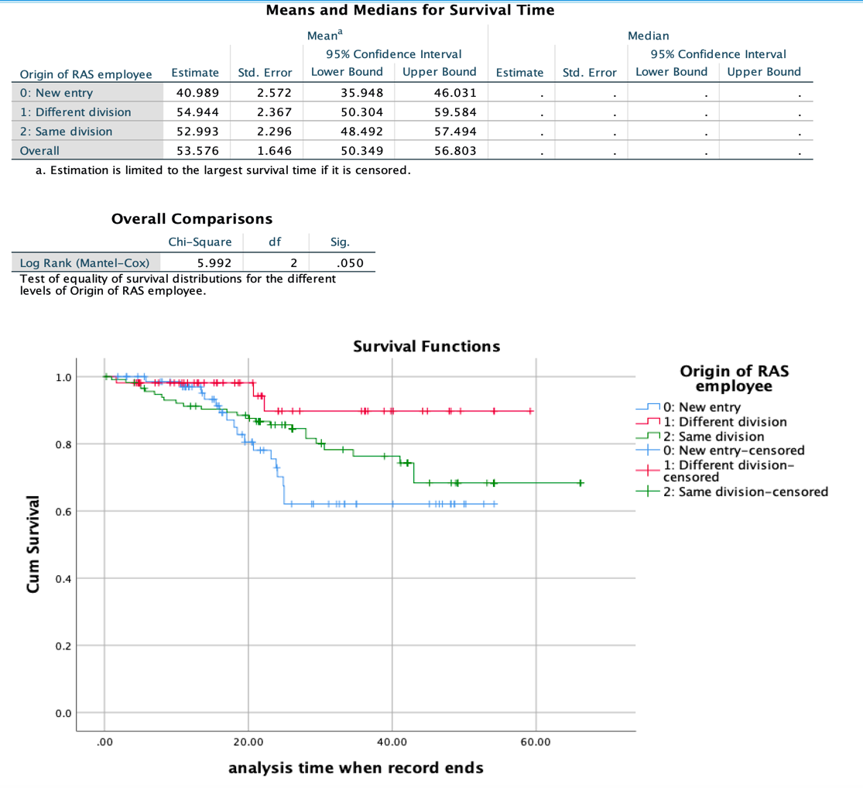

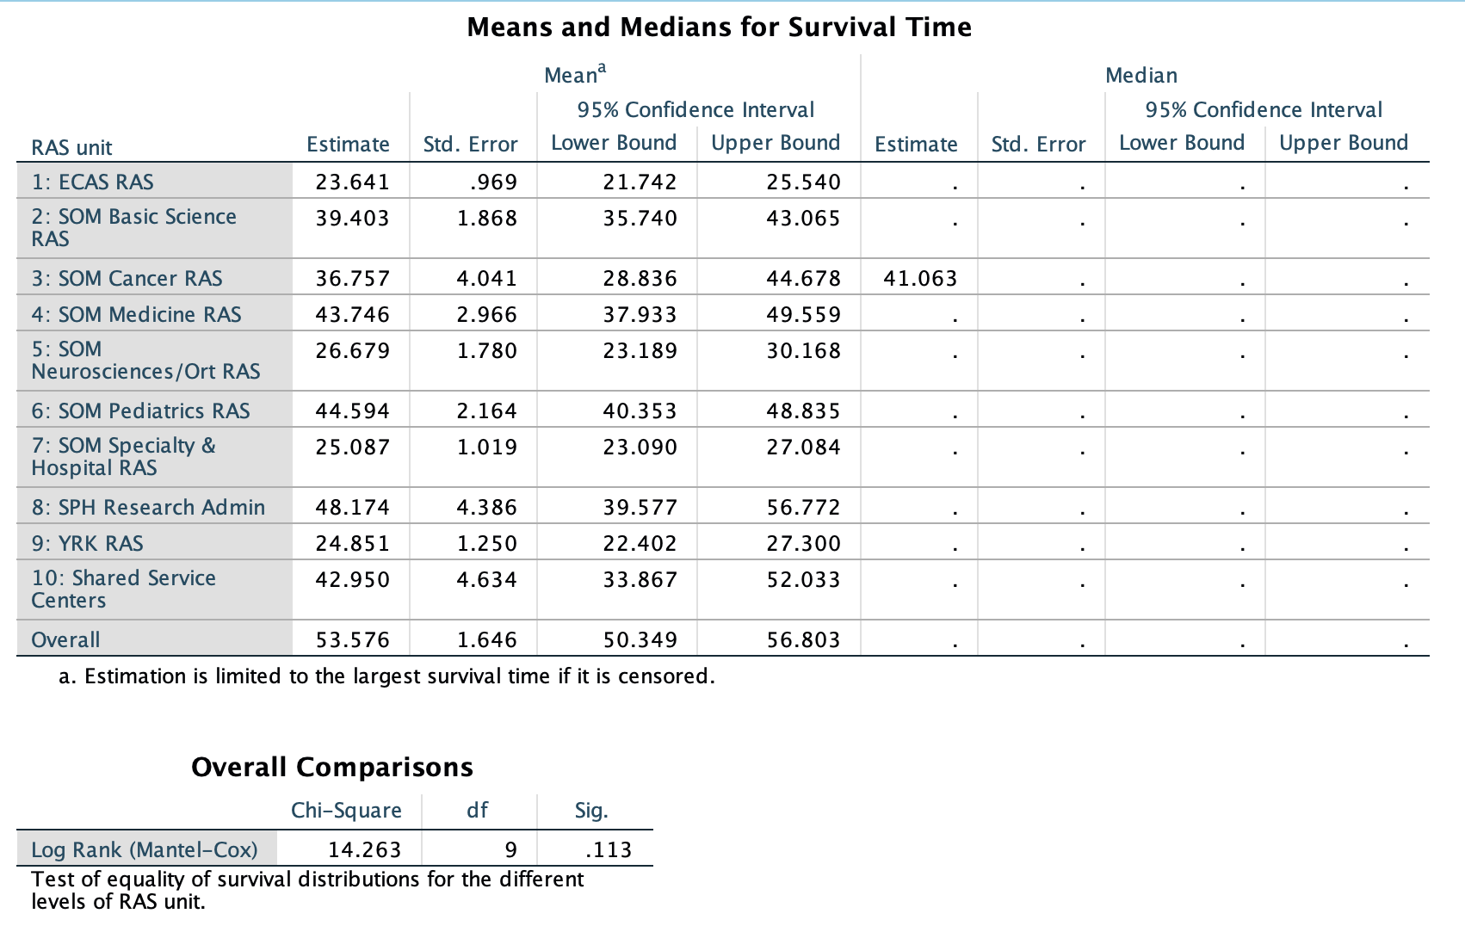

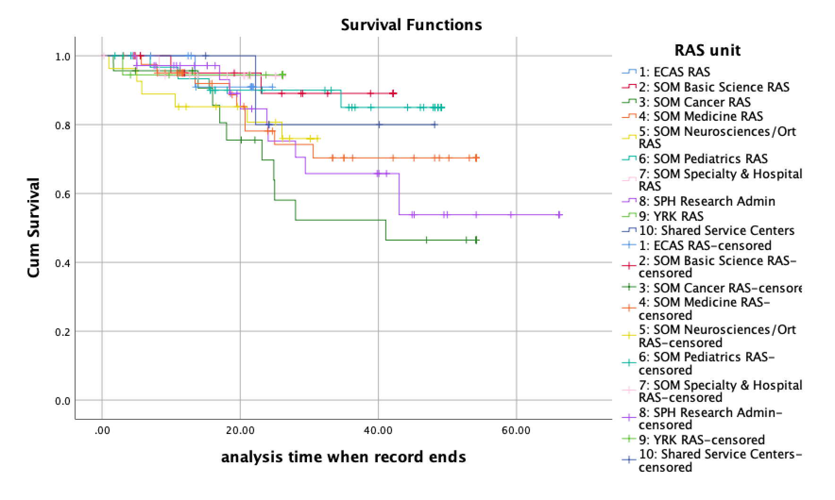

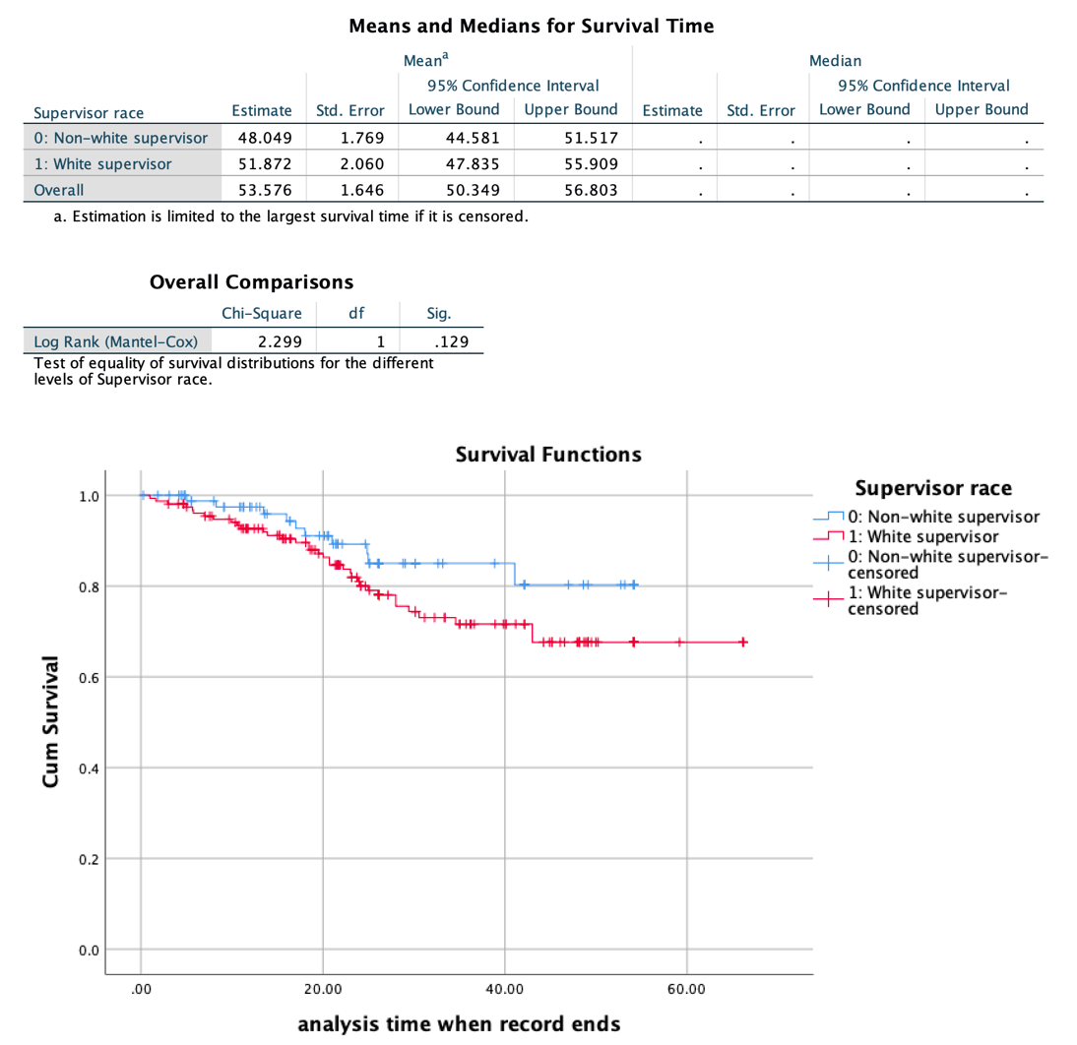

4). Cox Regression models:

Model 1:

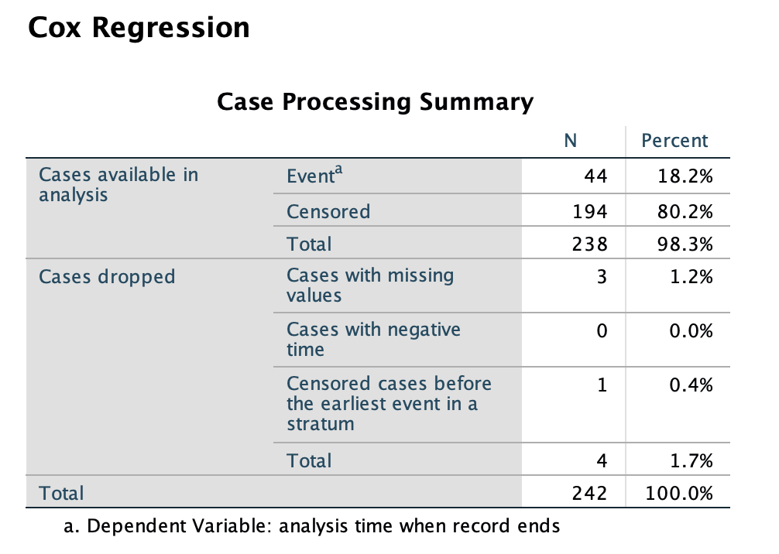

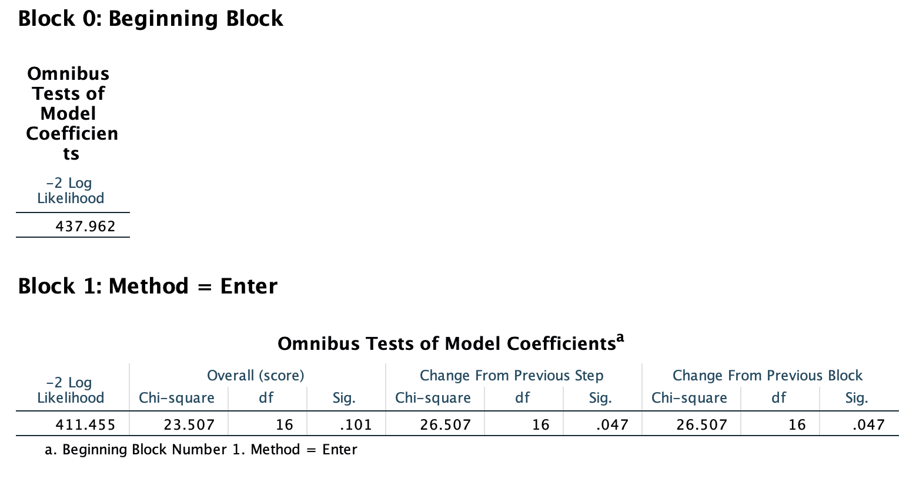

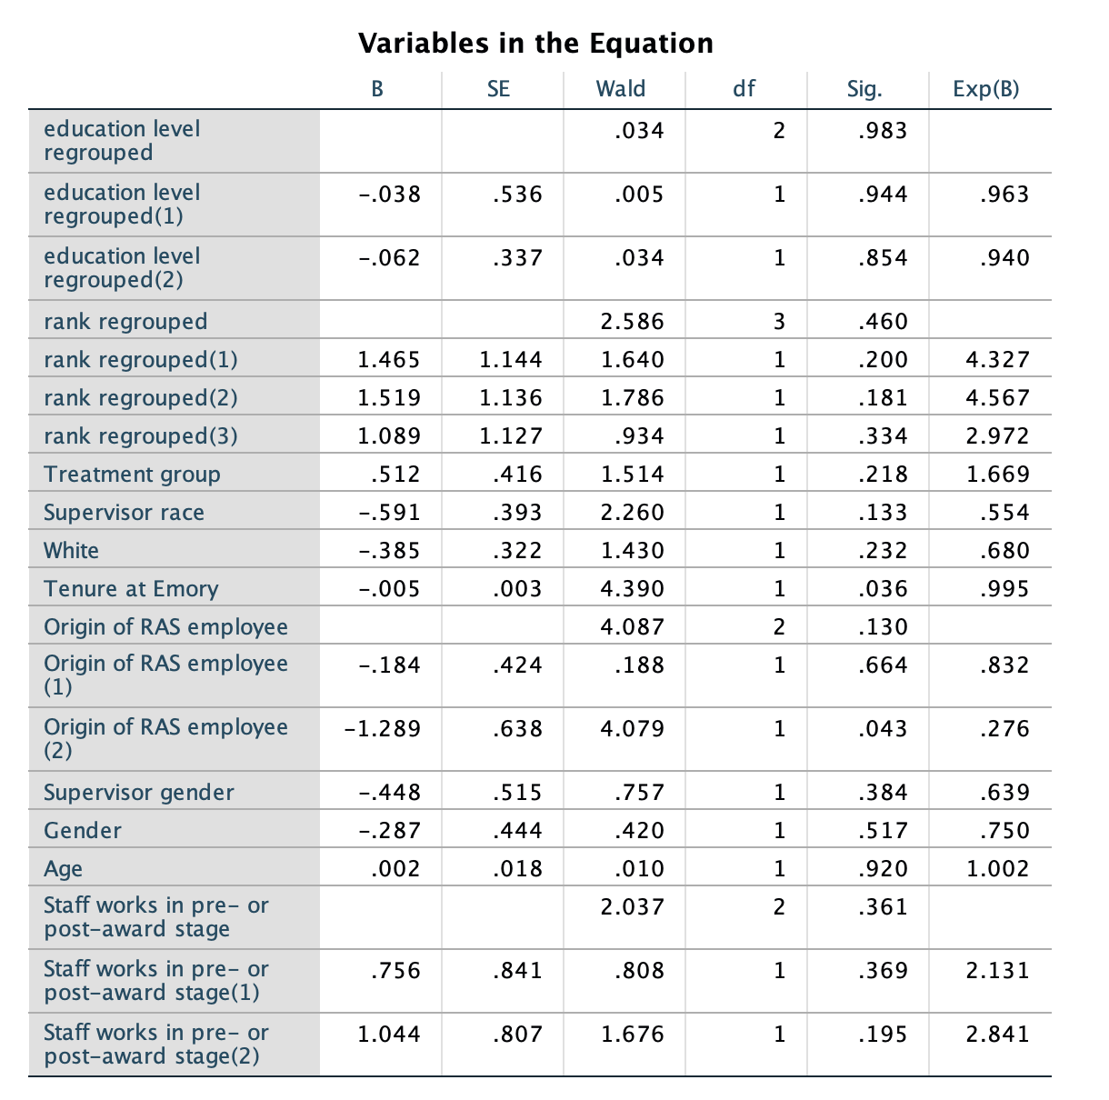

Model 2:

